|  |
| --- |
| **THANKS A BUNDLE** |
| *Improving support and access to online telecommunications products for consumers with cognitive disabilities* |
|  |
|  |
| Yvette Maker, Jeannie Marie Paterson, Bernadette McSherry, Lisa Brophy, Anna Arstein-Kerslake, Alex Callahan and Eugene Teo |
|  |

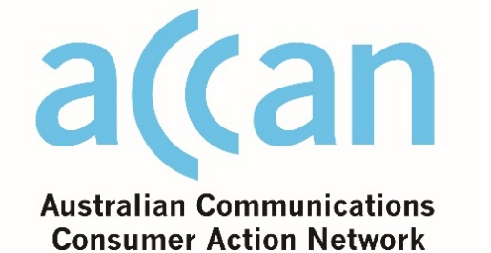

Thanks a bundle: Improving support and access to online telecommunications products for consumers with cognitive disabilities

Authored byYvette Maker, Jeannie Marie Paterson, Bernadette McSherry, Lisa Brophy, Anna Arstein-Kerslake, Alex Callahan and Eugene Teo

Published in 2018

The operation of the Australian Communications Consumer Action Network is made possible by funding provided by the Commonwealth of Australia under section 593 of the *Telecommunications Act 1997*. This funding is recovered from charges on telecommunications carriers.

Melbourne Social Equity Institute  
Website: [socialequity.unimelb.edu.au](https://socialequity.unimelb.edu.au/)  
Email: [social-equity@unimelb.edu.au](mailto:social-equity@unimelb.edu.au)

Australian Communications Consumer Action Network  
Website: [accan.org.au](http://www.accan.org.au/)   
Email: [grants@accan.org.au](mailto:grants@accan.org.au)   
Telephone: 02 9288 4000

If you are deaf, or have a hearing or speech impairment, contact us through the National Relay Service: [www.relayservice.gov.au](http://www.relayservice.gov.au/).

ISBN: **978 0 9876418 0 9**

Creative Commons logo

This work is copyright, licensed under the Creative Commons Attribution 4.0 International Licence, except where otherwise indicated. You are free to cite, copy, communicate and adapt this work, providing you attribute the authors and “Melbourne Social Equity Institute, supported by a grant from the Australian Communications Consumer Action Network”. To view a copy of this licence, visit <http://creativecommons.org/licenses/by/4.0/>

This work can be cited as: Maker, Yvette; Paterson, Jeannie Marie; McSherry, Bernadette; Brophy, Lisa; Arstein-Kerslake, Anna; Callahan, Alex and Teo, Eugene (2018) *Thanks a Bundle: Improving Support and Access to Online Telecommunications Products for Consumers with Cognitive Disabilities*, Australian Communications Consumer Action Network, Sydney and Melbourne Social Equity Institute, University of Melbourne.

Table of contents

Executive summary 5

Recommendations 8

Glossary 10

List of figures 13

1. Introduction 14

2. Telecommunications suppliers’ legal obligations to consumers with cognitive disabilities 17

2.1 Consumer protection 17

2.2 Human rights requirements 20

3. Previous research 25

3.1 Introduction 25

3.2 Barriers to telecommunications consumer protection and empowerment 25

3.3 Options for improving accessibility of information and support 29

3.4 Conclusion 34

4. Study outline and methodology 35

4.1 Study outline 35

4.2 Research methodology 35

5. Analysis of suppliers’ websites 38

5.1 Overview: positive features of existing websites 38

5.2 Overview: website features that need improvement 39

5.3 Details of the website analysis 42

6. Recommendations for suppliers 65

7. Conclusion 72

References 75

Attachment A: Toolkit for suppliers 80

Attachment B: List of additional resources 120

# Executive Summary

Access to mobile phones, tablets, home phones and internet services is increasingly important for Australians to keep in touch with friends, family and colleagues, access services and organise daily activities. However, the websites that many consumers use to explore their options for purchasing telecommunications devices and plans, and ask questions about those options, are not necessarily accessible to all. Online information and sales material do not currently cater to the requirements of consumers with cognitive disabilities who may have difficulties with learning, memory, concentration and/or decision-making. Prior research about this consumer group’s experiences and information needs recognises that people with cognitive disabilities are diverse and have a range of requirements and preferences. The small amount of existing research does indicate that sales information and contract terms can be particularly unclear or inaccessible for this group of consumers, and standard website design does not consider their requirements. Previous studies also indicate that consumer information is not necessarily clear or helpful for any consumers when they are weighing up options and making decisions.

Telecommunications providers in Australia are required to provide clear, accurate and accessible information and assistance to consumers, including consumers with cognitive disabilities. These requirements arise from the Telecommunications Consumer Protections Code (‘the Telecommunications Code’), the Australian Consumer Law, and the United Nations Convention on the Rights of Persons with Disabilities (‘the Convention’).

This report presents the results of a 2018 study conducted by an interdisciplinary research team, which was supported by the Melbourne Social Equity Institute. The study aimed to:

* increase awareness among telecommunications suppliers of their legal obligations in relation to consumers with cognitive disabilities, as well as the corporate, social and economic benefits of making services more accessible and available to them;
* assess the extent to which telecommunications suppliers’ online information about choosing a product and getting help or assistance complies with the Telecommunications Code requirements about disclosure and clarity and human rights requirements in relation to accessibility and the exercise of legal capacity by consumers with cognitive disabilities; and
* support good outcomes for consumers by developing practical guidance for telecommunications suppliers to provide accessible information for consumers with cognitive disabilities about selecting a phone, tablet or internet service, managing the cost, and what to do when problems arise.

In May 2018, we assessed the extent to which nine telecommunications suppliers’ online information and sales materials about mobile, tablet, home phone and internet services met the requirements of consumers with cognitive disabilities, and suppliers’ domestic and international obligations regarding this group. The purpose of the analysis was to survey the general state of play in the industry (not ‘name and shame’ suppliers) and develop detailed, practical recommendations for suppliers to make their information more accessible for consumers with cognitive disabilities. We focused on five service types: postpaid mobile, prepaid mobile, postpaid tablet, home internet and home phone. For each type of service, we analysed the websites of four or five suppliers. Telstra, Optus and Vodafone, the three tier one suppliers, were analysed for each type of service, alongside two smaller suppliers, the selection of which differed for each service type.

The website analysis was guided by the requirements in the Telecommunications Code, the Convention, the World Wide Web Consortium’s Web Content Accessibility Guidelines, and insights from the existing research literature on accessibility and support measures for consumers with cognitive disabilities. The analysis indicated that existing websites do have some features that are likely to facilitate consumers’ access to information about phone, tablet and internet services. These included webpages with clearly marked links, lots of white space and text in high-contrast colours, and webpages that have jargon-free descriptions of product and service features and easy-to-find information about low cost plans and devices. The analysis also demonstrated many shortcomings of current online information and sales material, including webpages cluttered with text and images, important information that is hidden, hard to find or jargon-heavy, inconsistent presentation of price, use of very small fonts, and vague or hidden information about where to go for assistance or advice.

In consultation with a representative from People with Disability Australia, an organisation of and for people with disability, and a representative from the Victorian Mental Illness Awareness Council (‘VMIAC’), an organisation of and for mental health consumers, we developed a set of 12 recommendations to telecommunications providers for improving their online information and sales materials for consumers with cognitive disabilities. We recommend that suppliers provide clear and easy-to-read websites, make targeted use of images to tell complex stories, offer tools for comparing options, make webpages easy to navigate, avoid jargon and technical language, and provide information in multiple formats including plain language, Easy English and video. We also recommend company-wide changes to support the implementation of these recommendations, such as providing disability and mental health awareness training to staff and ensuring that designated staff members are responsible for providing and maintaining access and support for consumers with cognitive disabilities.

To facilitate the implementation of the recommendations, and in consultation with People with Disability Australia and VMIAC, we have also created a toolkit of materials to assist providers to give written information in Easy English. Easy English is a format that is likely to be accessible for people with cognitive disabilities, as well as other consumers who prefer or require clearer communication. The toolkit (Attachment A) consists of four ‘things you need to know’ factsheet templates that address the key issues and questions that consumers might have when they are:

1. shopping for a service;
2. paying for a service;
3. experiencing financial hardship; or
4. having a problem with their device or service.

The factsheets were formatted into Easy English and tested with four people with intellectual disability by the Intellectual Disability Rights Service in New South Wales. If suppliers adapt these factsheets with their own contact information and offerings, consumers with cognitive disabilities can be better supported to select and use the services that meet their needs and preferences, either by themselves or with the support of a trusted person.

The outcomes of this research can contribute to ensuring the consumer rights and human rights of people with cognitive disabilities are respected when they make decisions about telecommunications products and services. Improving website information and sales material, and making it easier for consumers to get assistance, may also have a range of benefits for suppliers. First, it will assist with meaningful compliance with the Australian Consumer Law and the Telecommunications Code in terms of the provision of ‘plain language’ information and communication with consumers generally, and consumers with disabilities in particular. More broadly, it is likely to make suppliers’ products and services available to the hundreds of thousands of Australians with cognitive disabilities, and to the many other consumers who currently find online information and sales materials complex, unhelpful, and difficult to navigate.

# Recommendations

1. **Include people with disabilities in website and information design processes**

Any changes to improve accessibility for consumers with cognitive disabilities must include people with cognitive disabilities, and their representative organisations, in every stage of planning, development, implementation and testing.

1. **Implement organisation-wide changes**

Changes to online information and sales material will only be effective if they are part of a wider culture of accessibility and inclusion of consumers with cognitive disabilities. Suppliers should develop and implement a Disability Action Plan, provide disability and mental health training to staff, and assign responsibility for ensuring accessibility to senior staff.

1. **Make webpages clear and easy to read**

Keep sentences short, use lots of white space, limit the amount of information per page, and consider the size and colour contrast of text.

1. **Make webpages easy to navigate**

Make sure it is easy to find and follow links, that link titles reflect destination material and lead to logical places, and that it is not necessary for consumers to scroll too much to find information.

1. **Make sure low-cost plans and handsets are easy to find and access**

Make sure it is easy to find and select low-cost plans and handsets online, and that low-cost options are generally available and in stock.

1. **Make important product and service information easy to find**

Important information like total price and extra charges should be easy to find, and price should be presented in a consistent and clear manner. Where the purchase involves multiple charges, each cost should be itemised and the overall cost should be presented in clear, large font.

1. **Make it easy to compare options based on important product or service features**

Give consumers the option to view one or more choices side-by-side. This makes it easy to compare options based on important features.

1. **Avoid jargon where possible, or explain the meaning of complex terms**

Define terms that consumers must understand when selecting a product or service. Do not assume that everyone will understand common but technical terms like ‘gigabyte’ or ‘SIM-card’. Present information in straightforward language and refer to common, relatable concepts. Consider using graphics or images to enhance understanding.

1. **Provide information in plain language and/or Easy English formats**

Offer plain language or Easy English versions of all important information including online sales information and information about getting assistance. Different consumers will have different information needs and preferences; consider offering multiple options including video and audio.

1. **Emphasise images and storytelling**

Images can be a powerful way to communicate information. They may be the only accessible form of information for some people. Formats like cartoons and comics can tell a clear, short story, provided they are not patronising.

1. **Be creative and give people options**

Be creative when thinking of different formats for presenting information. For example, information could be on a poster, in flowcharts, part of a ‘guided’ online tour, or in a captioned video. Give consumers the option to choose how they want to receive information. This might include offering multiple versions of the website.

1. **Ensure multiple forms of assistance are available for asking questions or getting help**

Companies should offer live chat, telephone numbers and email for people to get in touch. These should be easy to find and read, and it should be easy to identify the right contact point for a particular query or problem. There should also be the option to ask questions face-to-face.

# Glossary

|  |  |
| --- | --- |
| **ADSL2+** | A common way of connecting to the internet, using an existing phone line. |
| **Broadband** | The most common form of high-speed internet. |
| **Broadband speed** | How fast and easy it is for **data** to travel on an internet connection. For example, how long it takes for videos to load or emails to send. |
| **Cognitive disability/People with cognitive disabilities/Consumers with cognitive disabilities** | People who, due to impairment or disability, have difficulties or perceived difficulties with:   * the ability to learn, concentrate on, process, remember, or communicate information; * awareness; and/or * decision-making |
| **Consumer Protection** | The laws that protect **consumers** if there is a problem, including the Australian Consumer Law and the Telecommunications Code. |
| **Consumer Transaction** | The process of buying a product or a service, including signing a contract or paying money. |
| **Consumer/Telecommunications Consumer** | A consumer is a person who buys things. A telecommunications consumer is a person who buys telephone or internet services or products. |
| **Contractual terms** | What the **consumer** and the **supplier** have agreed to do. For example:   * How much the **consumer** need to pay * How much **data** the **supplier** will supply each month |
| **Data** | Data is used to describe:   * The way a mobile phone or tablet connects to the internet using the mobile phone network * The amount of internet that can be used by a mobile phone or internet user. For example, ‘15GB of data.’ |
| **Data and credit expiry** | When **data** and credit is purchased before it is used, it can usually only be used for a set amount of time. This amount of time, or the date when it must be used by, is called ‘data and credit expiry.’ |
| **Data and credit roll-over** | Some prepaid plans allow data or credit to be used after expiry if more **data** or credit is bought or added before the expiry date. This is called ‘data and credit roll-over.’ |
| **Gigabyte (GB)** | A unit of measurement of digital information or **data**. |
| **Handset** | A mobile or home phone. |
| **Information Disclosure** | The practice of providing **consumers** with information about a **product** or service before they buy it to allow them to make an informed choice. |
| **Modem** | A device that allows a **consumer** to connect a computer to the internet through the phone line. |
| **Naked DSL** | A way of connecting to the internet that does not need an active phone line connection. |
| **National Broadband Network (NBN)** | An upgrade to Australia’s existing phone and internet infrastructure. All people who have had an NBN upgrade in their area need to connect to the internet through the NBN. |
| **Plan** | A contract with a telecommunications supplier where they supply telephone or internet services, usually in exchange for a monthly fee. A plan for mobile or tablet services often includes the use of a handset that is paid off over time. |
| **Postpaid** | A **plan** where the fee is due after the telephone or internet service has been provided, usually monthly. |
| **Prepaid** | A **plan** where the fee is due before the telephone or internet service has been provided. It is usually done by buying credit in advance to make calls and use **data**. |
| **Products/Telecommunications Products** | Products are things people buy and use every day. Telecommunications products are things you use to talk to people who aren’t with you or to use the internet. For example:   * Mobile or home phone * Tablet * Home internet |
| **Sans-serif font** | A sans-serif font is a font that does not have small lines attached to the end of the strokes in a letter. Examples of common sans-serif fonts are Arial, Verdana and Calibri. The text used in this document is sans-serif. |
| **Screenshot** | A picture of a computer screen taken using the computer. |
| **SIM card** | A SIM card is a microchip in a mobile phone that connects the phone to a phone network. SIM stands for ‘Subscriber Identity Module.’ |
| **SIM-only** | A SIM-only plan is a plan that requires the consumer to use a mobile handset or tablet that they already own. |
| **Standard form contract** | A standard form contract is a contract where the **supplier** decides the terms and the **consumer** agrees to them. |
| **Supplier/Telecommunication Supplier** | A supplier is a company that sells products and services to you. A telecommunications supplier is a company that sells telephone and internet products or services. |
| **Technical language/jargon** | Special words used by a group of people that can be difficult for others to understand. |
| **Telecommunications Industry Ombudsman (TIO)** | An independent organisation where **consumers** can make complaints about telephone or internet suppliers. |

# List of Figures

Figure 1: Screenshot of Optus iPhone SE page.

Figure 2: Screenshot of Optus tablet plans.

Figure 3: Screenshot of Optus tablets with data plans.

Figure 4: Screenshot of Amaysim phone home page.

Figure 5: Screenshot of Telstra postpaid mobile plans with ‘Medium’ plan selected.

Figure 6: Screenshot of Telstra handsets.

Figure 7: Screenshot of Vodafone page after a plan has been selected, and a handset is being considered.

Figure 8: Screenshot of Optus tablets with data plans.

Figure 9: Screenshot of Vodafone tablets with data plans.

Figure 10: Screenshot of Vodafone prepaid plans, scrolled down to the bottom of the page.

Figure 11: Screenshot of Amaysim prepaid plans.

Figure 12: Screenshot of Optus prepaid plans.

Figure 13: Screenshot of Boost Mobile prepaid plans.

Figure 14: Screenshot of Vodafone plan comparison table.

Figure 15: Screenshot of Vodafone handset description page.

Figure 16: Screenshot of Telstra postpaid plans with ‘Large’ plan selected.

Figure 17: Enlarged screenshot of Telstra postpaid plans.

Figure 18: Screenshot of Vodafone postpaid plans.

Figure 19: Screenshot of Telstra broadband plan information.

Figure 20: Screenshot of iiNet broadband plan information.

Figure 21: Screenshot of Telstra NBN homepage.

Figure 22: Side-by-side screenshots of iiNet broadband plans.

Figure 23: Screenshot of Optus broadband plan information.

Figure 24: Screenshot of the Amaysim Broadband plan information.

Figure 25: Screenshot of Telstra Broadband Frequently Asked Questions page.

Figure 26: Screenshot of Amaysim Broadband speeds page.

Figure 27: Screenshot of Telstra home phone plans.

Figure 28: Screenshot of Telstra NBN internet speed information.

Figure 29: Screenshot of Optus Help and Support page.

# 1. Introduction

Interconnectedness through technology is increasingly essential for all Australians’ engagement in employment, health and education, social interaction and access to services, including government services such as Centrelink and the National Disability Insurance Scheme.[1] People with cognitive disabilities must deal with a range of barriers to accessing telecommunications services. There are many different types of products available; these are bundled in many different combinations and the pricing arrangements are complex. Requirements in the Telecommunications Consumer Protections Code (‘the Telecommunications Code’) go part of the way to ensuring that consumers are provided with the information they need to make a decision. But these requirements do not generally go far enough to ensure people with cognitive disabilities have sufficient information or support to access telecommunications products on an equal basis with others. One issue is that telecommunications suppliers’ information and communications are not tailored to the requirements of people with cognitive disabilities.[2] In particular, although many consumers will use the internet to look for the products they want or need, important information about products, the contracting process and contractual rights and obligations is not provided online in easy-to-understand formats. Little online support is available for consumers in trying to decide what telecommunications product might be best for them nor is it easy for consumers to find out how or where they may get such support.

This report presents the results of a study conducted in 2018 by an interdisciplinary research team, which was supported by the Melbourne Social Equity Institute. We assessed the extent to which telecommunications suppliers’ online information and sales materials about telecommunications products met the requirements of consumers with cognitive disabilities as at May 2018. We sought to develop effective tools and guidance to assist telecommunications suppliers to make their information and communication more accessible to this consumer group. We consulted with a representative from People with Disability Australia, an organisation of and for people with disabilities, and a representative from the Victorian Mental Illness Awareness Council (‘VMIAC’), an organisation of and for mental health consumers, to ensure that the recommendations and tools that we developed were appropriate and useful for the community. We also sought expert input from our Advisory Board. The Advisory Board members were Margaret Boulos (Carers Victoria), Carol Geyer (Telecommunications Industry Ombudsman), Bruce Bonyhady (Melbourne Disability Institute), Nadine Cocks (independent peer researcher), Colin Hiscoe (Reinforce/Voice at the Table), Lucy Ledger (Independent Mental Health Advocate), Patrick McGee (Australian Federation of Disability Organisations), Eva Sifis (Voice at the Table/By Accident) and Natalie Tomas (Office of the Public Advocate). We are grateful to these individuals and organisations for their contribution to this research.

Protection for telecommunications consumers is provided through the telecommunications-specific provisions in the Telecommunications Code[3] and the general consumer protections in the Australian Consumer Law.[4] The Australian Consumer Law contains provisions that aim to set a base standard of fairness in the content of contracts and the quality of goods and services provided and allows contracts to be set aside where they are procured by misleading, unconscionable or coercive conduct. However, this regime operates to offer recourse after things have gone wrong; in relation to consumers with cognitive disabilities, it is based on setting aside contracts that are obtained with ‘impaired’ consent. The Telecommunications Code requires suppliers to give consumers critical information about the contract terms that govern the products they are interested in purchasing in a clear manner. There are no express requirements for this material to accommodate the information needs of a range of consumers, including those with cognitive disabilities. There is no legal requirement in either the Telecommunications Code or the Australian Consumer Law for suppliers to provide information and assistance to help people make decisions about the products and services, or develop other means of facilitating equitable access to them.

Human rights obligations, however, require that information provided to consumers is accessible, including for consumers with cognitive disabilities. The significant changes associated with the roll-out of the National Broadband Network (NBN) mean it is especially important for telecommunications companies to provide clear information and ensure clear communication with all consumers. Suppliers must also ensure that consumers who need support in making decisions have that support. In light of evidence that prevailing approaches to providing consumer information are not useful or helpful for consumers of all kinds, initiatives to support consumers with cognitive disabilities may make those products more accessible to *all*.

This study aimed to:

* increase awareness among telecommunications suppliers of their legal obligations in relation to consumers with cognitive disabilities, as well as the corporate, social and economic benefits of making services more accessible to them;
* assess the extent to which telecommunications suppliers’ online information about choosing a product and getting help or assistance complies with the Telecommunications Code requirements about disclosure and clarity, and human rights requirements, in relation to consumers with cognitive disabilities; and
* support good outcomes for consumers by developing practical guidance for telecommunications suppliers to provide accessible information about selecting a phone, tablet or internet service, managing the cost and what to do when problems arise for consumers with cognitive disabilities.

The report is in seven sections. Following Part 1 (this introduction), Part 2 briefly sets out telecommunications suppliers’ current obligations in relation to consumer protection and human rights law. In Part 3, we review the existing literature on the limitations of the Australian Consumer Law and the Telecommunications Code, and information generally, for protecting consumers, as well as the problems and barriers to access to telecommunications products (and contracting for services more broadly) for consumers with cognitive disabilities. In Part 4, we introduce and describe the methodology for the central element of the study, namely, the analysis of a selection of telecommunications suppliers’ existing online information and sales materials, assessing the extent to which those materials currently meet these obligations. Part 5 sets out the findings from the analysis, and Part 6 lists our key recommendations to assist telecommunications suppliers to improve the accessibility of their information and sales material for people with cognitive disabilities. Part 7 summarises the study and proposes ways forward for suppliers, researchers, and other stakeholders to work towards full and equal access to telecommunications products for all consumers.

This report contains technical and legal language that is commonly used in the telecommunications field. The glossary on page 12, above, explains the meaning of some of the more technical or difficult words.

# 2. Telecommunications suppliers’ legal obligations to consumers with cognitive disabilities

## Consumer protection

### 2.1.1 The Australian Consumer Law

The Australian Consumer Law applies to consumer (and some business) sales of telecommunications services and products. Its purpose is to ensure basic standards of quality[5] and safety[6] in the supply of goods and services. It also contains prohibitions on various forms of unfair business practices that impede consumers from making free and informed decisions about the goods and services they purchase. These include prohibitions on misleading or deceptive conduct,[7] undue harassment and coercion,[8] and unconscionable conduct,[9] as well as provisions governing unsolicited sales.[10]

The Australian Consumer Law also contains protections against substantive unfairness in the terms of standard form contracts themselves. Part 2-3 renders void unfair terms in standard form consumer and small business contracts. This regime is complemented by Part 3-2, which provides mandatory guarantees of quality in the supply of goods and services to consumers.

The provisions in the Australian Consumer Law provide a safety net of protection to consumers. They provide remedies and sanctions where consumers have been misled,[11] subjected to predatory or exploitative conduct,[12] and where products do not work or are defective. They do not, however, go further and require positive measures to ensure consumer goods and services are available to all, including by supporting consumers with cognitive disabilities in selecting appropriate products and understanding their contractual obligations.

### 2.1.2 The Telecommunications Consumer Protections Code

The Telecommunications Code is a code governing the conduct of suppliers of telecommunications products pursuant to section 117 of the *Telecommunications Act 1997* (Cth). It is ‘designed to ensure good service and fair outcomes for all Consumers of Telecommunications Products in Australia’.[13] The Telecommunications Code contains rules about consumer sales, service and contracts, billing, credit and debt management, changing suppliers, and complaint handling.

*Method of communication*

The Telecommunications Code contains rules relating specifically to communication with consumers and the ways in which information must be provided. Under the Telecommunications Code, telecommunications suppliers must communicate with consumers in ‘plain language’.[14] They must ensure that any information provided to consumers is ‘clear, accurate, free of material omissions, relevant, current and… timely’.[15] Suppliers must equally ensure sales staff are trained to promote products in ‘a fair and accurate manner to assist consumers in making informed purchasing decisions’.[16]

The clarity of information on websites is specifically addressed by the Telecommunications Code. Thus a supplier must ensure that ‘consumers can view and download all relevant terms and conditions of its Telecommunications Products from a website’.[17] A supplier should moreover ‘have regard to its web content complying with the Web Content Accessibility Guidelines’ (‘the Web Guidelines’).[18] The Web Guidelines were developed by the World Wide Web Consortium (‘W3C’). This consortium is a community of organisations, staff and volunteers that develops standards for web design.[19] One of its projects was to develop the Web Guidelines (via the W3C Web Accessibility Initiative) to provide a standard of web accessibility, to assist individuals, governments and organisations to know how to improve the accessibility of their websites, and to make the internet more accessible for people with disabilities.[20] The guidelines include requirements that text be ‘content readable and understandable’ and that webpages be made to ‘appear and operate in predictable ways’.[21]

The Telecommunications Code contains rules designed to support consumers who have what it describes as ‘different’ or ‘special’ needs. It requires suppliers to communicate ‘in a way that is appropriate to the Consumer’s communication needs including those with special needs’.[22] The types of ‘special needs’ that suppliers should be aware of are not defined in the Telecommunications Code, and no detail is given about how to address them. It should further be noted that the focus on ‘special needs’ is problematic from a human rights perspective; this terminology – and the responses is necessitates – has been criticised for being patronising and imprecise, and for implying that people with disabilities require special or separate treatment, rather than having a right to be included in existing processes and systems.[23]

*Disclosure*

The Telecommunications Code obliges telecommunications suppliers to provide certain information to consumers. The aim of these information requirements is to ensure that consumers have all the information relevant to their purchase, and to assist consumers in comparing products and services to make an informed decision.[24]

In particular, suppliers are obliged to provide a summary of each current offer, known as a Critical Information Summary.[25] An ‘offer’ is defined as ‘a current, standard in-market plan containing pricing that is made by a Supplier for the provision of Telecommunications Products, which is available to any individual Consumer or Consumers as a class.’[26] The Telecommunications Code specifies the information that the Critical Information Summary must contain,[27] including the minimum term for the product, exclusions, information about pricing, information about dispute resolution and contact details for the Telecommunications Industry Ombudsman.

The Critical Information Summary must:

* appear in a separate document to the full contract terms;[28]
* be no longer than two A4 pages;[29]
* be readily accessible on the supplier’s website linked to the relevant offer and available at the supplier’s stores;[30] and
* be provided to all consumers (except those buying over the phone) before they consent to entering a telecommunications contract;[31]

Suppliers must also give a ‘general overview’ of the Critical Information Summary to those buying over the phone, and provide a copy within five working days.[32]

The Telecommunications Code further requires other relevant information to be made available to consumers, including information about the product description, manufacturer, technical information, payment and billing, usage, post-sale support, mobile coverage, international roaming and resellers.[33]

The Telecommunications Code requires suppliers to recognise consumers’ use of ‘Authorised Representatives’ to act on their behalf as their agent[34] and ‘Advocates’ who can assist with communication (but who are not their agent).[35] If a consumer identifies a particular need, suppliers must indicate if they have a product that may suit that need and must train their staff in understanding and advising on consumer needs.[36] Suppliers are required to make information available about telecommunications products offered specifically for consumers with ‘different disabilities’.[37]

Compliance with the Telecommunications Code is monitored by the independent monitoring body Communications Compliance and the Australian Communications and Media Authority (‘ACMA’). The Telecommunications Industry Ombudsman provides free-of-charge dispute resolution services to residential and small business consumers, including in relation to breaches of the Telecommunications Code.

## Human rights requirements

Australia has ratified the United Nations Convention on the Rights of Persons with Disabilities (‘the Convention’). The Convention sets out several rights that are relevant to consumers with cognitive disabilities and these rights have implications for how telecommunications suppliers engage with this consumer group.

The Convention prohibits all discrimination on the basis of disability, and requires people with disabilities to be recognised as ‘equal before and under the law’.[38] Discrimination on the basis of disability includes treating a person with disabilities unfavourably, either directly or through practices and policies, and through the denial of reasonable accommodation.[39] The Convention stipulates that discrimination ‘by any person, organisation or private enterprise’ is prohibited.[40] The most significant rights enshrined in the Convention relating to telecommunications services for consumers with cognitive disabilities are the right to accessibility and the right to equal recognition before the law.[41] This includes the enjoyment of ‘legal capacity’ on an equal basis with others.

### The right to access

Access-related rights are enshrined in Article 9 of the Convention. Article 9 requires those who signed or ratified the Convention to ‘take appropriate measures to ensure to persons with disabilities access, on an equal basis with others, to … information and communications, including information and communications technologies and systems.’ On this basis, telecommunications suppliers are expected to ensure that their information, websites, technology and communications are accessible. Australian Federal and State discrimination laws also oblige suppliers to ensure that people with disabilities have access to goods and services on an equal basis with others.[42] This obligation to provide information in an accessible manner, and to communicate in a manner that is appropriate to the individual, is reflected to an extent in the Telecommunications Code, discussed above.

People with cognitive disabilities face particular barriers when accessing information. According to the Committee on the Rights of Persons with Disabilities (‘the Committee’), which monitors the implementation of the Convention in Australia and other signatories,[43] this can be remedied with the provision of information in easy-to-read, or ‘Easy English,’ formats (also called ‘Easy Read’ or ‘Accessible Written Information’).[44] This implies a greater obligation than the requirement in the Telecommunications Code to provide information in ‘plain language’. The Committee has also emphasised the importance of ensuring that information on the internet is accessible.[45] As noted above, the Telecommunications Code contains other references to accessibility, and requires that suppliers ‘have regard’ to the Web Guidelines when designing websites.[46]

Article 9 of the Convention also requires that information and communication technology and systems must be accessible to persons with disabilities. This includes the right to access mobile phones, computers and the internet.[47] Technology is accessible if it can be ‘used in an equal or equitable manner by all users without relying on a specific sense or ability’ or if it is compatible with a broad range of assistive technologies.[48] The Convention also encourages information and communication technology to be made accessible ‘from the outset’ to limit the costs associated with adaptation.[49] The Telecommunications Code implies some of these obligations, by requiring suppliers to identify products that suit a person’s ‘specific needs’ and to train staff in understanding and advising on the person’s needs. However, while the Telecommunications Code focuses on products ‘offered specifically for consumers with different disabilities,’[50] Article 9 instead encourages an emphasis on universal accessibility or designing all products with broad accessibility in mind.[51]

The Committee has emphasised that access to information, technologies and systems is not only an end in itself; it is also essential for people with disabilities to exercise their right to ‘live independently and participate in all aspects of life’ by, for example, communicating with family and friends, seeking and engaging in employment, accessing education, interacting with services and, as outlined above, making consumer decisions.[52]

While the Convention mainly creates obligations for states (governments), the Committee has interpreted Article 9 of the Convention to also require private entities to ensure accessibility for people with disabilities.[53]

### Recognition of legal capacity and supported decision-making

It is often assumed that people with cognitive disabilities are unable to make financial decisions, enter contracts or make other significant choices about their lives because of their disability. They may be subject to ‘substitute decision-making’, whereby another person is appointed (or self-appointed) to make decisions for the person, often based on what the appointee thinks is the person’s ‘best interests’.

Article 12 of the Convention sets out the right to equal recognition before the law. It states that people with disabilities ‘enjoy legal capacity on an equal basis with others in all aspects of life’.[54] It requires a distinction to be drawn between a person’s legal capacity and mental capacity, or decision-making skills. Under the Convention, a lack of decision-making skills or experience is an unacceptable reason to prevent persons with disabilities making their own decisions and having their legal capacity recognised.[55] Recognition of legal capacity means persons with disabilities can make their own decisions (including legal decisions) on the basis of what they want and need, including consumer decisions such as entering a contract.[56]

This does not mean that all people are expected to make decisions on their own. The Convention holds that people should be provided with the support that is necessary to exercise their decision-making power. This is known as ‘supported decision-making’.[57] In a supported decision-making arrangement, a person chooses another person or people for support in making one decision, or a range of decisions. The role of supporters is to ensure that the will and preferences of those supported are expressed and respected, rather than substituting their own judgement.[58] Supported decision-making arrangements can be informal or formal, and some jurisdictions offer formal mechanisms for appointing a supported decision-maker.[59]

Even if a substitute decision-making arrangement such as guardianship is in place, it is still possible – and preferable from a human rights perspective – for appointed decision-makers to employ supported decision-making principles and support the expression and fulfilment of the supported person’s will and preferences.

The rights set out in Article 12 have several implications for telecommunications suppliers. Suppliers should ensure that consumers are supported to exercise their legal capacity when contracting for a product or service. It will not generally be appropriate for suppliers to offer this support directly, because suppliers’ profit incentive can create a conflict of interest, and because a key principle of supported decision-making is that supported persons choose their own supporter(s), rather than having someone imposed on them.

Suppliers can nevertheless facilitate supported decision-making and the exercise of legal capacity through several means. First, they can provide consumers with the information they need to make decisions and ensure that information is accessible in terms of both where it is located and the form in which it is presented. Secondly, suppliers can recognise and facilitate existing supported decision-making arrangements. This means, for example, making provision for a third person to be involved in sales and follow-up conversations and processes, and/or to be listed on a consumer’s account with the consumer’s express permission. The Telecommunications Code includes an obligation to recognise consumers’ authorised representatives and advocates. However, these arrangements potentially lead to substitute decision-making rather than supported decision-making. In such circumstances, it remains important that the consumer has provided permission. Suppliers should also ensure that staff are aware of key supported decision-making principles, especially the need to prioritise the supported consumer’s will and preferences, not those of the supporter.

While it is important to avoid discriminatory assumptions that people with cognitive disabilities are inherently vulnerable, suppliers may sometimes have legitimate concerns about abuse, undue influence or conflict of interest in supported decision-making or substituted decision-making relationships. Under the common law, if a trader had notice of undue influence, a contract may be set aside on the ground of that influence.[60] The Australian Securities and Investments Commission provides detailed advice for identifying and responding to financial abuse.[61]

# 3. Previous research



## Introduction

The Telecommunications Code, the Australian Consumer Law and the Convention impose clear requirements on telecommunications suppliers to provide information in particular formats, to respond to the needs of individual consumers, and to recognise and facilitate the exercise of legal capacity, to ensure that consumers with cognitive disabilities can access their services on an equal basis with others. Little previous research has looked specifically at the experiences, rights or needs of people with cognitive disabilities in the context of telecommunications products and services. However, some studies have suggested that there are fundamental problems with current approaches to providing information and accessibility for some or all consumers. This includes research identifying significant limits on the usefulness of information disclosure for empowering and protecting consumers in general, and research highlighting the specific accessibility issues affecting people with cognitive disabilities in relation to sales and contracting information, telecommunications technology, and information on the web. Some research has also explored options for making information more useful and accessible to consumers, including the use of Easy English principles, web design guidelines, and technology to present more relevant and tailored information. In this section, we review the research in this field and note the main gaps and outstanding questions.

## Barriers to telecommunications consumer protection and empowerment

### The limits of information in protecting all consumers

Consumer protection law has traditionally relied on promoting good consumer decision-making by ensuring consumers are provided with relevant, comprehensive and accurate information about the goods and services they are considering buying. This is achieved through prohibitions on misleading conduct, and mandatory disclosure requirements that specify the information that suppliers must provide to consumers, such as in the Critical Information Summary. Recently however, consumer advocates, scholars and researchers have identified several reasons why there are limits to the efficacy of information rules in protecting consumers.[62]

First, consumers may not read material provided to them because they do not have the time or the skills to do so.[63] This problem is compounded where information relevant to consumers’ contracting decisions is expressed in obscure or legalistic language.

Secondly, disclosure may not be an effective tool for better decision-making where consumers have low levels of literacy and therefore cannot meaningfully extract information from the disclosure documents, even if written in relatively clear language.[64] Decision-making may equally be affected by low financial literacy.[65]

Thirdly, studies in behavioural economics, which draw on psychology and economics, suggest that there are cognitive limitations on consumers’ ability to use information effectively in making decisions.[66] Research has indicated that individuals are poor at assessing risks associated with a transaction. In making decisions, consumers are not good at processing large amounts of information and consequentially tend to focus on a few key features,[67] such as price or brand. Individuals tend to ‘use heuristics (shortcuts) to assess risk.’[68] Moreover, they tend to be overly optimistic about their ability to avoid risk.[69]

The factors that lead consumers not to read sales and contract material can be exaggerated in online contracting.[70] Researchers have highlighted that the opportunity to purchase by a ‘click’ may counteract any inclination to contemplative decision-making.[71] Sales information and terms can be easily hidden online or overshadowed by other material such as graphics or interactive displays.[72]

Indeed, Eliza Mik points to the way in which online business can control the information that is available to consumers and the way in which it is available. Mik observes that:

Online businesses influence consumer behaviour by means of a wide range of technologies that determine what information is displayed and how and when it is displayed. This creates an unprecedented power imbalance between the transacting parties ... [73]

These insights suggest that merely providing more information to consumers is unlikely to improve their ability to select products suitable for their needs. Indeed, there is a risk that too much mandatory information will in fact reduce consumer engagement and understanding. More nuanced disclosure complemented by other protective strategies is required. The Critical Information Summary and other requirements under the Telecommunications Code may overcome some of these difficulties by requiring standardised information to be provided in a clear, consistent form. However, the requirements in the Telecommunications Code are not necessarily sufficient to ensure that relevant information is accessible to consumers with cognitive disabilities.

### Inaccessibility of sales and contract information

The shortcomings of providing sales and contract information to empower consumers may be exacerbated for consumers with cognitive disabilities. A few studies have pointed to barriers to contracting for these consumers. Susan Hayes and Fiona Martin conducted a study in 2007 that surveyed 94 consumers with intellectual disability and 53 carers about their perceptions of interactions with banks in Australia. The carers were a combination of family members and paid carers from community or residential services.[74] The researchers found that consumers identified many barriers to accessing financial services, including ‘problems’ with understanding forms, brochures and other types of information.[75] The majority of the consumers surveyed did not use internet banking, with most of these consumers stating that this was due to lack of training, expense, and the complexity of the online service.[76] The researchers also reported that there was a lack of ‘plain English’ information for consumers.[77]

More recently, our research team conducted a pilot study on the barriers to accessing consumer transactions in the finance, telecommunications, insurance and utilities industries in 2016.[78] The study involved interviews with nine people who self-identified as ‘experiencing challenges with their cognition or mental health’, as well as consumer lawyers and advocates and representatives from the insurance and banking sectors.[79] The participants reported a range of challenges for consumers with cognitive disabilities when entering into consumer contracts, including complex terms and conditions, a lack of confidence in dealing with large companies, difficulties communicating with suppliers, and inadequate support for decision-making.[80]

### Inaccessibility of telecommunications technology

Research indicates that technology can constitute another barrier to accessing telecommunications services and their benefits, as it is not generally designed with people with cognitive disabilities in mind.[81] Telecommunications technology includes computers, mobile phones and the internet.[82]

People with cognitive disabilities may face barriers when accessing websites due to challenges with learning, concentrating on, processing, remembering, or communicating information. There has been some consideration of the accessibility of websites for people with cognitive disabilities. Peter Blanck has stated that some websites require a high level of ‘cognitive load’ due to ‘cascading demands on cognitive resources’ or other forms of complexity.[83] For example, some people with cognitive disabilities may need longer to take in the information on a web page, meaning timed web pages would not be accessible (such as payment pages).[84]

A review of empirical evidence of the accessibility of electronic communication for people with a range of cognitive disabilities, published by Johan Borg and colleagues in 2015, found that there were relatively few studies on this issue, and that the studies that did exist generally involved few participants.[85] The authors assessed 29 studies investigating the accessibility of the internet, email, telephone, online chat, and other technologies, and observed that the studies tended to focus on one or two ‘reported diagnoses’ such as intellectual disability, aphasia or dyslexia.[86] This made it difficult to make generalisations about the barriers to accessibility, aside from concluding that the requirements of people with cognitive disabilities are diverse.[87] For example, the authors referred to a study of the use of multimedia interfaces, which found that people with a diagnosis of dyslexia and autism found ‘text-only’ interfaces easier to use, whereas a similar study indicated that people with ‘learning disabilities’ found an interface with text, sound and symbols easier to use.[88] It is also worth noting that most of the studies reviewed by Borg and his colleagues did not test the accessibility of standard technology, but rather the usefulness of technology that had been adapted with people with cognitive disabilities in mind, or the accessibility of technology created specifically for a particular study.

In 2011, Linda Mechling reviewed twenty-one studies of the benefits of using portable electronic devices, carried out between 2000 and 2010, for people with a diagnosis of ‘moderate intellectual disability’ or ‘autism spectrum disorder’.[89] Many of the findings of the reviewed studies are likely to be out of date, as much of the technology is no longer popular or available (such as MP3 players and ‘personal digital assistants’). The review identified that research in this area was in the beginning stages, and that further research was necessary to determine the best way to close the ‘digital divide’.[90] This further research does not appear to have eventuated, meaning academic guidance for developing accessible technology for people with cognitive disabilities is limited.

## 3.3 Options for improving accessibility of information and support

### 3.3.1 Transparency

Some scholars have turned their attention to resolving existing problems with consumers’ access to information and services, including consumers with cognitive disabilities. One regulatory response to the general problems of information overload and other bars to consumers’ use of information about services and products has been to require the information to be provided in a form that is ‘transparent’. Thus, as noted above, the Telecommunications Code requires information to be expressed clearly [91] and in plain language.[92]

In order to be clear, sales and contract information should be displayed in a way that allows a genuine opportunity for it to be read by consumers. For example, standard form contracts are sometimes printed using capital letters. This approach is inconsistent with requirements of clear presentation. As Jean Braucher notes, it is harder to read terms in capital letters because there is less definition between the letters of the words.[93]

Plain language or ‘readability’[94] is influenced by factors such as: avoiding jargon; using short words, where possible, in preference to long ones; and resorting to the first and second person when referring to the parties (‘I’ and ‘You’) instead of the third person. Complexity can also be reduced by using short sentences; limiting the number of ideas in each sentence; avoiding textual ambiguities; inserting headings and limiting the need for cross-reference to other parts of the document.

The application of transparency requirements to online contracting material requires specific attention, and there is little research examining this issue. Methods for the effective presentation of information will differ between paper and online transactions.[95] The lack of attention currently given by many online retailers to the transparency of their contract terms is revealed when comparing those documents to the sophisticated product promotions on websites.

### 3.3.2 Easy English guidelines to improve access for people with cognitive disabilities

As discussed above, the Committee on the Rights of Persons with Disabilities has stated that written information should be provided in easy to read formats (such as Easy English) in order to ensure accessibility for people with cognitive disabilities. The use of Easy English is also supported by Disabled People’s Organisations, including People with Disability Australia, the Australian Federation of Disability Organisations and Disability Advocacy Network Australia.[96]

Disability service providers, self-advocacy groups, researchers, and other bodies have published guidelines for developing Easy English materials.[97] These guides generally make recommendations on both the content and formatting of documents. They recommend a straightforward style of writing that uses short sentences, simple and clear language and avoids jargon. They also recommend the use of photographs or other images to accompany and help explain text. The guides also propose several formatting features, such as having plenty of blank space, using sans serif fonts (such as Arial or Verdana) and using high contrast colours (such as black text on a white background).

However, research on the usefulness of Easy English for people with cognitive disabilities is limited. Julie Anderson and colleagues recently reviewed eight guides to creating Easy English and noted that only one of them was clearly informed by research. The other seven did not provide information about what research (if any) they had drawn on, but did refer to other guides in their references.[98] Rebekah Sutherland and Tom Isherwood have also noted that guides to Easy English often explicitly state that they are not based on evidence, and rather on a combination of expert opinion and community consensus.[99]

Julie Anderson and colleagues also reviewed eight experimental studies into the accessibility of written information for people with intellectual disabilities. Two of the studies found that content written in Easy English was easier to understand than content not presented in Easy English.[100] The other studies considered the usefulness of images or symbols to accompany text specifically.[101] These studies were not able to confirm the usefulness of images, but did find that the inclusion of symbols had a positive impact on understanding, so long as the symbols were already familiar to the person.[102] They concluded that available research was limited and existing guidelines contradictory, meaning more research is required to establish an evidence base for creating Easy English materials.[103] Deborah Chinn and Claire Homeyard conducted a review of 42 studies evaluating the impact of accessible formats on the accessibility of health information. They found that most studies concluded that providing simplified information, or information accompanied by images, had no positive effect on understanding.[104] However, a study conducted by Barbara Hurtado and colleagues found that participants were able to gain basic knowledge of the topic presented to them in an Easy English leaflet that was also read aloud to them.[105] This appears to be the only study in the review that tested individuals’ understanding where they had some form of support when reading and interpreting Easy English materials. In contrast to many guides to Easy English, this study found that images presented with text were less effective for people with better literacy than images presented alone. The authors proposed that this may be due to sensory overload when both images and text were used.[106]

While Anderson and colleagues called for further research to improve the evidence base for Easy English, they did conclude that existing research supported ‘material written in short clear sentences with information broken into smaller chunks’ as having a positive impact on understanding for people with intellectual disability.[107] A 2006 study by Janet Owens of accessible information for people with ‘complex communication needs’ (including participants with cognitive disabilities) found that many of the suggestions commonly found in Easy English guides made written information more accessible.[108] Focus group participants in that study indicated that larger fonts, more space between text and less complex language made written information easier to understand.[109] The evidence that consumers in general are not good at processing large amounts of information to make decisions (discussed above) indicates that these features would likely benefit a range of people.

### 3.3.3 Use of technology

Researchers have started to investigate the opportunities presented by new technologies in making information, particularly information that must by law be disclosed to consumers, more accessible and useful. ‘Smart’ or interactive disclosure enables ‘data to be generated and analysed by, or tailored to the specific needs of, the reader who is accessing it’.[110] Online tools are now available to allow better navigation by consumers and tailoring of information to their preferences instead of navigating cumbersome documents.[111] Such information can be presented in different formats, such as pop up boxes or embedded videos, playing to the best learning style of the recipient. It does not need to be processed in a linear fashion, allowing recipients to move across information that is relevant to their own needs, or alternatively to use self-assessment tools to direct them to the information most likely to be pertinent to their circumstances.[112] Technology may also be utilised to enable support for consumers with cognitive disabilities in decision making, although as indicated above, researchers have yet to explore these possibilities.

### 3.3.4 Web design

The Web Guidelines, discussed above, state that content complying with the standards ‘will not be accessible to individuals with all types, degrees or combinations of disability, particularly in the cognitive language and learning areas,’ and because of this caveat, compliance with the standards has generally been claimed only in regard to access for people with sensory and physical disabilities.[113] However, American academic Peter Blanck has analysed the Web Guidelines and identified several guidelines that are relevant specifically to people with cognitive disabilities.[114] According to Blanck, these include guidelines 2.2 and 2.4, which require users be given ample time to use and navigate a webpage;[115] guideline 3.1, which requires web content to be ‘readable and understandable’; and guideline 3.2, which requires that ‘[w]eb pages appear and operate in predictable ways.’[116]

### 3.3.5 Support with interpreting information, making decisions, and communicating with suppliers

There is a growing body of research on supported decision-making, including research to develop practical support models and evaluate their effectiveness in facilitating the exercise of legal capacity. Virtually none of this research has examined supported decision-making in the context of consumer transactions. Our 2016 study, discussed above in regard to the accessibility of sales and contract information, indicated that consumers (and other stakeholders) saw a need for better support for decision-making, including support to interpret information, weigh up options, make decisions, and communicate with suppliers (for instance, where consumers did not feel confident to do so).[117] The study indicated that the current lack of support could be solved through improving capacity for supported decision-making in four areas of the community: disability and mental health service providers; legal advocates; consumers and their families and informal supporters; and, most relevantly for the current study, suppliers of products and services, including telecommunications suppliers. According to the study participants, suppliers could improve their capacity to provide support through raising awareness amongst front-line workers and providing them with training, and by developing ‘non-discriminatory support and referral process’.[118]

## 3.4 Conclusion

Research indicates that prevailing approaches to sales and contracting information are not effective in empowering consumers generally, and consumers with cognitive disabilities specifically, to make informed decisions. Issues such as information overload and a lack of literacy can affect all consumers. These issues may combine with overly complex, inaccessible presentation of information on paper and on websites, and a lack of accessible technology, to exclude consumers with cognitive disabilities from getting the telecommunications products and services they want and need. Researchers and other practitioners have pointed to some solutions to these issues, including presenting information in more straightforward and accessible ways, using technology to provide relevant information in useful ways, and improving support for decision-making.

However, some key questions remain unanswered. As we have noted, there has been very little research exploring the requirements of consumers with cognitive disabilities in relation to sales and contracting processes, especially in the area of telecommunications products and services. Researchers have not considered the appropriateness of existing consumer protection laws and standards (including the Australian Consumer Law and the Telecommunications Code) for consumers with cognitive disabilities. In addition, there has been no research that deals explicitly with the human rights obligations of telecommunications suppliers to people with disabilities. Our study seeks to address some of these gaps in the literature and provide practical guidance for suppliers.

# 4. Study outline and methodology



## Study outline

We analysed a selection of telecommunications suppliers’ websites to assess the extent to which the information they provide about choosing a product and getting help or assistance complies with the Telecommunications Code and human rights requirements, including guidelines on communication and accessibility, in relation to consumers with cognitive disabilities. We considered, but did not focus on, Australian Consumer Law compliance, working on the assumption that the material reviewed was compliant with the protections in that legislation, and so not misleading or unfair. The purpose of the analysis was to survey the general state of play in the industry (not ‘name and shame’ suppliers) and develop detailed, practical recommendations for suppliers to make their information more accessible for consumers with cognitive disabilities. The websites were accessed in May 2018. While we recognise that most websites will have been updated since then, our analysis is only able to address web content from that period.

## Research methodology

### Data collection and website analysis

The first part of the study analysed the websites of a sample of telecommunications services suppliers in relation to five types of service:

1. Postpaid mobile service
2. Prepaid mobile service
3. Postpaid tablet data service (such as Apple iPad or Samsung Galaxy tablets)
4. Home internet service
5. Home phone service

Postpaid services are services that consumers pay for at the end of the usage period (for example, the end of the month), after they receive a bill or through an automatic monthly payment. For prepaid services, consumers must pay for the service before it is used by purchasing and using a credit recharge voucher, online recharge, or an automatic payment when existing credit runs out.

For each service, we analysed the websites of five suppliers (aside from tablet data services, where we only identified four suppliers in the field). We selected a combination of small, medium and large suppliers. Telstra, Optus and Vodafone, the three tier one suppliers, were analysed for each type of service, alongside two smaller suppliers that differed according to service type. The other suppliers were Amaysim, Boost, Dodo, iiNet, Kogan and TPG.

For each website, we mimicked the process of browsing and selecting a service from the perspective of a consumer who has no previous experience of purchasing that type of service. We took screenshots of each webpage. We took written notes describing the process and noted several specific features of the website and the shopping process. This was guided by a series of questions based on the key accessibility and consumer protection measures for consumers with cognitive disabilities that are identified in the Telecommunications Code, the Web Guidelines and other relevant literature, as discussed earlier.[119] The Telecommunications Code requires suppliers to provide information to consumers in ‘plain language,’ ensure content is ‘clear, accurate, free of material omissions, relevant, current [and] …timely’ and ensure communication with consumers is appropriate for those with ‘special needs.’ The Web Guidelines and existing Easy English guidelines, alongside more specific advice on the use of plain and clear language as is already required by the Telecommunications Code, provide suggestions for making web content easy to navigate and understand. These suggestions include using large, sans-serif fonts, using lots of empty space, and easy-to-identify links. On this basis, the analysis was guided by questions about the size and location of written information; the use of technical terms or jargon; grammar and sentence length; the availability of information in alternative formats; and the ease of getting additional assistance from the supplier.

The results of the analysis are presented in Part 5, below.

|  |
| --- |
| The questions we used for the analysis were:   * Where is the information on the screen? * How many times do you have to click through to find the information?   + Are links clearly marked?   + Do they take you to logical places? * What size is the information? (for example, are they unreadably small, quite small, large, very large). Can the font size be increased? * How is the information presented? (High contrast to background/blends into background, colour, crowded/spaced-out) * Describe how understandable the language is   + How complicated is the language and grammar?   + Are the sentences long or short?   + Does it contain technical language or jargon?   + Are terms defined? * Is the font serif or sans-serif? * If the information includes an image, is the image also described by text? * Is any information presented in alternative formats, such as Easy English or video? * Is there anything distracting on the page? (for example, flashing colours, video ads, videos that auto-play, moving banners, sound that auto-plays). |

### Formulating the recommendations for suppliers

The website analysis indicated that, while some aspects of telecommunications suppliers’ websites were consistent with accessibility and consumer protection guidelines, all suppliers could do more to improve their offerings to consumers with cognitive disabilities. We formulated a set of recommendations based on suppliers’ existing obligations and the shortcomings identified in the analysis. We also drafted a toolkit for suppliers comprising factsheet templates that suppliers could use to convey information about shopping and communicating with suppliers for consumers with cognitive disabilities. We then collaborated with two major representative organisations of people with cognitive disabilities, People with Disability Australia and the Victorian Mental Illness Awareness Council (‘VMIAC’). This collaboration involved consultation meetings with a representative of each organisation and written feedback on later drafts. The purpose of these meetings was to get feedback and advice on the draft materials we had developed, and the progress of the study, from a disability advocacy perspective. The final recommendations are presented in Part 6, below.

# 5. Analysis of suppliers’ websites



## Overview: positive features of existing websites

The analysis indicated that some suppliers’ websites had some positive measures already in place. These elements are likely to facilitate access to information and the contracting process for consumers with cognitive disabilities and signify a level of compliance with the Telecommunications Code and other accessibility requirements. Positive features found on one or more websites included:

* Webpages that are easy-to-navigate, meaning:
  + Links are clearly marked and lead to logical places;
  + The consumer does not need to click or scroll across or down too many times to find information.
* Webpages that are designed for clarity and readability, meaning:
  + There is lots of white/empty space, and limited information per page;
  + Text is presented in high contrast for better readability;
  + Key information is easy to find, because it is presented in large, bold, high contrast fonts.
  + Information is presented in short sentences, with one idea per sentence.
* Low-cost plans that are easy to find and access.
* Key information (such as total cost, included data, SMS and calls and/or download speeds) that is easy to compare through tables.
* Provision of a short summary of different options, without jargon. This summary does not necessarily replace more detailed information but can be a useful complement to it.
* Availability of live chat for asking pre-purchase questions in real-time or getting other assistance with the browsing and selection process.
* Clear listing of relevant contact number(s) for further information or assistance prior to finalising a purchase.
* Descriptions of internet speeds in plain language (without relying on knowledge of technical language).
* An easy-to-use tool that presents consumers’ broadband connection options when they type in their residential address.
* Clear statement of total cost throughout the shopping process.

The recommendations for suppliers in Part 6, below, include more detailed guidance on these positive website features and how they can be implemented more consistently.

## Overview: website features that need improvement

The website analysis also identified many elements of suppliers’ online information and sales materials that are unclear, overly complex, or otherwise unlikely to be accessible for consumers with cognitive disabilities. There were problems with the clarity of the process for comparing mobile, tablet, home broadband and home phone services. Important information was frequently hard to find, overly technical, or presented in cluttered contexts.

### General issues

Issues that were common to all service types included:

* Websites that are difficult to navigate because:
  + The consumer must scroll across and down the page many times to find information;
  + The consumer must read a lot of information to find what they are looking for;
  + There is no option to make font sizes larger or smaller;
  + Links to information are hidden among big blocks of text;
  + Links are in low-contrast colours (such as grey-on-grey or grey-on-white); and
  + Link titles are unclear, and multiple clicks are required to get to information (for example, a link titled ‘learn more’ does not lead directly to all the further information – see Figure 1).

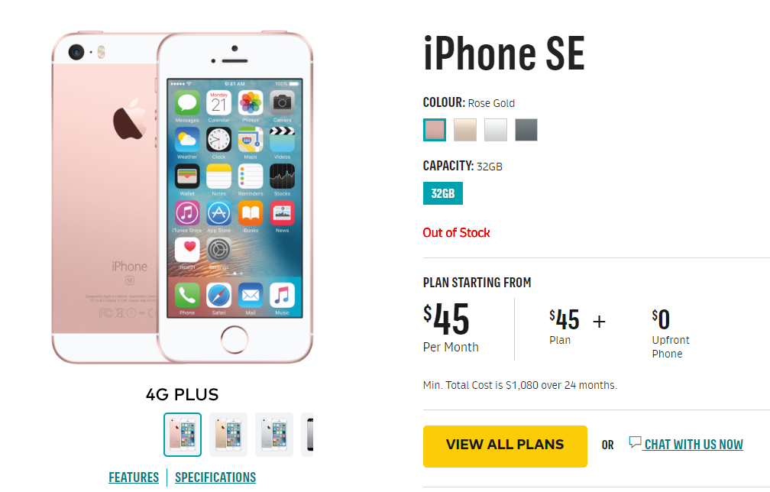

Figure 1: Screenshot of Optus iPhone SE page. This is where the consumer is directed upon clicking ‘learn more’ on the general handsets page, but it only contains a small amount of information about device colour and price. The consumer then needs to click the link to ‘features’ at bottom-left to find more detailed information. The ‘features’ button leads to a detailed description of all of the features, explained in clearer language.

* Important information that is hard to find. For example, it is unclear, hidden at the bottom of the page, or on a separate page. This often includes mandated information like the link to the Critical Information Summary.
* Live chat that is the only easily accessible option for getting assistance. Live chat that requires consumers to type questions and read answers will not be accessible to all consumers.
* Live chat or ‘contact us’ pages that are cluttered, difficult to navigate, or do not clearly state contact details.

### Issues specific to mobile and tablet services

The online information and sales material relating to mobile and tablet services also had some common limitations that should be avoided. This included situations where:

* It is difficult to find low cost options. For example, the low-cost plan is hidden from view unless the consumer scrolls all the way to the left of the screen.
* It is difficult to compare plans and handsets/tablets. For example, there are multiple options but there is no way to limit the information shown to only the plans the consumer wants to compare.
* It is difficult to be sure of the total monthly price until all selections have been made.
* Price is presented in an inconsistent or unclear manner. For example, Figure 2 shows the price of tablet plans based on amount of data and features (and includes a tablet). Figure 3 shows the (very different) minimum prices of tablet plans based on the type of tablet.

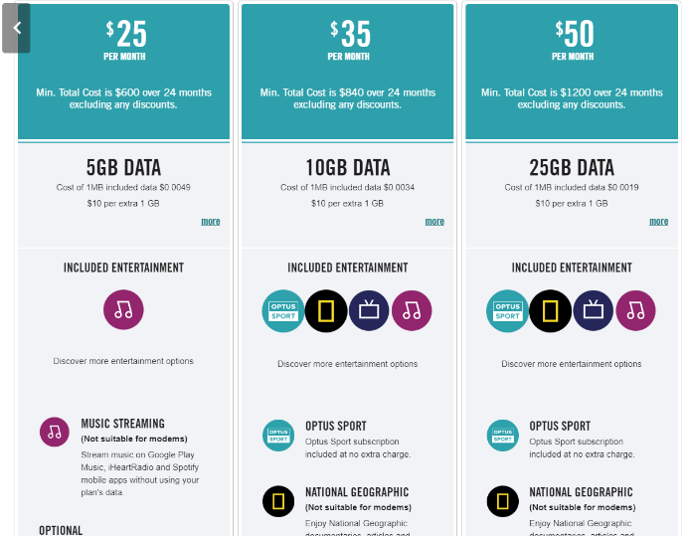

Figure 2: Screenshot of Optus tablet plans. It shows the price and features of three tablet plans, sorted by plan type.

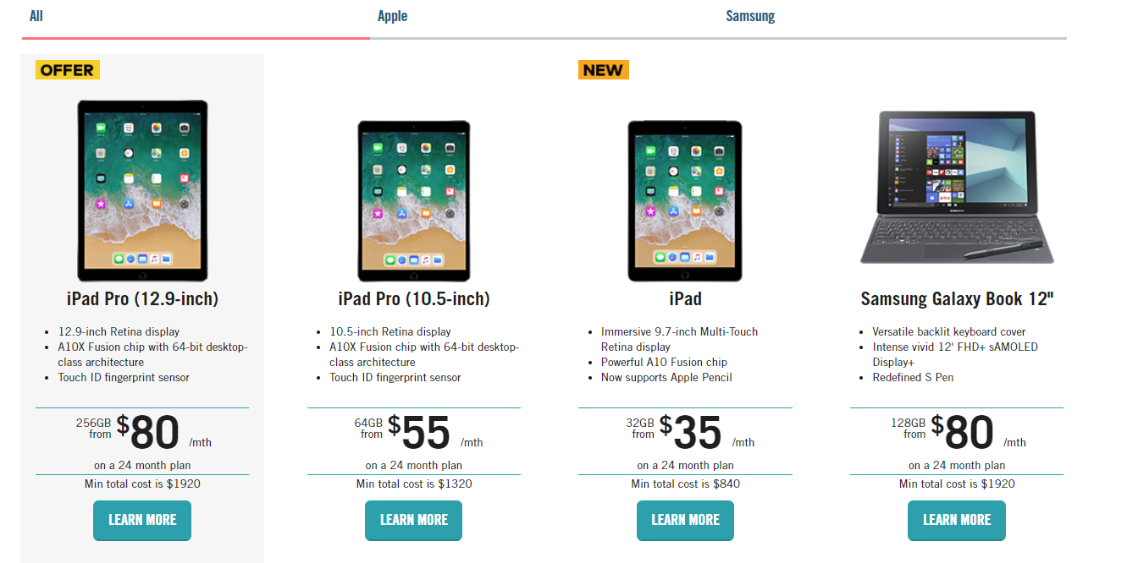

Figure 3: Screenshot of Optus tablets with data plans. The price of tablet plans sorted by type of tablet.

* Low-price handsets are listed as sold-out or are otherwise unavailable.
* Phone specifications are presented in very small print.
* Information is not presented in a way that allows easy comparison of products on multiple relevant features (such as price, handset, included calls and data, excess usage fees, credit expiry periods)
* Phone and plan specifications use technical terms or jargon without clear and straightforward definitions of these terms or their implications for the consumer’s experience and options. For example, ‘4GX’, ‘SIM-only’, and technical details about screen resolution and camera quality.
* Consumers are presented with an unhelpful amount of information (for example, on one webpage, 1,000 products were presented after the consumer selected ‘phones’).
* Images are used that are not related to, and do not explain, the text (see for example Figure 4).

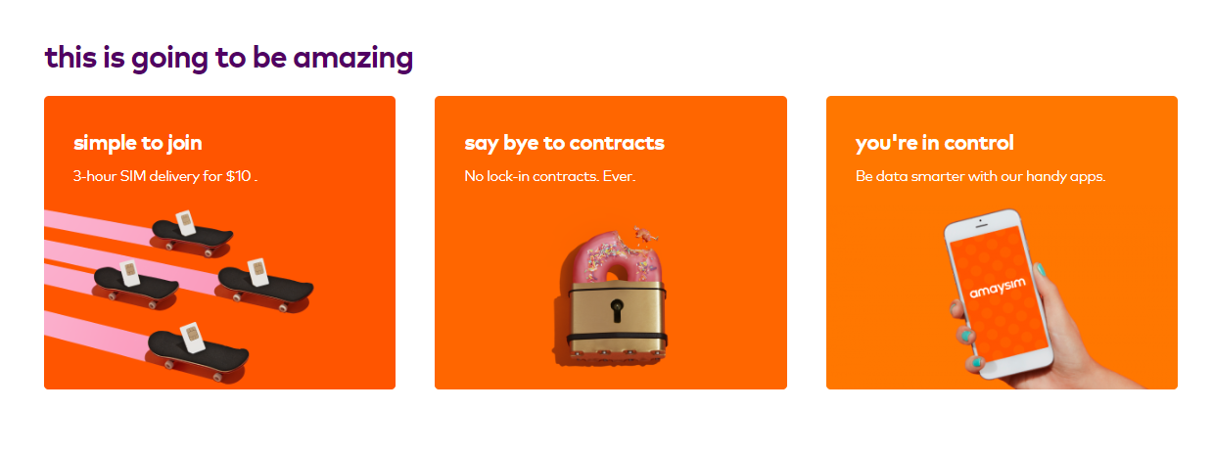

**Figure 4: Screenshot of Amaysim phone home page. The images under ‘this is going to be amazing’ are abstract marketing images that do not enhance the consumer’s understanding.**

### Issues specific to home internet and phone services

Some issues only arose in relation to home internet and home phone service offerings. These included:

* Inconsistent presentation of whether a home broadband plan is bundled with home phone connectivity.
* Home phone handsets that are only available to view instore and not online.
* Technical terms such as ‘ADSL2+’, ‘NBN’, ‘data’ or ‘modem’ that are not explained.
* Information that is not presented in a way that allows easy comparison of products on multiple relevant features (such as contract term lengths, administrative fees, internet speeds, and router installation fees for home broadband).

## Details of the website analysis

In this section, we present the analysis in more detail, setting out key areas of concern and detailed examples of positive and negative features of websites. We discuss the analysis of online information and sales materials relating to mobile and tablet services first, followed by home internet and phone services.

### Mobile and tablet services: online information and sales material

For this part of the analysis, we compared the websites of five mobile phone suppliers that offer prepaid and postpaid mobile plans. These included large suppliers offering many plans across the price spectrum with or without a mobile handset, medium suppliers offering a limited number of plans with or without a mobile handset, and small SIM-only suppliers who offer only a few plans.[120] We also compared the websites of four suppliers that sell postpaid tablet data plans. These suppliers generally sell iPads and Samsung tablets bundled with a data plan that enables the user to connect to and use the internet without a Wi-Fi connection.

For mobile phone and tablet services, we compared the accessibility of information about the plans, the phones and tablets that were available with the plans, the overall accessibility of the process of selecting a plan and then a handset or tablet, and the availability of assistance or support.

#### General layout

The overall layout of websites depended on the size of the supplier. For Telstra, Optus and Vodafone, the websites generally contained a drop-down menu with a link titled ‘Mobile’ (or similar). When clicked, this led to a page presenting the available mobile plans. The same menu process was used for tablet data plans. These menus were long, and contained lots of levels, meaning they could be difficult to navigate. It was common for these suppliers to use very long webpages for mobile and tablet sections, meaning the consumer could scroll down for a long time through marketing and product information before reaching the bottom of the page.

Smaller suppliers’ websites commonly had a simple menu on the front page, with only one level and a few items, and much less information per page. On these pages, it was common for the first click to take the consumer directly to a plan comparison table (described in more detail below).

In terms of general clarity of the websites, all fonts were sans-serif, and most text was high contrast (except for some small print), in line with the Web Guidelines. However, fonts were often small, especially for legally required (as opposed to marketing) information, and there was no way for consumers to make font sizes larger. As outlined in more detail below, all websites contained multiple examples of jargon that was not explained or defined.

#### Choosing a mobile plan and handset

For the postpaid suppliers who offered bundled mobile handset and service plans, it was difficult to tell from the website information whether the cost of the desired phone would be covered by the price of the plan. Because of the way the plan and handset menus interacted, the consumer could only be sure of the price after selecting both a plan option and a handset option. This related to the order of the process and the way the information was presented. The consumer could select either a plan or a handset first. These options are described in more detail below.

##### Choosing a plan first

If the consumer selected a plan first, a description of the plan appeared that included the cost of the plan per month. It was not always clear if this price was inclusive of the cost of a handset, or which handset was available on that plan (see for example Figure 5).

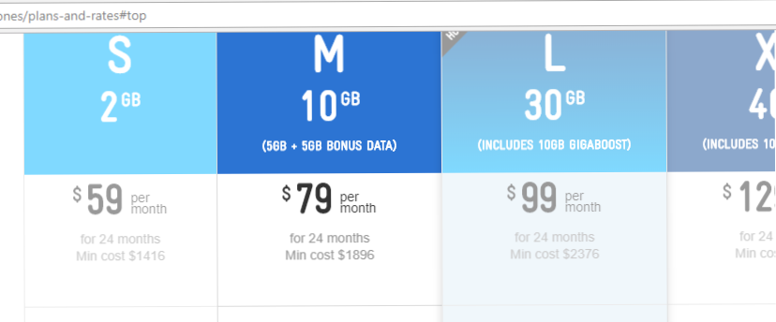

Figure 5: Screenshot of several Telstra postpaid mobile plans with the ‘Medium’ plan selected. It is unclear whether the listed price of ‘$79 per month’ includes the cost of the handset.

The consumer was then sent to a page listing the handset options (see for example Figure 6, below). On the handset page, all options were presented, regardless of the minimum price. This meant that a consumer might select a plan based on its low price, but then be presented with a much more expensive plan after they subsequently selected a handset.

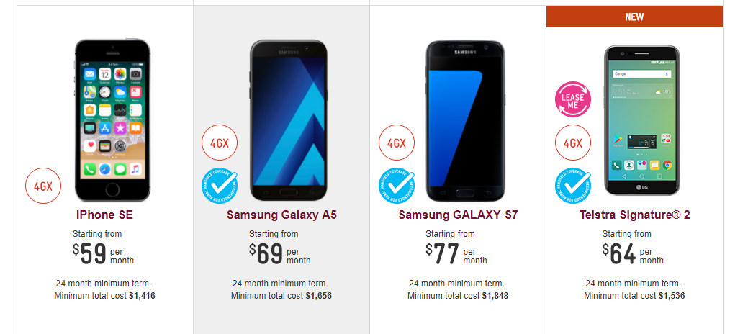

Figure 6: Screenshot of part of the Telstra mobile handsets page showing four mobile handsets. This page shows the price of plans when connected with specific handsets.

##### Choosing a handset first

If the consumer opted to choose a handset first, the plans page would appear after a handset was selected. That page showed all plans regardless of whether all plans (for example, the cheapest plans) were available with the handset that the consumer had already selected.

##### Price of plan and handset separated for better clarity

Vodafone took a clear approach in providing separate prices for plans and handsets. The prices were added together to show a running tally of the total price as selections were made. The consumer could select either a plan or handset first. As the consumer selected items, they were added to a top banner (see Figure 7 below) so it was easy for the consumer to keep track of what the final price would be.

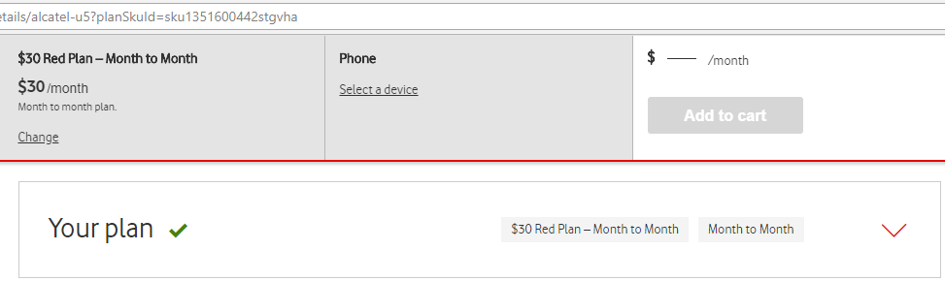

Figure 7: Screenshot of Vodafone page after a plan has been selected, and while a handset is being considered. The top banner shows the plan that has been selected (and its monthly price), but the handset has yet to be selected.

#### Choosing a tablet plan and tablet

Information about tablet plans was generally more limited than information about mobile phone plans. However, for tablet offerings that included both a data plan and a tablet, the larger suppliers had the same issues of clarity as with phone plans. If the consumer selected a plan before selecting a tablet, they would be taken to the tablet page (see for example Figure 8), where the minimum prices of the tablets were mostly more expensive than the cheaper plans. It was therefore unclear what was included in the tablet prices that were presented, or what the final price would be once all selections were made.



Figure 8: Screenshot of Optus tablets with data plans. Tablet plan prices based on type of tablet.

In contrast, the Vodafone website clearly stated an added cost per month for a standard plan with each tablet description, which made it easier to understand and compare prices (see Figure 9).

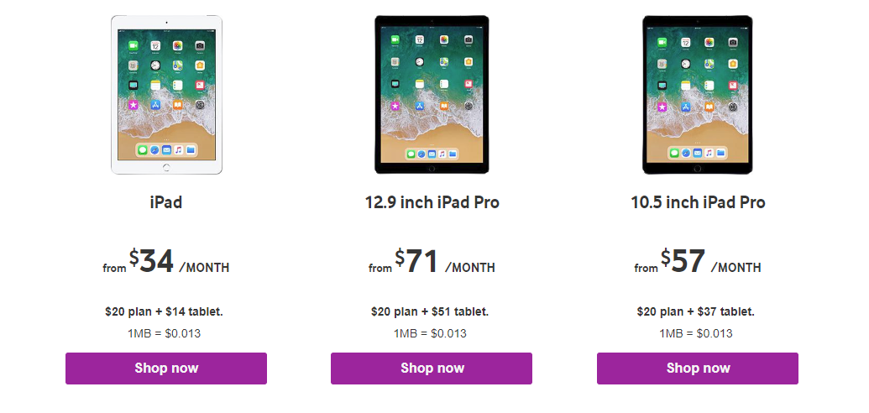

Figure 9: Screenshot of Vodafone tablets with data plans. Information presented below the price of the tablet clearly shows how the total price is calculated from a combination of plan and tablet price.

#### Choosing a SIM-only plan

SIM-only suppliers sell plans that do not come with a mobile phone handset. A consumer who signs up for a SIM-only service will be given a SIM card, which they must insert into a mobile phone handset to activate and use the service. Prepaid and SIM-only suppliers seemed to assume that all consumers would understand that a ‘SIM-only’ plan does not include a handset, because this was not explained on any of the websites we viewed (see for example Figures 10 and 11).

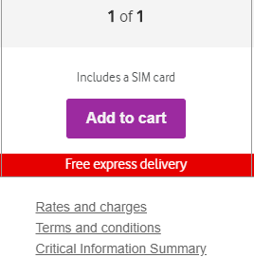

Figure 10: Screenshot of Vodafone prepaid plans, scrolled down to the bottom of the page. Small print states ‘Includes a SIM card’ but no other details are given.

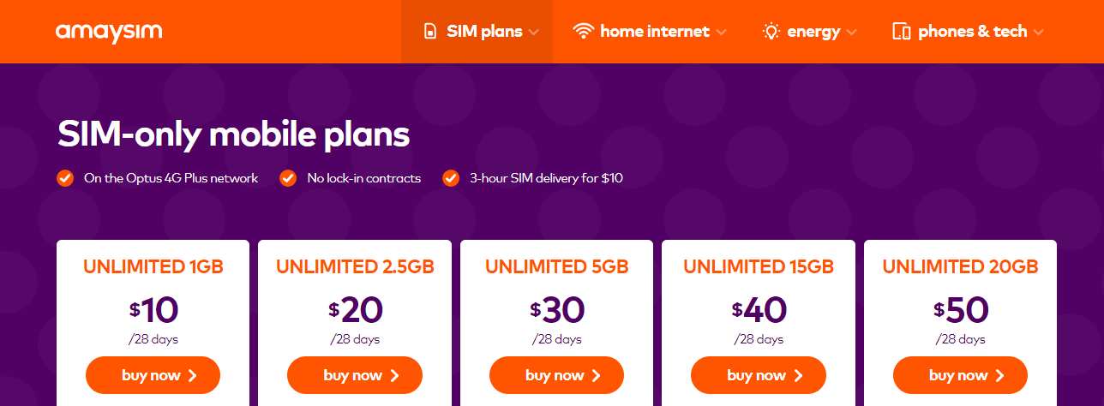

Figure 11: Screenshot of Amaysim prepaid plans. These plans are described as ‘SIM-only’ but this is not explained.

#### Fine print in prepaid plans

Each prepaid mobile supplier we reviewed offered multiple plans with various options for data and credit expiry, and data and credit roll-over, at the end of each billing period. The meaning of ‘expiry’ and ‘rollover’ was not made clear. For the suppliers that offered a larger number of plan options, this information was often written in small font and in low contrast colours, making it difficult to find (see for example Figure 12).

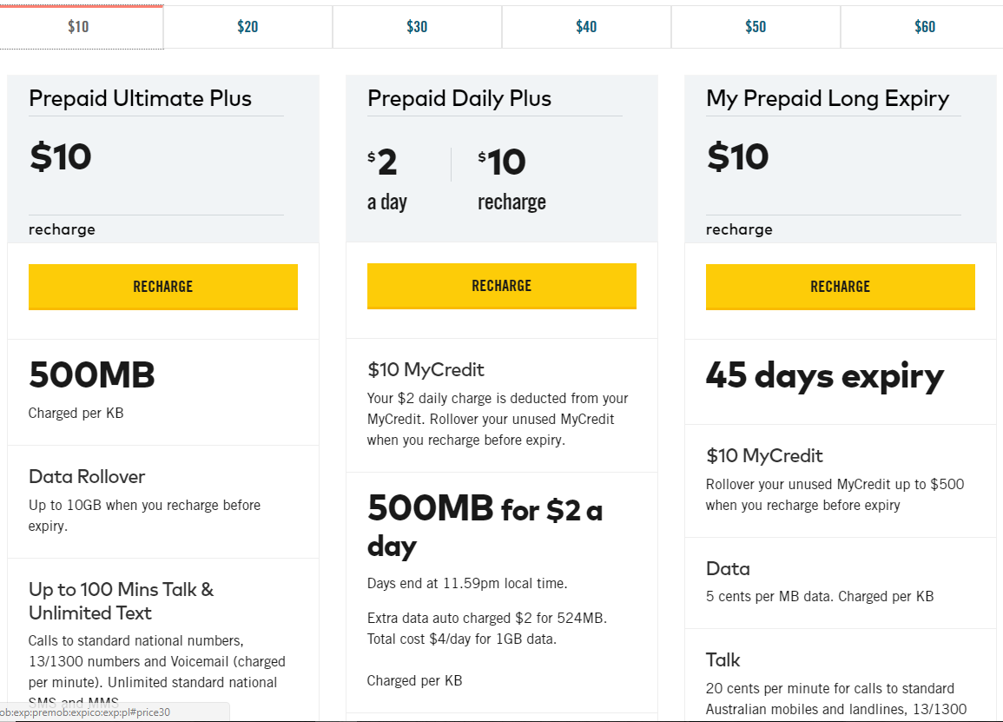

Figure 12: Screenshot of Optus prepaid plans. Information about credit and rollover are written in small print and are on different levels of the table, making it hard to see and compare them. The bold text highlights the selling point of the plan, and so de-emphasises other important information.

For the smaller suppliers, this information was likely to be presented as part of a clear plan comparison table, meaning it was easy to find and compare different options. There was also less variety than for the larger suppliers, meaning it was easier to understand that the same credit expiry and rollover rules applied to multiple plans. This reflected the simpler structure of these suppliers’ plans (see for example Figure 13, below).

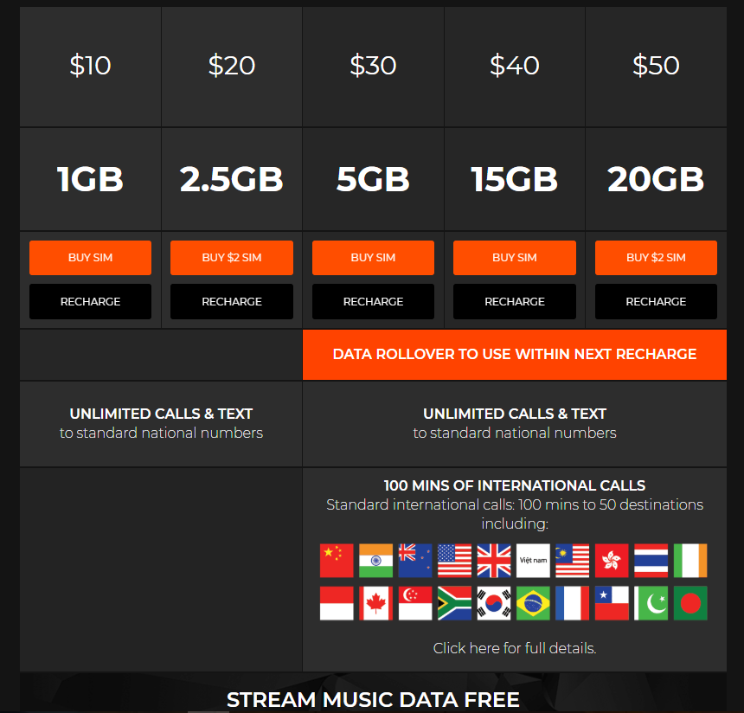

Figure 13: Screenshot of Boost Mobile prepaid plans. Data rollover and credit information is easy to see and compare as it in larger, high contrast text and the same information is on the same level of the table across the plans.

For Vodafone, there was also an option to select three plans to appear in a comparison table, which set out the price and other features of the plan side-by-side (see Figure 14, below).

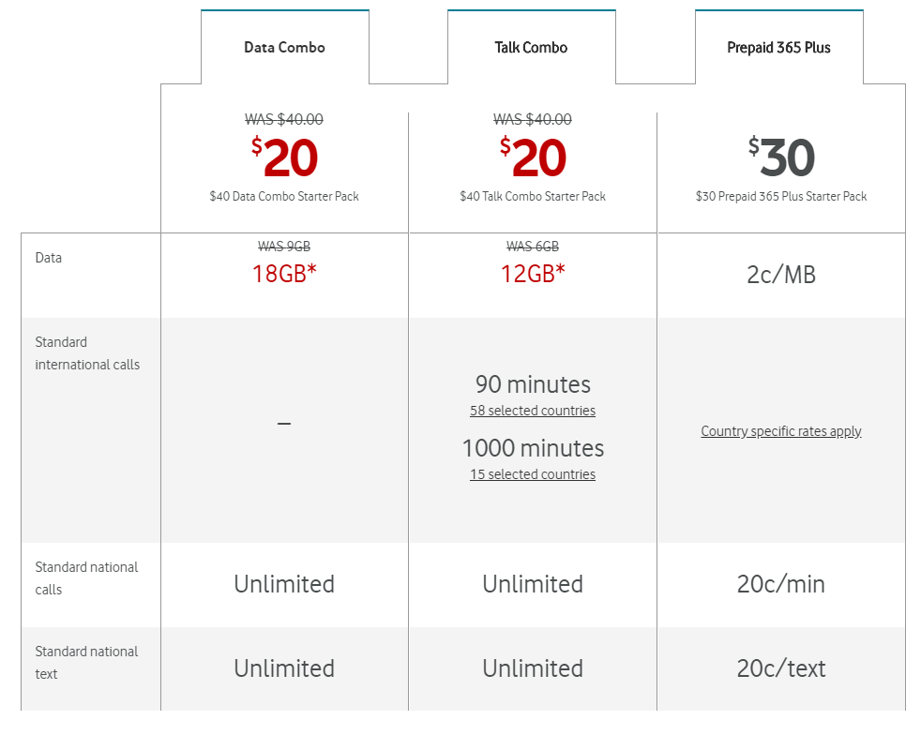

Figure 14: Screenshot of Vodafone plan comparison table. This table was created when the consumer selected three plans and clicked a ‘compare’ button.

#### Technical language and jargon

Choosing a mobile phone/tablet and plan required an understanding of the jargon used to describe features such as data connectivity and screen and camera quality. For example, one handset was described as having ‘1136-by-640 resolution, a 12MP camera with Focus Pixels and True Tone flash and an A9 chip with integrated M9 motion coprocessor.’ If consumers are unfamiliar with technical information about mobile phones and tablets, the information presented may not be sufficient to help them choose between devices.

When it came to the plans themselves, some technical language was used, but the suppliers often provided links to explain the jargon. For example, the Vodafone website explained that one plan offered 40GB of data at ‘your max speed’, which contained a link elaborating on the meaning of this phrase. It said that ‘your max speed is the fastest speed the Vodafone network can deliver to your phone at the time and place you’re using data.’ These explanations nevertheless required consumers to have some knowledge of important ideas, such as the fact that data is measured in megabytes and gigabytes.

Some consumers will appreciate detailed, technical information about their handset and service options. Some suppliers also offered short descriptions of handsets and/or services with limited jargon. These are likely to be more accessible and useful for consumers with or without disabilities who do not want to, or cannot, decipher complex technical information (see for example Figure 15).

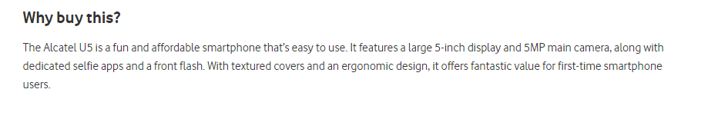

Figure 15: Screenshot of Vodafone handset description page. Under the heading ‘Why buy this?’, there is a description of the phone in relatively straightforward terms, although some technical details could be explained in more detail.

#### Critical Information Summaries

As outlined above, the Telecommunications Code obliges mobile and tablet suppliers to provide a Critical Information Summary to consumers prior to entering a contract. On most websites surveyed, the Critical Information Summary for each service was signalled by a link at the bottom of plan information (see Figures 16-18). It was always in very small print and was often de-emphasised with the use of a low-contrast colour (such as grey-on-grey). The descriptions of the plans were detailed, making it unlikely that the consumer would see or click on the link at the end. None of the websites surveyed explained what the Critical Information Summary was, what it contained, or why it might be useful for consumers.

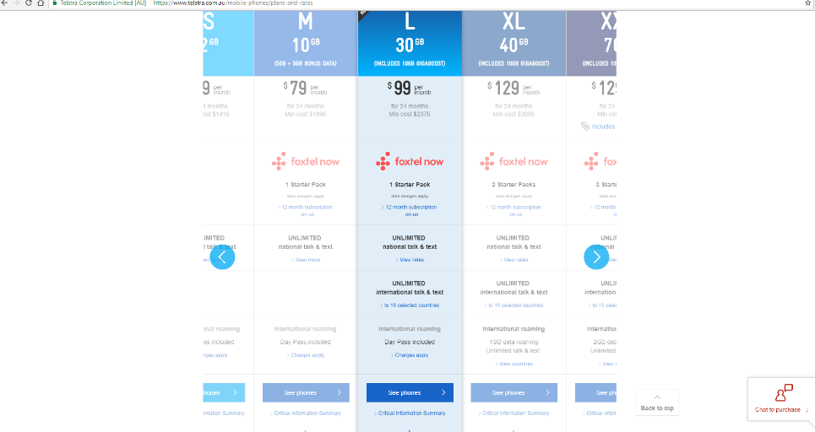

Figure 16: Screenshot of Telstra postpaid plans with ‘Large’ plan selected. The Critical Information Summary link is at the bottom of each column.



Figure 17: Enlarged screenshot of Telstra postpaid plans showing the link to the Critical Information Summary at the bottom of the ‘Large’ plan description.

Figure 18: First column in larger text reads ‘16GB data $50 per month, month to month.’ In smaller text, ‘Red Plan. Standard Int’l mins from Oz. 1000 mins for Zone 1, 150 mins for Zone 2. 8000 Qantas Points online. Hot offers. T&C’s apply. Offer for current customers (arrow for drop down menu). Students get 10% off plan fees (arrow for drop down menu).’ The middle column has a purple border and a tag saying ‘Recommended.’ A red banner at the top says ‘*Get 10GB bonus data at your Max Speed.’ Larger text at the top of the column says ‘Unlimited $60 per month, month to month. With 30GB at your Max Speed.’ Smaller text says ‘Unlimited plan. Standard Int’l mins from Oz. 2000 mins for Zone 1, 200 mins for Zone 2. 10,000 Qantas Points online. Hot offers. T&C’s apply. Get 10GB bonus data at your Max Speed (arrow for drop down menu). Offer for current customers (arrow for drop down menu).’ Third column has a red banner at the top says ‘*Get 10GB bonus data at your Max Speed.’ Larger text at the top of the column says ‘Unlimited $80 per month, month to month. With 60GB at your Max Speed.’ Smaller text says ‘Unlimited plan. Standard Int’l mins from Oz. 3000 mins for Zone 1, 300 mins for Zone 2. 15,000 Qantas Points online. Hot offers. T&C’s apply. Get 10GB bonus data at your Max Speed (arrow for drop down menu). Offer for current customers (arrow for drop down menu).’
At the bottom of each column are four links. ‘See full plan details’ is in small text but high contrast. ‘Select this plan’ is a purple button and very noticeable. ‘Critical information summary’ and ‘Terms and conditions is in small faint text.

Figure 18: Screenshot showing the details of three Vodafone postpaid plans in side-by-side columns. The Critical Information Summary link is at the bottom of each column in small text.

#### Getting assistance

Most suppliers offered assistance to consumers browsing their website through a live chat function. Live chat can allow the prospective consumer to connect with a customer service representative (or a ‘chat-bot’ computer that emulates a customer service representative), type questions, and receive answers. The live chat was usually available on all webpages throughout the shopping process, or it would pop up at some point in the process. While the pop-up live chat is more obvious than having a link on the website, it does risk compromising the focus or concentration of a user.[121] Other options for assistance were usually listed at the very bottom of (often very long) pages of information, meaning consumers had to scroll down and might not find this information. These other options included the customer service phone number and/or a ‘frequently asked questions’ page. Telstra and Optus also had a page to ‘crowd source’ solutions to problems; on these pages, potential consumers could post questions to which members of the public could offer answers, with no input from the supplier. None of the suppliers offered any information written in Easy English.

### Home internet and phone services: online information and sales material

We compared the websites of five home broadband service suppliers and five home phone (landline) service suppliers. For home broadband suppliers, we compared the consumer’s ability to choose the type of internet connection, the accessibility of information about term lengths, connection or administrative fees, modem and modem installation fees, and download speeds. For home phone suppliers, we compared handsets and service choices, with reference to the price of different call types (national, mobile and international) and features. The handset comparison was limited because only two suppliers offered handsets.

The broadband and home phone websites had the same clarity issues as the mobile phone and tablet sites described above. While most website fonts were sans-serif, font sizes were often small and non-adjustable. Legally required information was especially likely to be small and difficult to read (see for example Figure 19, where the price per month is prominently displayed, whereas the minimum cost and connection charge are displayed in small, low contrast font).

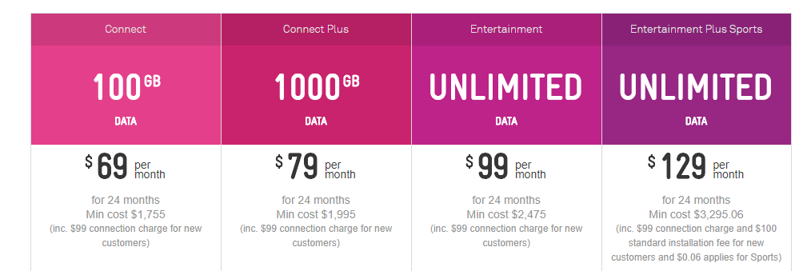

Figure 19: Screenshot of Telstra broadband plan information. Price per month and included data are presented in large, high-contrast fonts, whereas minimum cost, contract length and connection fee are in small, low-contrast font.

It was also common for sites to be cluttered with information and options, with limited explanation or clear links to further information (see for example Figure 20).

Figure 20: image shows step 2 and step 3 for broadband plan selection. Step 2 asks the consumer to ‘Select contract length’ and there are two choices in horizontal boxes. The selected box is highlighted in orange and the text says ’24 month contract’ in bold, and ‘($0.00 activation fee) Optional included Wi-Fi modem. Activation fee waived’ in small, thin text that is difficult to read. There is also a blue circle that says ‘fetch.’ The unselected option says ‘No lock-in contract’ in bold and ‘($79.95 activation fee)’ in small text.
Step 3 asks the customer to ‘Select a plan.’ The options are in the same horizontal boxes. The unselected option says ‘Naked DSL’ in bold, and ‘No line rental, cheaper call rates’ in small text. The selected option is highlighted in orange and says ‘ADSL2+’ in bold and ‘includes phone line rental’ in small text. Below that there is information about different aspects of the ADSL2+ plan arranged in boxes. To the left in a long column it says ‘500GB, $0.12 per GB, pay as you go calls.’ To the right in two boxes next to each other it says ‘Liimitless Data, pay as you go calls’ and Liimitless Data, local & standard national calls, calls to Australian mobiles.’ Below these boxes is a large box titled ‘Fetch Entertainment Offer.’ Inside that box is an image of a set top box, the Netflix, YouTube and Stan logos, and an image of a movie clapper board with the ‘play’ symbol on it. Text below these images says ‘Fetch set top box’ ‘Stream from Netflix, Stan subscriptions, YouTube and Catch Up TV straight to your big screen’ and ‘Access the latest TV shows and movies plus get 30 pre-selected movies each month.’

Figure 20: Screenshot of iiNet broadband plan information. The screen is cluttered, with multiple tiers of information.

#### Choosing a broadband service and home phone bundle

With only one exception, the home internet suppliers only gave consumers a choice between ‘NBN’ or ‘non-NBN’ broadband. All suppliers had a simple tool that allowed consumers to input their address to see if one or more broadband services were available in their area (see Figure 21). The large suppliers offered a definition of ‘NBN’ that focused on the higher speeds available on the NBN in some areas.

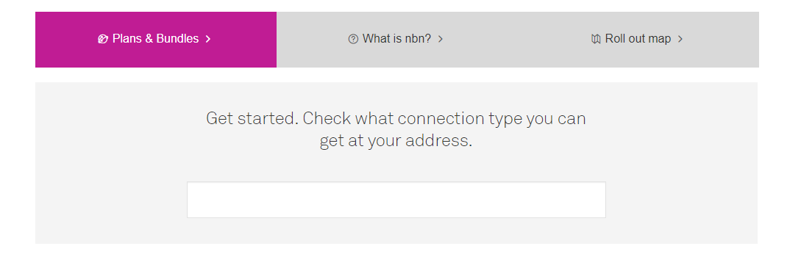

Figure 21: Screenshot of Telstra NBN homepage with a tool for inputting the consumer address to get NBN information.

For non-NBN broadband, the consumer did not usually have a choice about whether to purchase an ADSL2+ service (which requires a home phone line connection) or another type of broadband service, such as ‘Naked’ DSL (which does not require a home phone line connection).[122] Most suppliers offered an ADSL2+ service bundled with a home phone line.[123] Telstra and Optus bundled a basic phone line with their internet plans, with options to add call packages. Vodafone and Amaysim did not offer phone lines, because the broadband service they offered (NBN) does not require a phone line connection.

iiNet offered the biggest range of broadband services. Consumers could choose NBN (where available), ADSL2+ or Naked DSL. The difference between ADSL2+ and Naked DSL services was briefly described at the top of the iiNet broadband plans page. The description of ADSL2+ was, ‘Includes phone line rental’. Naked DSL was described as ‘No line rental fee, cheaper call rates’. This reflects the fact that iiNet offers a Voice over Internet Protocol (‘VoIP’) service known as ‘Netphone.’ VoIP services enable consumers to make calls using their broadband connection and a home phone handset, without renting a phone line. An important difference between VoIP and a home phone line is that VoIP does not carry a guarantee that the consumer will have access to a phone line in an emergency. While further information about Netphone was available in an FAQ section on the iiNet website, the reason for different price points between ADSL2+ and Naked plans was not clear, and the brief distinction drawn between ADSL2+ and Naked DSL could be confusing or unclear for the consumer (see Figure 22).

Figure 22: image shows step 2 and step 3 for broadband plan selection. Step 2 asks the consumer to ‘Select contract length’ and there are two choices in horizontal boxes. The selected box is highlighted in orange and the text says ’24 month contract’ in bold, and ‘($0.00 activation fee) Optional included Wi-Fi modem. Activation fee waived’ in small, thin text that is difficult to read. There is also a blue circle that says ‘fetch.’ The unselected option says ‘No lock-in contract’ in bold and ‘($79.95 activation fee)’ in small text.
Step 3 asks the customer to ‘Select a plan.’ The options are in the same horizontal boxes. The unselected option says ‘Naked DSL’ in bold, and ‘No line rental, cheaper call rates’ in small text. The selected option is highlighted in orange and says ‘ADSL2+’ in bold and ‘includes phone line rental’ in small text. Below that there is information about different aspects of the ADSL2+ plan arranged in boxes. To the left in a long column it says ‘500GB, $0.12 per GB, pay as you go calls.’ To the right in two boxes next to each other it says ‘Liimitless Data, pay as you go calls’ and Liimitless Data, local & standard national calls, calls to Australian mobiles.’ Below these boxes is a large box titled ‘Fetch Entertainment Offer.’ Inside that box is an image of a set top box, the Netflix, YouTube and Stan logos, and an image of a movie clapper board with the ‘play’ symbol on it. Text below these images says ‘Fetch set top box’ ‘Stream from Netflix, Stan subscriptions, YouTube and Catch Up TV straight to your big screen’ and ‘Access the latest TV shows and movies plus get 30 pre-selected movies each month.’

Figure 22: Side-by-side screenshots of iiNet broadband plans with cluttered home internet information making it difficult to find home phone information.

Most websites included information about the home phone call packages bundled with a home broadband package (see for example Figure 23). This information was generally straightforward and presented clearly, although terms like ‘pay as you go rates’ were not defined, which could be confusing. Home phone information was also hidden on some websites, generally due to over-cluttered and confusing pages. For iiNet, it was difficult to tell if the home phones were bundled with internet or not (see Figure 22, above).

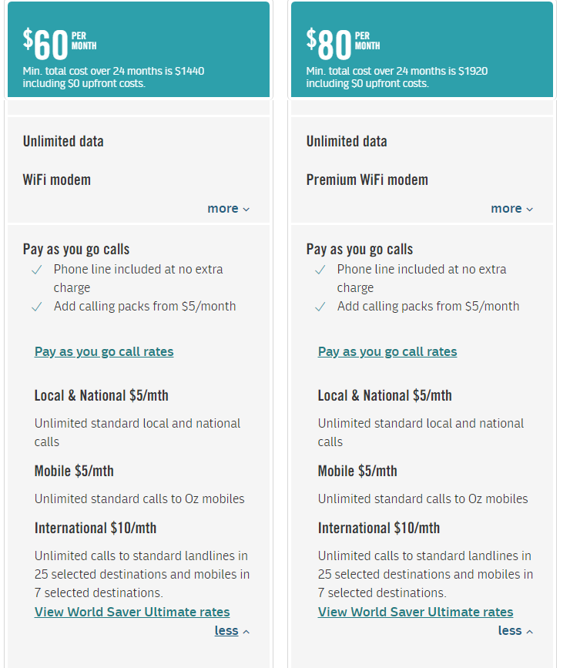

Figure 23: Screenshot of Optus broadband plan information, showing detailed information about local, national, mobile and international call packages for home phone service.

#### Connection or administrative fees

For most suppliers, consumers could choose between short-term (for example, month-by-month) or long-term (for example, 24-month) broadband plans. The price difference between a long- or short-term plan was an administrative or connection fee that must be paid when the consumer signs up for the service. For example, short-term or casual month-to-month plans included an extra connection fee, whereas 24-month plans did not; or connection fees were lower for longer plans. This difference was often presented on suppliers’ websites in small, low contrast font, and was only emphasised clearly by one supplier. It would be easy for a consumer to miss this information when browsing. Important information was sometimes only contained in the Critical Information Summary, such as an early cancellation fee that some suppliers charged if a consumer terminated a 24-month plan before 24 months had passed (see also section 5.3.2.7, below).

#### Modem installation costs

For broadband services, the cost of a modem was often clearly presented on the webpage (see for example Figure 24). Some consumers with cognitive disabilities may want or need assistance with installing or setting up the service. The additional costs of this were often hidden, only contained in the Critical Information Summary, or only available by contacting a sales representative. These costs are significant; during a live chat inquiry conducted during data collection, $140 was quoted.

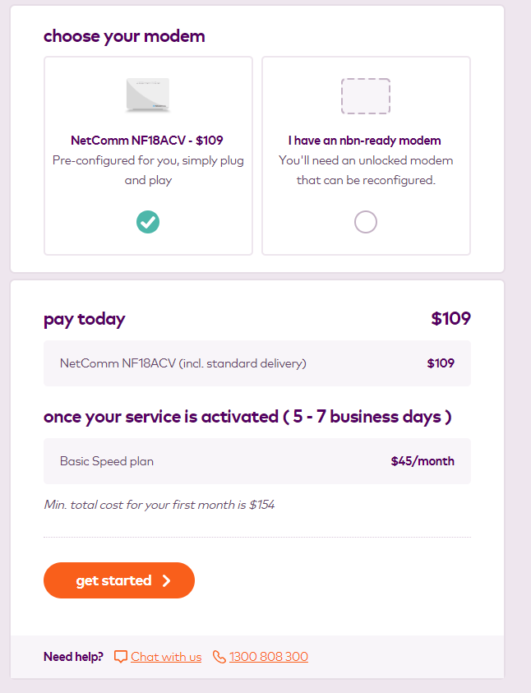

Figure 24: Screenshot of Amaysim Broadband plan information, where the $109 charge for the ‘NetComm NF18ACV’ modem is clearly displayed.

#### Broadband speed information

Three of the broadband suppliers presented broadband speed information, although the prominence of this information differed between websites. In one instance, speed information was listed among 111 ‘FAQ’ entries, and the speed was only stated in technical terms such as ‘maximum of 50Mbps into the home.’ (see Figure 25).

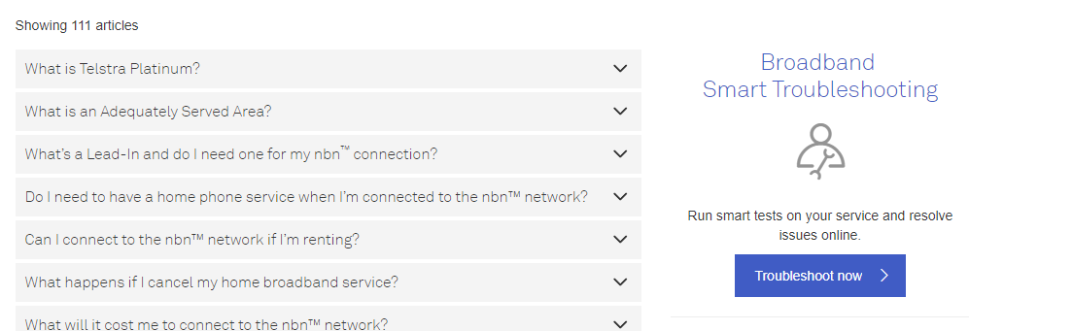

Figure 25: Screenshot of Telstra Broadband Frequently Asked Questions page. The speed information is one of the 111 ‘articles’ available under the support page.

In contrast, Amaysim offered descriptions of available speeds in terms of consumers’ typical requirements or usage patterns (see Figure 26), which may be more useful for consumers when comparing and selecting a plan, although many technical terms remained unexplained in these ‘straightforward’ descriptions.

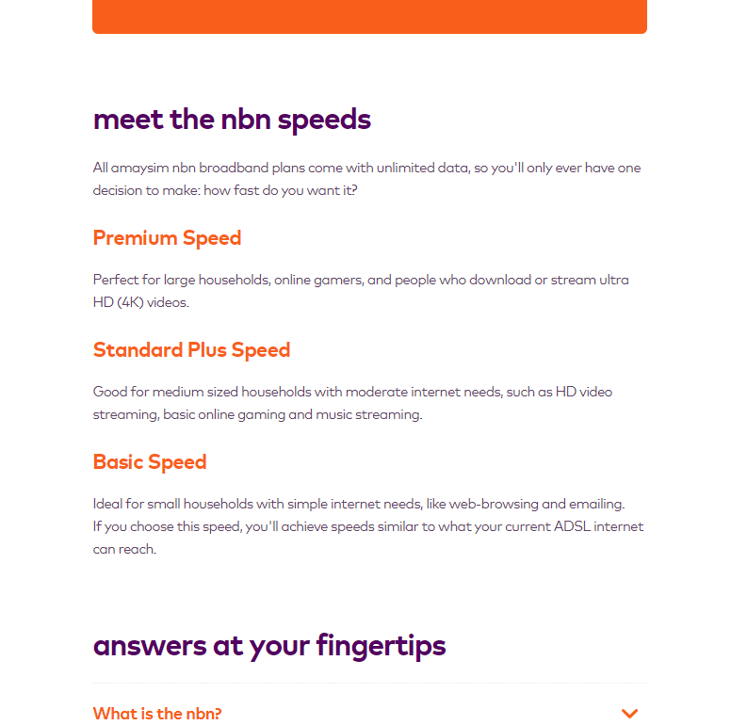

Figure 26: Screenshot of Amaysim Broadband speeds page.

#### Choosing a home phone plan

Apart from issues with internet and home phone bundling described above, home phone line information was generally presented in a more straightforward and less cluttered manner than broadband information, probably because there were only a small number of options available (see for example Figure 27).

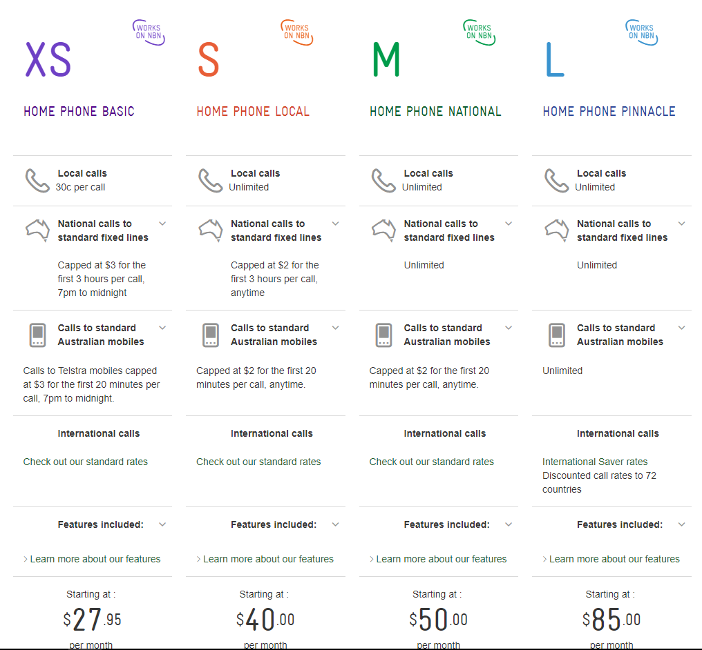

Figure 27: Screenshot of Telstra home phone plans. Clear home phone plan information is presented on dimensions including local, national and mobile call costs and minimum price per month.

Some suppliers offered a standalone home phone service (not bundled with home internet). It was not common for home phone suppliers to sell handsets, and only Telstra provided home phone handset information. Optus did not provide handset information online but encouraged consumers to view handsets instore.

#### Technical language and jargon

Choosing a home broadband plan involved navigating technical language about the types of plans, broadband speeds, download speeds, and other features. Choosing between plans required an understanding of terms such as ‘NBN’, ‘ADSL2+’, ‘modem’ and ‘data,’ and concepts such as the measurement of data in gigabytes. These terms were not explained on most websites. A good example of a supplier explaining unfamiliar terms and concepts is demonstrated in Figure 28. In that example, Telstra explained the different NBN speeds in terms of the types of activities that a person might use the service for and the number of people who will be sharing the service, although some terms (like ‘capable online gaming’) may not be familiar to all consumers.

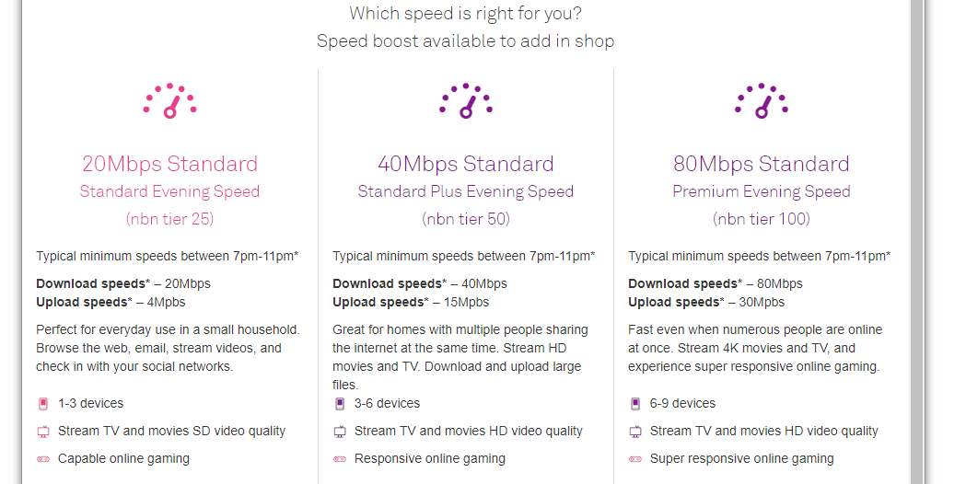

Figure 28: Screenshot of Telstra NBN internet speed information, with information about download/upload speeds, typical uses, number of devices, and quality of TV/movie streaming and gaming.

#### Critical Information Summaries

For some suppliers, the link to the Critical Information Summary could be found at the bottom of the internet or home phone plan description. For suppliers that only offered NBN broadband, it was necessary for the consumer to input their home address and scroll through a large amount of information before finding the Critical Information Summary link. The link was generally presented in small, low contrast font.

#### Getting assistance

In a similar way to the assistance offered on the mobile/tablet pages, most websites offered a live chat option for broadband and home phone sales (see section 5.3.1.8 above). A link to the live chat was generally available on all pages or would pop up automatically at some point in the process. Other options that were listed on some webpages included a support phone number and FAQ pages. However, some support sites were aimed at current consumers and were difficult to navigate for prospective consumers (see for example Figure 29). One supplier offered a call-back service, where the consumer could leave contact details and receive a call back rather than waiting on hold. Telstra and Optus also provided crowd-sourced information, as they did for mobile/tablet plans. As with mobile phone services, none of the suppliers provided any information written in Easy English about their products, services, or the ways a consumer could get assistance.

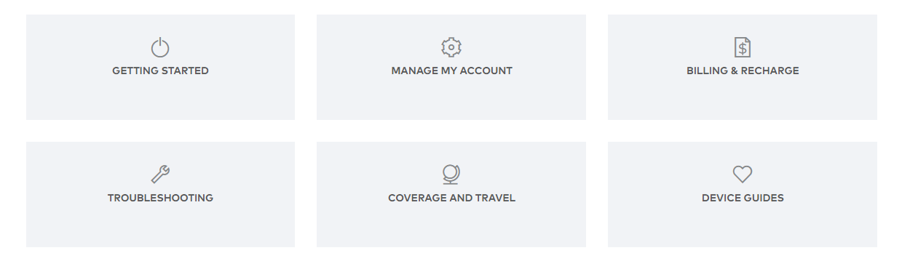

Figure 29: Screenshot of Optus Help and Support page, containing links with very general descriptions like ‘Getting started’ and ‘Troubleshooting’.

# 6. Recommendations for suppliers

This section sets out 12 recommendations for telecommunications suppliers to make simple, easy-to-implement changes to improve access and support for consumers with cognitive disabilities. These suggestions also offer practical guidance to ensure better compliance with the Telecommunications Code, the Convention and suppliers’ other obligations. They are based on the existing literature, our analysis of suppliers’ websites, and expert advice from People with Disability Australia and the Victorian Mental Illness Awareness Council (‘VMIAC’).

The attachments to this report provide additional information and materials to assist suppliers to implement these recommendations, including a toolkit to support suppliers to produce Easy English information for consumers with cognitive disabilities (Attachment A), and a list of additional resources for producing accessible documents and websites (Attachment B).

## Include people with disabilities in website and information design processes

This will assist with better compliance with the Telecommunications Code requirement for communication to be appropriate for consumers with disabilities.[124]

* Any changes to improve accessibility for consumers with cognitive disabilities must include people with cognitive disabilities, and their representative organisations, in every stage of planning, developing, implementing and testing. This will ensure that the changes are accessible and meaningful to the people who will use and benefit from them.

## Implement organisation-wide changes

This will assist suppliers to comply with the Telecommunications Code requirement to foster a culture where non-compliance with the code is unacceptable.[125]

* The changes proposed in this document will only be effective if they are part of a wider culture of accessibility and inclusion of consumers with cognitive disabilities.

For example, responsibility for accessibility should be attached to one or more designated positions in the organisation and should be identified as a core and measurable task, to ensure that the issue is addressed even if there are personnel or budget changes.

Implement a Disability Action Plan. This is a document that organisations use to reduce and remove barriers experienced by people with disabilities.[126] This is a concrete way to commit to and monitor progress on improving access and equality for people with cognitive and other disabilities.

* Disability and mental health awareness training should be provided to all staff, and should be delivered by people with expertise and lived experience of disability. This should include training on the organisation’s obligations to this consumer group, enhancing general communication skills, the accessibility features of products, and the benefits of supported decision-making. This training must also address the shortcomings of pressure-selling and other sales tactics.[127]
* Employing or contracting people who have professional skills and experience to produce information in Easy English and other accessible formats, including people with cognitive disabilities to test the materials, will ensure that changes can be implemented quickly and effectively.

## Make webpages clear and easy to read

This is consistent with the Telecommunications Code requirement for suppliers to communicate in plain language, ensure information is clear and accurate, and have regard to the Web Guidelines.[128]

* Include lots of white or empty space.
* Present information in short sentences, with one idea per sentence.
* Limit the amount of information per page so consumers do not get overwhelmed by too much information at once.
* Present text in high contrast (such as black-on-white) for better readability.
* Present text in large, bold, high contrast fonts.
* Include options for consumers to make font sizes larger or smaller and turn off images.

## Make webpages easy to navigate

This will assist suppliers to comply with the Telecommunications Code requirement to have regard to the Web Guidelines.[129]

* Mark links in high-contrast colours.
* Ensure link titles reflect the destination material.
* Ensure links lead to logical places.
* Keep it brief. The consumer should not need to click or scroll across/down too many times to find information.

## Make sure low-cost plans and handsets are easy to find and access

This will assist suppliers to comply with the Telecommunications Code requirement to have regard to the Web Guidelines.[130]

* Ensure that consumers do not have to scroll to the left or right to find the cheapest options.
* Ensure that low-cost handsets or tablets are generally available and in-stock.
* For mobile and tablet offerings, ensure that consumers who have selected a low-cost handset are sent to a ‘plans’ page that clearly shows services that are available with that handset, rather than services that require a more expensive handset.

## Make important product and service information easy to find

This is consistent with the Telecommunications Code requirements for suppliers to ensure information is clear, relevant, timely, current and accurate, and to have regard to the Web Guidelines.[131]

* Highlight important information such as total price. For example, use bold text or coloured text boxes.
* Where the purchase involves multiple charges (such as a handset/tablet charge and a service charge), each cost should be itemised and the overall cost of all elements should be presented in large, clear font.
* Ensure that price is always presented in a consistent and clear manner (for a good example, see Figures 7 and 9;[132] for a poor example, see Figures 2 and 3)[133].

## Make it easy to compare options based on important product or service features

This is consistent with the Telecommunications Code requirement that suppliers ensure information is clear and accurate and have regard to the Web Guidelines.[134]

* Give consumers the option to compare one or more products or services in a simple format, such as a table.
* Ensure that there is no time limit to do this so consumers do not feel rushed to decide.
* Present key information in a way that is easy to compare (see for example Figures 7, 9, 13 and 14).
  + Broadband consumers may be interested in price, data usage limits, download speeds, activation fees, contract term lengths and early termination fees, installation fees and whether landline bundling is optional or mandatory, and any costs associated with it.
  + Mobile consumers may be interested in price, included data, SMS and call charges and credit expiry periods (for prepaid services) and monthly charges, included calls and data, excess usage fees or limits (for postpaid services).

## Avoid jargon where possible or explain the meaning of complex terms

This will assist suppliers to comply with the Telecommunications Code requirement to communicate in plain language.[135]

* Define terms that consumers must understand when selecting a product or service. Do not assume that everyone will understand common terms. For example, terms like broadband, gigabyte, handset, and ‘SIM-only’ could be defined using ‘mouse-over’/hover links or a dedicated glossary page.
* Present information in straightforward language and refer to common, relatable concepts. This applies to technical details of handsets and tablets (such as data storage capacity and camera specifications) and to technical details of mobile, broadband and home phone plans (such as download speeds and data and call usage limits). For example:
  + mobile and tablet suppliers could include a brief description of the main selling points of each mobile handset or tablet (see Figures 15 and 28).[136] This could be further improved by noting negative features or limitations of the product in comparison to other options.
  + broadband service suppliers could contextualise information about download limits (like ‘500GB/month’) with an explanation of how this translates to hours of streaming television/movies, hours of streaming music, or hours of gaming for the consumer (see for example Figures 26 and 28).[137]
* Consider using graphics or images that relate to the text and can enhance a consumer’s understanding, such as graphics depicting the relative download speed or data allowance of different service options. Ensure that graphics are relevant and clearly relate to the accompanying text (for a bad example, see Figure 4).

## Provide important information in plain language and/or Easy English formats

This is consistent with the Telecommunications Code requirement for suppliers to communicate with consumers in plain language, and in a way that is appropriate to their needs.[138]

* In addition to the website improvements discussed above, suppliers should strongly consider providing key information in formats that are accessible to people with cognitive disabilities.
* Accessible information on the sign-up process, and on making inquiries and complaints if there is a problem, can be especially crucial to ensuring that consumers with cognitive disabilities can exercise their consumer rights. (See the toolkit at Attachment A for sample documents that can be adapted by suppliers.) It is also important to use Easy English principles when designing bills, such as making total price and important phone numbers easy to identify.
* Written information in Easy English, and captioned videos presenting the key features of products and services, will be accessible to a wide range of consumers.
* Some consumers, such as some mental health service users, may not find Easy English information useful or appropriate for them. Some people may find information delivered in plain language, by video, audio, or face-to-face to be more accessible. Plain language is a style of writing that suits people with average literacy skills and does not use images.
* These resources should be developed with input from people with a variety of cognitive disabilities (people with intellectual disability, people with Acquired Brain Injury, mental health consumers, and others) to ensure they are accessible and useful for their entire target audience.

## Emphasise images and storytelling

This will assist suppliers to comply with the Telecommunications Code requirement to communicate with consumers in a way that is appropriate for their needs.[139]

* Images can be a powerful way to communicate information. They may be the only accessible form of information for some people.
* Images are unlikely to be helpful if they are used in isolation. Images should be used to tell a story with a beginning, middle and end.
* Formats like cartoons and comics can tell a clear, short story. However, it is important not to be patronising. For example, avoid images that might seem childish.
* It is important to remember when using images that they are described so they are accessible to people who use screen readers or other similar technology.

## Be creative and give people options

This will assist suppliers to comply with the Telecommunications Code requirement to communicate with consumers in a way that is appropriate for their needs.[140]

* Presenting information in a range of formats will improve accessibility for a wide range of consumers, including people with low literacy and people with different learning styles. In addition to plain language, Easy English, and videos, alternative formats like posters, flowcharts, image-only documents, and ‘guided tours’ of the website by a virtual host may also be appropriate, depending on the type of information being presented and the needs of the consumer.
* Online captioned videos that have a structured ‘how-to’ format may be particularly helpful to explain how to use products, fix problems or get assistance.
* Giving consumers the option of viewing multiple versions of your website can help cater to diverse needs. For example, a plain version could use large text, lots of empty space and lots of images, while a technical version could have all the details that some consumers want.

## Ensure multiple forms of assistance are available for asking questions or getting help

This will assist suppliers to comply with the Telecommunications Code requirement to communicate with consumers in a way that is appropriate for their needs.[141]

* Clearly indicate the availability of live chat through an obvious link on all pages in the browsing and sign-up process.
* Make sure other options are available for people who might not want to use live chat, or for whom live chat is inaccessible. This could include clearly listed telephone numbers and email addresses for enquiries.
* Ensure that contact details are listed on uncluttered webpages, and it is easy to identify the appropriate contact number or email address for a particular type of enquiry (for example, ‘help or advice for choosing a service’; ‘help with the sign-up process’).
* Provide options for face-to-face communication to discuss sales or service enquires, and link to details of how to find the nearest store in the ‘finding assistance’ section.

# 7. Conclusion

In this study, we analysed the websites of nine telecommunications suppliers to assess the accessibility of online information and sales materials for mobile, tablet, broadband and home phone plans for consumers with cognitive disabilities. We found that most websites had many shortcomings. This included information that was difficult to read, take in and understand, few options to get assistance, and confusing, multi-step processes for shopping and selecting a product or service. Some websites had some positive features, such as customisable comparison tables and plain language explanations of complicated concepts.

In response to this analysis, and drawing on past research and the expert advice of representative organisations of people with disabilities and mental health consumers, we have proposed twelve recommendations for suppliers to improve their website offerings for consumers with cognitive disabilities. Most of the recommendations are focused on improving the content and format of websites and other information channels, drawing on Easy English principles and the Web Guidelines. These include recommendations about providers’ governance and processes, including delivering disability and mental health training and actively consulting consumers with cognitive disabilities when designing and redesigning information and websites; recommendations about improving the look and navigability of websites; recommendations about providing information in accessible formats; and recommendations about improving communications and access to live assistance for consumers. The attached toolkit for suppliers provides four Easy English templates to assist suppliers to develop accessible materials for a diverse range of consumers with cognitive disabilities (Attachment A).

Improving website information and sales material, and making it easier for consumers to get assistance, can have a range of benefits for suppliers. Such improvements will assist with meaningful compliance with the Australian Consumer Law and the Telecommunications Code in regard to the guidelines relating to the provision of ‘plain language’ information and communication with consumers generally, and consumers with disabilities in particular.[142] More broadly, it is likely to make suppliers’ products and services more accessible to the hundreds of thousands of Australians with cognitive disabilities,[143] and to the many other consumers who currently find information and sales processes complex and difficult to navigate.[144]

Good consumer outcomes may also have positive financial consequences for businesses. If consumers can find and access products and services that fit their budgets, needs and wants, they may be more satisfied with their service and more able to pay their bills. This is likely to lead to considerable savings for suppliers. For example, KPMG recently estimated the annual cost of writing off bad debts and pursuing unpaid bills to suppliers of another fundamental service, retail energy services, at $270 million.[145]

While suppliers can do much to improve their current offerings, changes to the Telecommunications Code, and perhaps other forms of regulation, are also necessary to ensure that suppliers can – and are clearly obliged to – maximise accessibility for consumers with cognitive disabilities. For example, the requirement to fit the Critical Information Summary on two pages may reflect an honourable aim but in practice means the documents are very cluttered and difficult to read. Furthermore, the use of vague terms like ‘different’ or ‘special needs’ does not provide useful guidance for suppliers, and also implies that disability accessibility is an add-on, rather than something that should be suppliers’ core business. Similarly, while the emphasis in the Code on products ‘offered specifically for consumers with different disabilities’ can be important in terms of devices to support augmentative and alternative communication, this emphasis ignores the fact that all products should be designed with accessibility in mind.

The Telecommunications Code is currently undergoing a process of review. A draft amended code has been released, and public comments on that draft were invited until 10 August 2018.[146] The draft proposes only minor changes to the sections regarding people with disabilities, including replacing reference to products ‘specifically for consumers with different disabilities’ with reference to products ‘designed for consumers with different disabilities,’[147] and stating that suppliers ‘must’ (rather than ‘should’) have regard to the Web Guidelines.[148] Neither change would substantively alter or strengthen the relevant parts of the Code, suggesting further consideration and reform is necessary.

Our analysis also indicates that further research is required to develop the evidence base and ensure that accessibility measures address the diverse requirements and experiences of consumers with cognitive disabilities. For example, the evidence for the existing guidance on Easy English material is limited, and larger-scale research that tests different approaches with people with cognitive disabilities would help to ensure that Easy English materials improve individuals’ access to information and have practical benefits for their decision-making. Projects to develop the supported decision-making skills of self-advocacy groups, family members and other informal supporters, disability and mental health service providers, lawyers, consumer advocates and financial counsellors are also necessary to ensure that people with cognitive disabilities have access to the assistance necessary to make decisions and contract for phone, tablet and internet services. More detailed, systematic analyses of the accessibility of mobile handsets, tablets and other telecommunications technology are also needed to ensure that suppliers can recommend suitable products based on a consumer’s stated wants and needs.

# References

A *Articles/Books/Reports*

Anderson, Julie, Keith McVilly, Stella Koritsas, Hilary Johnson, Michele Wiese, Roger Stancliffe,   
K Lyon, Naomi Rezzani and J Ozge, *Accessible Written Information Resources for Adults with Intellectual Disability: Good Practice Summary* (2017) Research to Action Guide, NDS Centre for Applied Disability Research

Anderson, Julie, Keith McVilly, Stella Koritsas, Hilary Johnson, Michele Wiese, Roger Stancliffe,   
K Lyon, Naomi Rezzani and J Ozge, *Accessible Written Information Resources for Adults with Intellectual Disability: A Rapid Review of the Literature* (2017)Research to Action Guide, NDS Centre for Applied Disability Research

Australian Securities and Investments Commission, *Financial Literacy and Behavioural Change* (Report 230, March 2011)

Ben-Shahar, Omri and Carl E Schneider, *More Than You Wanted to Know: The Failure of Mandated Disclosure* (Princeton University Press, 2014)

Blanck, Peter David, *eQuality: The Struggle for Web Accessibility by Persons with Cognitive Disabilities* (Cambridge University Press, 2014)

Borg, Johan Ann Lantz and Jan Gulliksen, ‘Accessibility to Electronic Communication for People with Cognitive Disabilities: A Systematic Search and Review of Empirical Evidence’ (2015) 14 *Universal Access Information Society* 547-562

Braucher, Jean ‘Delayed Disclosure in Consumer E-Commerce as an Unfair and Deceptive Practice’ (2000) 46 *Wayne Law Review* 1805-1867

Chinn, Deborah and Claire Homeyard, ‘Easy Read and Accessible Information for People with Intellectual Disabilities: Is It Worth It? A Meta-Narrative Literature Review’ (2017) 20(6) *Health Expectations* 1189-1200

Commonwealth Treasury, *Financial Systems Inquiry: Final Report* (November 2014)

Davis, Jeffrey, ‘Protecting Consumers from Overdisclosure and Gobbledygook: An Empirical Look at the Simplification of Consumer-Credit Contracts’ (1977) 63(6) *Virginia Law Review* 841-920

Disability Rights Now, *Civil Society Report to the United Nations Committee on the Rights of Persons with Disabilities: Compiled by Disability Representative, Advocacy, Legal and Human Rights Organisations* (August 2012)

Eisenberg, Melvin Aron, ‘The Limits of Cognition and the Limits of Contract’ (1995) 47 *Stanford Law Review* 211-259

Gernsbacher, Morton Ann, Adam R Richard, M Theresa Balinghasay and Jilana S Boston, ‘“Special Needs” Is an Ineffective Euphemism’ (2016) 1(29) *Cognitive Research: Principles and Implications* 1-13

Godwin, Andrew, ‘[Brave New World: Digital Disclosure of Financial Products and Services’](https://findanexpert.unimelb.edu.au/individual/publicationS1119384)(2016) 11(3) Capital Markets Law Journal 442-457

Hale, Rachel, Bernadette McSherry, Jeannie Paterson, Lisa Brophy and Anna Arstein-Kerslake, *Consumer Transactions: Equitable Support Models for Individuals with Decision-Making Impairments* (Melbourne: University of Melbourne 2017)

Hayes, Susan C and Fiona B Martin, ‘Consumers with an Intellectual Disability and Carers: Perceptions of Interactions with Banks,’ (2007) 11(1) *Journal of Intellectual Disabilities* 9-22

Hillman, Robert A, ‘Online Boilerplate: Would Mandatory Website Disclosure of E-standard Terms Backfire?’ (2006) 104(5) *Michigan Law Review* 837-856

Hillman, Robert A and Jeffrey J Rachlinski, ‘Standard-Form Contracting in the Electronic Age’ (2002) 77 *New York University Law Review* 429-495

Howells, Geraint, ‘The Potential and Limits of Consumer Empowerment by Information’ (2005) 32(3) *Journal of Law in Society* 349-370

Hurtado, Barbara, L Jones and F Burniston, ‘Is Easy Read Information Really Easier to Read?’ (2013) 58(9) *Journal of Intellectual Disability Research* 822-829

Jaeger, Paul, ‘Telecommunications Policy and Individuals with Disabilities: Issues of Accessibility and Social Inclusion in the Policy and Research Agenda’ (2006) 30 *Telecommunications Policy* 112-124

Korobkin, Russell, ‘Bounded Rationality, Standard Form Contracts, and Unconscionability’ (2003) 70 *University of Chicago Law Review* 1203-1295

KPMG, *Quantifying the Cost of Customers Experiencing Difficulties in Paying Energy Bills* (Report prepared for Energy Consumers Australia, November 2016) 29 <http://energyconsumersaustralia.com.au/wp-content/uploads/KPMG-ECA_Estimating_costs_associated_with_payment_difficulties_and_disconnections_October_2016.pdf.pdf>

Lussier-Desrochers, Dany, Claude L Normand, Alejandro Romero-Torres, Yves Lachapelle, Valérie Godin-Tremblay, Marie-Ève Dupont, Jeannie Roux, Laurence Pépin-Beauchesne and Pascale Bilodeau, ‘Bridging the Digital Divide for People with Intellectual Disability’ (2017) 11(1) *Cyberpsychology: Journal of Psychosocial Research on Cyberspace* 53-74

Maker, Yvette, Anna Arstein-Kerslake, Bernadette McSherry, Jeannie Marie Paterson and Lisa Brophy, ‘Ensuring Equality for Persons with Cognitive Disabilities in Consumer Contracting: An International Human Rights Perspective’ (2018) 19(1) *Melbourne Journal of International Law* 178-199

Maker, Yvette, Bernadette McSherry, Lisa Brophy, Jeannie Marie Paterson and Anna Arstein-Kerslake, ‘Supporting People with Decision-making Impairments: Choice, Control and Consumer Transactions’ (2017) 24 *Journal of Law and Medicine* 756-762

Maker, Yvette, Jeannie Marie Paterson, Anna Arstein-Kerslake, Bernadette McSherry and Lisa Brophy, ‘From Safety Nets to Support Networks: Beyond “Vulnerability” in Protection for Consumers with Cognitive Disabilities’ (2018) 41(3) *UNSW Law Journal* 818-45

McSherry, Bernadette, ‘Legal Capacity Under the Convention on the Rights of Persons with Disabilities’ (2012) 20(1) *Journal of Law and Medicine* 22-27

Mechling, Linda ‘Review of Twenty-First Century Portable Electronic Devices for Persons with Moderate Intellectual Disabilities and Autism Spectrum Disorders’ (2011) 46(4) *Education and Training in Autism and Developmental Disabilities* 479-498

Mik, Eliza, ‘The Erosion of Autonomy in Online Consumer Transactions’ (2016) *Law, Innovation and Technology* 1-38

Owens, Janet, ‘Accessible Information for People with Complex Communication Needs,’ (2006) 22(3) *Augmentative and Alternative Communication* 196-208

Paterson, Jeannie Marie, 'Consumer Contracting in the Age of the Digital Natives' (2011) 27 *Journal of Contract Law* 152-170

Ramsay, Iain, *Consumer Law and Policy: Text and Materials on Regulating Consumer Markets* (Oxford: Hart Publishing, 2nd ed, 2007)

Scope Communication Resource Centre, *Easy English Writing Style Guide* (November 2007)

Sunstein, Cass R, ‘Behavioural Analysis of Law’ (1997) 64(4) *University of Chicago Law Review* 1175-1195

Sutherland, Rebekah Joy and Tom Isherwood, ‘The Evidence for Easy-Read for People with Intellectual Disabilities: A Systematic Literature Review’ (2016) 13(4) *Journal of Policy and Practice in Intellectual Disabilities* 297-310

Xavier*,* Patrick, *Behavioural Economics and Customer Complaints in Communication Markets* (Report prepared for the Australian Communications and Media Authority (ACMA), 2011)

B *Cases*

*ACCC v EDirect Pty Ltd* [2012] FCA 1045

*ACCC v Excite Mobile Pty Ltd* [2013] FCA 350

*ACCC v Harrison* [2016] FCA 1543

*ACCC v Origin Energy Electricity Limited* [2015] FCA 278

*ACCC v TPG Internet Pty Ltd* [2013] HCA 54

*Baltic Shipping Co v Dillon* (1991) 22 NSWLR 1

*Buccoliero v Commonwealth Bank of Australia* (2011) 16 BPR 30,333

*Perpetual Trustees Victoria Ltd v Ford* (2008) 70 NSWLR 611

C *Legislation*

*Australian Guidelines for Electronic Commerce* *2006* (Cth)

Communications Alliance, *Draft Industry Code: Telecommunications Consumer Protections Code,* DR: C628: 2018 (Draft for Public Comment) 9 July 2018

Communications Alliance, *Telecommunications Consumer Protections Code,* C628: 2015 (incorporating Variation No 1/2018) July 2018

*Competition and Consumer Act 2010* (Cth)

*Disability Discrimination Act 1992* (Cth)

*Equal Opportunity Act 2010* (Vic)

*Fair Trading Act* *1999* (Vic)

*National Consumer Credit Protection Act 2009* (Cth)

D *Treaties/United Nations Documents*

Committee on the Rights of Persons with Disabilities, *Communication No 1/2010: Views Adopted by the Committee at its Ninth Session (15-19 April 2013),* 9th sess, UN Doc CRPD/C/9/D/2010 (21 June 2013)

Committee on the Rights of Persons with Disabilities, *General Comment No. 1 (2014) Article 12: Equal recognition before the law*, 11th sess, UN Doc CRPD/C/GC/1 (19 May 2014)

Committee on the Rights of Persons with Disabilities, *General Comment No.* *2 (2014) Article 9: Accessibility*, 11th sess, UN Doc CRPD/C/GC/2 (22 May 2014)

Committee on the Rights of Persons with Disabilities, *General Comment No. 6 (2018) on Equality and Non-discrimination,* 19th sess, UN Doc CRPD/C/GC/6 (26 April 2018)

*Convention on the Rights of Persons with Disabilities*, opened for signature 30 March 2007, 2515 UNTS 3 (entered into force 3 May 2008)

E *Other*

Australian Bureau of Statistics, *4433.0.55.003 - Intellectual Disability, Australia* (30 June 2014)<http://www.abs.gov.au/ausstats/abs@.nsf/Lookup/4433.0.55.003main+features102012>

Australian Bureau of Statistics, *4433.0.55.004 -*  *Psychological Disability, Australia* (9 February 2015) <http://www.abs.gov.au/ausstats/abs@.nsf/Latestproducts/4433.0.55.004Main%20Features52012?opendocument&tabname=Summary&prodno=4433.0.55.004&issue=2012&num=&view=>

Australian Communications Consumer Action Network (ACCAN), *Telecommunications Consumer Protection Code: Submission by the Australian Communications Consumer Action Network to Communications Alliance* (10 August 2018)

Australian Securities and Investments Commission, *Moneysmart: Financial Abuse* (24 October 2018) Australian Securities and Investments Commission <https://www.moneysmart.gov.au/life-events-and-you/families/financial-abuse>

Family and Community Services, *Disability Inclusion Action Plans*, NSW Government <https://www.facs.nsw.gov.au/inclusion/advisory-councils/disability/inclusion-plans>

Health and Human Services, *Disability Action Plans* (15 September 2017) State Government Victoria <https://providers.dhhs.vic.gov.au/disability-action-plans>

[Programme for the International Assessment of Adult Competencies (PIAAC)](http://www.oecd.org/skills/piaac/Country%20note%20-%20Australia_final.pdf), *Survey of Adult Skills (PIAAC)* (2018) Organisation for Economic Co-operation and Development (OECD) <http://www.oecd.org/skills/piaac/>

Web Accessibility Initiative (WAI), *Understanding Success Criterion 2.2.4: Interruptions*, World Wide Web Consortium (W3C) <https://www.w3.org/WAI/WCAG21/Understanding/interruptions.html>

Web Accessibility Initiative (WAI), *Web Content Accessibility Guidelines (WCAG) 2.1* (5 June 2018) World Wide Web Consortium (W3C) <https://www.w3.org/TR/WCAG21/>

Web Accessibility Initiative (WAI), *Web Content Accessibility Guidelines (WCAG) Overview* (22 June 2018) World Wide Web Consortium (W3C)<https://www.w3.org/WAI/standards-guidelines/wcag/>

World Wide Web Consortium (W3C), *About W3C* (2018) World Wide Web Consortium (W3C)<https://www.w3.org/Consortium/>

# Attachment A: Toolkit for suppliers

## Toolkit: Easy English factsheets for consumers

Having a cognitive disability can affect a person’s ability to learn, concentrate on, process, remember or communicate information. Having a cognitive disability may also affect a person’s ability to make decisions. Information available online, over the phone, and in-store is often inaccessible to consumers with cognitive disabilities.

Providing written information in an Easy English format is one way to improve the accessibility of information. This can also help suppliers meet their obligations under the Telecommunications Consumer Protections Code.

This toolkit presents templates of Easy English factsheets on four key consumer issues:

1. Things to know when buying or signing up for a phone, tablet or internet service
2. Things to know about the cost and how to pay for a device and/or service
3. Things to know when you can’t pay for your phone, tablet or internet
4. Things to know when your phone, tablet or internet is not working

Each factsheet is accompanied by a glossary or ‘hard words’ section, which gives definitions of difficult terms.

The content and formatting of the factsheets was developed by Intellectual Disability Rights Service (‘IDRS’). IDRS also arranged testing of the factsheets by four people with intellectual disability. The research team also sought multiple rounds of feedback on the content and readability of the factsheets from People with Disability Australia, Victorian Mental Illness Awareness Council (‘VMIAC’) and members of the project Advisory Board.

## How to adapt the factsheets: four easy steps

The factsheets are designed to be adapted with the specific details and offerings of the company, and to the specific circumstances of the consumer.

1. **Add company-specific information**

Insert the appropriate telephone number, web address, and other company-specific information where marked with red font and square brackets.

1. **Seek image permission**

The factsheets use images that are licensed for use by Photosymbols and Shutterstock. Companies should apply directly to Photosymbols and Shutterstock for permission to use the images prior to publication.

For more information, visit <https://www.photosymbols.com/> or <https://www.shutterstock.com/> or contact the Melbourne Social Equity Institute at [social-equity@unimelb.edu.au](mailto:social-equity@unimelb.edu.au).

1. **Write customer-specific information on the factsheets at the point of sale or other contact with the customer**

For example, a salesperson can print factsheet 2 (‘how to pay’) and write in customised information about the total monthly cost to the customer and how and when they can pay.

1. **If making major changes to the content, consult an organisation that specialises in Easy English drafting**

Intellectual Disability Rights Service: <http://www.idrs.org.au/home/index.php>

Scope: <https://www.scopeaust.org.au/service/accessible-information/>

## Tips for making the factsheets as useful as possible

The following steps will ensure that factsheets are accessible and useful for consumers:

* Add useful information to the factsheets. For example, add phone numbers that lead directly to the appropriate team and/or a staff member with good communication skills and the authority to escalate matters.
* Add clear, easy-to-find links to the factsheets on your website.
* Advise all staff about the availability and purpose of the factsheets.
* Assign responsibility for updating the factsheets to a particular position in the organisation.
* Consult people with cognitive disabilities when making changes.

## Other accessibility measures

People with cognitive disabilities are a diverse group with an equally diverse range of needs and preferences. It is important to remember that Easy English information will not meet the needs and preferences of all consumers. For instance, some people might find Easy English information patronising or overly-simplistic. Others may not want written information at all. Alternative formats, such as captioned videos, audio versions and posters, should also be developed to cater to the widest possible audience.

## About the toolkit

This toolkit was created by a research team at the University of Melbourne to support good outcomes for consumers with cognitive disabilities by providing practical guidance for telecommunications suppliers to produce accessible information about selecting a phone, tablet or internet service, managing the cost, and what to do when problems arise.

Authored by Yvette Maker, Jeannie Marie Paterson, Bernadette McSherry, Lisa Brophy, Anna Arstein-Kerslake, Alex Callahan and Eugene Teo.

The project was funded by a grant from the Australian Communications Consumer Action Network (ACCAN). The operation of the Australian Communications Consumer Action Network is made possible by funding provided by the Commonwealth of Australia under section 593 of the *Telecommunications Act 1997*. This funding is recovered from charges on telecommunications carriers.

itle: Creative Commons logo

Except where indicated above, this work is copyright, licensed under the Creative Commons Attribution 4.0 International Licence. You are free to cite, copy, communicate and adapt this work, providing you attribute the authors and “the Melbourne Social Equity Institute, supported by a grant from the Australian Communications Consumer Action Network”. To view a copy of this licence, visit [http://creativecommons.org/licenses/by/4.0/](https://protect-au.mimecast.com/s/LM_FCk8vpKsDyLmVh2R0Dg?domain=creativecommons.org)

Melbourne Social Equity Institute   
Website: <https://socialequity.unimelb.edu.au/>   
Email: [social-equity@unimelb.edu.au](mailto:social-equity@unimelb.edu.au)

Australian Communications Consumer Action Network   
Website: [www.accan.org.au](http://www.accan.org.au/)    
Email: [grants@accan.org.au](mailto:grants@accan.org.au)    
Telephone: 02 9288 4000   
If you are deaf, or have a hearing or speech impairment, contact us through the National Relay Service: [www.relayservice.gov.au](http://www.relayservice.gov.au/).

# 1 Shopping for a new phone, tablet or internet service

Things you need to know

In this fact sheet **hard words** are in **bold**

You can find the meaning of hard words at the end of the factsheet

|  |  |
| --- | --- |
| [Mobile Phone](https://www.photosymbols.com/collections/technology/products/mobile-phone)  [A person sitting down, and looking at an iPad](https://www.photosymbols.com/collections/technology/products/use-ipad-1)  [Computer Laptop](https://www.photosymbols.com/collections/technology/products/computer-laptop)  [Person with fingers blocking ears](https://www.photosymbols.com/collections/feelings/products/stress-3)  [Contract with a hand signing it](https://www.photosymbols.com/collections/information/products/contract) | It is important to get the right information  to get what you need  phone  **tablet**  **internet service**  You do not want to be stuck in a **plan** that costs too much  It can be hard to get out of a plan once you  sign for it |
| [A hand writing signature](https://www.photosymbols.com/collections/research/products/signature)  Person talking to manager  [Shops](https://www.photosymbols.com/collections/places/products/shops-2)  [Person looking at a computer](https://www.photosymbols.com/collections/people-adults/products/indiana-computer) | Before you sign up to a plan   * talk to more than 1 company * look around in different stores * look on different websites |
| [Person holding up hand to say Stop](https://www.photosymbols.com/collections/feelings/products/no-3)  [A person thinking](https://www.photosymbols.com/collections/choices/products/think-twice1)  [A person with a hand up to ask question](https://www.photosymbols.com/collections/people-adults/products/indiana-question)  Hands taking money out of a wallet  [Person with both hands out asking question](https://www.photosymbols.com/collections/people-adults/products/charles-7)  [Person thinking](https://www.photosymbols.com/collections/law/products/think-10)    [A person talking to support worker](https://www.photosymbols.com/collections/relationships/products/support-advice1) | You **do not** have to sign up for  something today  Before you decide   * ask questions like     how much will it cost  what will I get  how many calls  how much **data**   * think about it at home * talk about it with a **support person** |
| [Two people looking at an iPad](https://www.photosymbols.com/collections/technology/products/ipad-help-1)  [Two people talking](https://www.photosymbols.com/collections/research/products/market-research)  [Person pointing at you with question marks behind](https://www.photosymbols.com/collections/choices/products/you-choose) | You can ask your **support person** to   * help you look around at different stores or websites * help you ask questions * help you decide what you want to buy |
| [Person choosing between two support people](https://www.photosymbols.com/collections/people-children/products/choose-support3) | If your **support person** isn’t doing what you want you can   * choose someone else to   support you   * make the decision without any help |
| [A person feeling stress](https://www.photosymbols.com/collections/feelings/products/stress)  [Clock showing 20 mins](https://www.photosymbols.com/collections/time-date/products/time-duration)  [A person talking to support worker](https://www.photosymbols.com/collections/relationships/products/support-advice1)  [A piece of paper that says 'info' and below there is writing in Easy English](https://www.photosymbols.com/collections/information/products/info-easy-read)  [Person on the phone](https://www.photosymbols.com/collections/technology/products/phone-1-upset)  [A person walking away](https://www.photosymbols.com/collections/people-adults/products/zola-8) | If you feel stress, tell the sales person   * you need more time * you need to talk to your **support person**      * you need more information   If you still feel stress you can   * hang up * walk out |
| [Information sign](https://www.photosymbols.com/collections/information/products/information-sign)  [A person reading while another person stands next to them](https://www.photosymbols.com/collections/information/products/share-information-2)  Two people talking on the phone  [Computer Laptop](https://www.photosymbols.com/collections/technology/products/computer-laptop)  [An open laptop with the word 'email' and an open envelope on the screen](https://www.photosymbols.com/collections/technology/products/email)  [A piece of paper that says 'info' and below there is writing in Easy English](https://www.photosymbols.com/collections/information/products/info-easy-read)  Two women - one is the support person. | You can get information about what you want to buy   * talk to someone in our shop * phone us *[supplier to add how to get through to a helpful person]* * look at our internet site *[supplier to add internet link]* * send us an email or talk on our website *[supplier to add internet link]* * ask for a printed copy of any information that we tell you   You can ask us to contact your **support person** and explain things to them |
|  |  |

**Hard words**

|  |  |
| --- | --- |
| [Computer Laptop](https://www.photosymbols.com/collections/technology/products/computer-laptop) | **internet service**  you pay for this so you can use the internet at home |
| [Contract with hand signing](https://www.photosymbols.com/collections/information/products/contract)  [Six calendar pages with different months  on them](https://www.photosymbols.com/collections/time-date/products/months) | **plan** is a **contract** you sign to agree to buy phone or internet   * usually paid monthly   you can ask to pay weekly or **fortnightly**  **fortnightly** is every 2 weeks |
| Two women - one is the support person | **support person** is someone you trust  to help you |
| [A person sitting down, and looking at an iPad](https://www.photosymbols.com/collections/technology/products/use-ipad-1)  [Person sitting on a chair, typing on a computer](https://www.photosymbols.com/collections/technology/products/james-15) | **tablet**  a flat, hand held device like   * iPad * Samsung Galaxy * Microsoft Surface   **data**  amount of internet you can use for   * watching TV or movies * listening to music * reading emails   like: 15GB of data |

# 2 Paying for a phone tablet or internet service

Things you need to know

In this fact sheet **hard words** are in **bold**

You can find the meaning of hard words at the end of the fact sheet

|  |  |
| --- | --- |
| [Contract with hand signing](https://www.photosymbols.com/collections/information/products/contract)  [Person on phone](https://www.photosymbols.com/collections/people-adults/products/phone-call-2)  [Mobile phone showing a text message](https://www.photosymbols.com/collections/technology/products/text-message)  [Mobile Phone](https://www.photosymbols.com/collections/technology/products/mobile-phone)  [A person sitting down, and looking at an iPad](https://www.photosymbols.com/collections/technology/products/use-ipad-1)  [A lap top with a telephone wire in front of it](https://www.photosymbols.com/collections/technology/products/internet) | When you sign up for a   * phone * **tablet** * **internet plan**   you have to pay for   * calls * texts * **data**   You may also have to pay for   * phone * **tablet** * **internet modem** |
| [Six calendar pages with different months on them](https://www.photosymbols.com/collections/time-date/products/months)  A Mobile Bill that says Please Pay Now. There is a phone next to it. | When do I pay   * most people have to pay every month   We will send you a   * bill * email * text   so you know when to pay  Paper bills cost extra money |
| Hand holding money  [Debit card](https://www.photosymbols.com/collections/money/products/debit-card)  [Website on computer](https://www.photosymbols.com/collections/technology/products/website)  [The BPay logo](http://www.google.com/url?sa=i&rct=j&q=&esrc=s&source=images&cd=&cad=rja&uact=8&ved=2ahUKEwiIucbfzObdAhWG7mEKHffXB9QQjRx6BAgBEAU&url=http://www.brandsoftheworld.com/logo/bpay&psig=AOvVaw30ttObqnRRwcBJi2GFSh07&ust=1538529794191972)  [Mobile Phone](https://www.photosymbols.com/collections/technology/products/mobile-phone)    [A person at the post office](https://www.photosymbols.com/collections/places/products/place-post-office)  Person talking to manager  [Two men in suits talking on the phone](https://www.photosymbols.com/collections/relationships/products/phone-conversation3) | How do I pay  You can pay in different ways *[supplier to include all available options.]*   * **Direct Debit** – we will take money from your account every month   direct debit only works if you have enough money in your account to pay   * pay through our *supplier* website or app * **BPay** – online banking * phone *[supplier to add phone number]* * at the post office * other ways – check withus   If a **guardian** or **administrator** manages  your money you will need to talk to them |
| [A person looking in their wallet](https://www.photosymbols.com/collections/people-adults/products/check-wallet)  [List with three things on it](https://www.photosymbols.com/collections/meetings/products/list)  Money and a calculator | How much can I pay  Before you decide to buy an item or sign up for a **plan**, it is a good idea to make a **budget**  A **budget** is a list of things you need to pay for like   * food * clothes * rent * bills   A **budget** also says how much money you get each month so you know how much to spend |
| A person with their hand up to ask a question  [A person looking in their wallet](https://www.photosymbols.com/collections/people-adults/products/check-wallet)  [A man sitting at a desk writing on a piece of paper](https://www.photosymbols.com/collections/people-adults/products/william-7)  [Person on phone holding a folder](https://www.photosymbols.com/collections/work/products/james-5) | If you have questions about   * how much money you can spend * your **guardian**   or **administrator**  call **Financial Counselling** Australia on  1800 007 007 |
| [Information sign](https://www.photosymbols.com/collections/information/products/information-sign)  [A person reading while another person stands next to them](https://www.photosymbols.com/collections/information/products/share-information-2)  Two people talking on the phone  [Website open on a computer](https://www.photosymbols.com/collections/technology/products/website)  [An open laptop with the word 'email' and an open envelope on the screen](https://www.photosymbols.com/collections/technology/products/email)  [A piece of paper that says 'info' and below there is writing in Easy English](https://www.photosymbols.com/collections/information/products/info-easy-read) | You can get information about how to pay in many ways   * talk to someone in our shop * phone us *[supplier to add how to get through to a helpful person]* * look at our internet site *[supplier to add internet link]* * send us an email or talk on our website *[supplier to add internet link]* * ask for a printed copy of any information that we tell you |
| Two women - one is the support person | You can ask us to contact your **support person** and explain things to them |

**Hard words**

|  |  |
| --- | --- |
| [The BPay logo](http://www.google.com/url?sa=i&rct=j&q=&esrc=s&source=images&cd=&cad=rja&uact=8&ved=2ahUKEwiIucbfzObdAhWG7mEKHffXB9QQjRx6BAgBEAU&url=http://www.brandsoftheworld.com/logo/bpay&psig=AOvVaw30ttObqnRRwcBJi2GFSh07&ust=1538529794191972) | **BPay**  online bill payment with  bank  you have to pay every time  this is different from direct debit |
| [Person sitting on a chair typing on a computer](https://www.photosymbols.com/collections/technology/products/james-15) | **data**  amount of internet you can use for   * watching TV or movies * listening to music * reading emails   like: 15GB of data |
| [A debit card](https://www.photosymbols.com/collections/money/products/debit-card) | **direct debit**  we take money out of your bank account every month  direct debit only works if you have enough money in your account to pay  this is different from BPay |
| Two people sitting down talking. They are both looking at the same piece of paper.  Money and a calculator | **financial counsellor**  someone who helps you manage money   * budgets * spending money * saving money |
| [A man sitting at a desk writing on a piece of paper.](https://www.photosymbols.com/collections/people-adults/products/william-7) | **guardian or administrator**  a person who can legally make decisions for you including about money |
| [A lap top with a telephone wire in front of it](https://www.photosymbols.com/collections/technology/products/internet) | **internet modem**  a device that lets you connect to the internet using telephone wire |
| [Computer Laptop](https://www.photosymbols.com/collections/technology/products/computer-laptop) | **internet service**  you pay for this so you can use  the internet at home |
| [Contract with a hand signing it](https://www.photosymbols.com/collections/information/products/contract)  Six calender pages for different months | **plan** is a **contract** you sign  to agree to buy phone or internet   * usually paid monthly   you can ask to pay weekly or **fortnightly**  **fortnightly** is every 2 weeks |
| Two women - one is the support person | **support person**  someone you trust to help you |
| [A person sitting down, looking at an iPad](https://www.photosymbols.com/collections/technology/products/use-ipad-1) | **tablet**  a flat hand held device like   * iPad * Samsung Galaxy * Microsoft Surface |

# 3 When you can’t pay for your phone tablet or internet

Things you need to know

In this fact sheet **hard words** are in **bold**

You can find the meaning of hard words at the end of the fact sheet

|  |  |  |
| --- | --- | --- |
| [A person on the phone who looks upset](https://www.photosymbols.com/collections/technology/products/phone-1-upset)  Stop sign | You should tell us if you are having  money problems  if you don’t tell us we might cut off  your phone or internet | |
| [Two people looking at the same piece of paper](https://www.photosymbols.com/collections/ideas/products/explain-2)  Six calender pages for different months  [Contract with a hand signing](https://www.photosymbols.com/collections/information/products/contract)  A phone with a stop sign over it  Two people shaking hands. One is talking. | We might be able to help you   * + put you on a **payment plan**   this means you pay little amounts each week   * + change your **plan**   + put limits on your phone or internet   this might mean people can only call you   * + give you the name of a group   who can pay part of your bill | |
| [A person on the phone holding a folder](https://www.photosymbols.com/collections/work/products/james-5)  [A person on the phone who looks upset](https://www.photosymbols.com/collections/technology/products/phone-1-upset) | If you need more help call  **Financial Counselling** Australia  1800 007 007  They might be able to   * tell you what to do if you have money problems | |
| [Information sign](https://www.photosymbols.com/collections/information/products/information-sign)  [A person reading while another person stands near them](https://www.photosymbols.com/collections/information/products/share-information-2)  Two people talking on the phone  [Website open on a computer](https://www.photosymbols.com/collections/technology/products/website)  [An open laptop with the word 'email' and an open envelope on the screen](https://www.photosymbols.com/collections/technology/products/email)  [A piece of paper that says 'info' and below there is writing in Easy English](https://www.photosymbols.com/collections/information/products/info-easy-read)  Two women - one is the support person | You can get information about money problems and how to pay in many ways   * talk to someone in our shop * phone us *[supplier to add how to get through to a helpful person]* * look at our internet site *[supplier to add internet link]* * send us an email or talk to us on the website *[supplier to add internet link]* * ask for a printed copy of any information that we tell you   You can ask us to contact your  **support person** and explain things to them | |
| [Two people talking. One person is writing notes. The other person is making a complaint.](https://www.photosymbols.com/collections/socialcare/products/appeal)  Telecommunications Industry Ombudsman logo  [Mobile Phone](https://www.photosymbols.com/collections/technology/products/mobile-phone)  [Website open on a computer](https://www.photosymbols.com/collections/technology/products/website)  [A hand writing on an envelope](https://www.photosymbols.com/collections/information/products/envelope-write)  [Hands writing an email on a tablet](https://www.photosymbols.com/collections/technology/products/email-write) | | If you are not happy with our help  you can contact  **Telecommunications Industry Ombudsman**  phone 1800 062 058  You can make a complaint about  phone or internet suppliers   * phone 1800 062 058 * use the **National Relay Service** if you are deaf or have a hearing or speech impairment   <http://www.relayservice.gov.au>   * write a letter   **PO Box 276**  **Collins Street West**  **Victoria 8007**   * online   <http://www.tio.com.au/making-a-complaint> |

|  |  |
| --- | --- |
| **Hard words**  Two people sitting down talking. They are looking at the same piece of paper.  Money and a calculator | **financial counsellor**  someone who helps you manage money   * budgets * spending money * saving money |
| [Computer Laptop](https://www.photosymbols.com/collections/technology/products/computer-laptop) | **internet service**  you pay for this so you can use  the internet at home |
| Six calender pages for different months | **payment plan**  you only pay little amounts each week  and only what you can afford |
| [Contract with hand signing](https://www.photosymbols.com/collections/information/products/contract)  Six calender pages for different months | **plan**  **plan** is a **contract** you sign  to agree to buy phone or internet   * usually paid monthly   you can ask to pay weekly or **fortnightly**  **fortnightly** is every 2 weeks |
| Two women - one is the support person | **support person**  someone you trust to help you |
| [A person sitting down, holding an iPad](https://www.photosymbols.com/collections/technology/products/use-ipad-1) | **tablet**  a flat hand held device like   * iPad * Samsung Galaxy * Microsoft Surface |
| [Two people talking. One person is writing notes. The other person is making a complaint.](https://www.photosymbols.com/collections/socialcare/products/appeal) | **Telecommunications Industry Ombudsman**  where you can make a complaint  about phone or internet suppliers |

# 4 When your phone tablet or internet is not working

Things you need to know

In this fact sheet **hard words** are in **bold**

You can find the meaning of hard words at the end of the fact sheet

|  |  |
| --- | --- |
| [Person on the phone who looks upset](https://www.photosymbols.com/collections/work/products/james-6)  A person talking to the manager | If your phone **tablet** or internet is not working  call us on *[supplier to add phone number]* and we will try to   * fix the problem * give you a new phone or **tablet** * give you your money back |
| [A person on the phone who looks upset](https://www.photosymbols.com/collections/technology/products/phone-1-upset)  [A person reading a book that says 'easy read' on it](https://www.photosymbols.com/collections/information/products/easy-read-logo) | If you need more help call  **Australian Competition and Consumer Commission (ACCC)**  1300 302 502  they have an Easy English fact sheet  **Your Rights When You Buy Something**  <https://www.accc.gov.au/publications/your-rights-when-you-buy-something> |

|  |  |
| --- | --- |
| [A person who is frowning](https://www.photosymbols.com/collections/people-children/products/robbie-10)  [A person reading while another person stands near them](https://www.photosymbols.com/collections/information/products/share-information-2)  Two people talking on the phone  [Website open on computer](https://www.photosymbols.com/collections/technology/products/website)  [An open laptop with the word 'email' and an open envelope on the screen](https://www.photosymbols.com/collections/technology/products/email)  [A piece of paper that says 'info' and below there is writing in Easy English](https://www.photosymbols.com/collections/information/products/info-easy-read)  Two women - one is the support person | If you have a problem   * talk to someone in our shop * phone us *[supplier to add how to get through to a helpful person]* * look at our internet site *[supplier to add internet link]* * send us an email or talk to us on the website *[supplier to add internet link]* * ask for a printed copy of any information that we tell you   You can ask us to contact your  **support person** and explain things to them |

|  |  |
| --- | --- |
| [Person with arms crossed and frowning](https://www.photosymbols.com/collections/people-adults/products/gavin-4)  Telecommunications Industry Ombudsman logo  [Two people talking. One person is writing notes. The other person is making a complaint.](https://www.photosymbols.com/collections/socialcare/products/appeal)  [Mobile Phone](https://www.photosymbols.com/collections/technology/products/mobile-phone)  [Website open on a computer](https://www.photosymbols.com/collections/technology/products/website)  [A hand writing on an envelope](https://www.photosymbols.com/collections/information/products/envelope-write)  [Hands writing an email on a tablet](https://www.photosymbols.com/collections/technology/products/email-write) | If you are not happy with our help  you can contact  **Telecommunications Industry Ombudsman**  you can make a complaint about  phone or internet suppliers   * phone 1800 062 058 * use the **National Relay Service** if you are deaf or have a hearing or speech impairment   <http://www.relayservice.gov.au>   * write a letter   **PO Box 276**  **Collins Street West**  **Victoria 8007**   * online   <http://www.tio.com.au/making-a-complaint> |

|  |  |
| --- | --- |
| **Hard words**  [A person reading a book that says 'easy read' on it](https://www.photosymbols.com/collections/information/products/easy-read-logo)  [Computer Laptop](https://www.photosymbols.com/collections/technology/products/computer-laptop) | **Australian Competition and Consumer Commission (ACCC)**  where you can get information about your rights when you buy something  **internet service**  you pay for this so you can use  the internet at home |
| [Contract with hand signing](https://www.photosymbols.com/collections/information/products/contract)  Six calender pages for different months | **plan**  **plan** is a **contract** you sign  to agree to buy phone or internet   * usually paid monthly   you can ask to pay weekly or **fortnightly**  **fortnightly** is every 2 weeks |
| Two women - one is the support person | **support person**  someone you trust to help you |
| [A person sitting down, holding an iPad](https://www.photosymbols.com/collections/technology/products/use-ipad-1) | **tablet**  a flat hand held device like   * iPad * Samsung Galaxy * Microsoft Surface |
| [Two people talking. One person is writing notes. The other person is making a complaint.](https://www.photosymbols.com/collections/socialcare/products/appeal) | **Telecommunications Industry Ombudsman**  where you can make a complaint  about phone or internet suppliers |

# Attachment B: List of additional resources

**Web Accessibility**

Web Content Accessibility Guidelines 2.1 (WCAGs)

<https://www.w3.org/TR/WCAG21/>

Checklist for compliance with WCAGs

<https://www.wuhcag.com/wcag-checklist/>

Web tool to check compliance with WCAGs

<http://wave.webaim.org/about>

Checklist for compliance with WCAGs will focus on accessibility for people with cognitive and learning disabilities

<https://webaim.org/articles/evaluatingcognitive/>

**Easy English Resources**

Scope Easy English Style Guide

<http://www.daru.org.au/wp/wp-content/uploads/2013/08/Easy-English-Writing-Style-Guide.pdf>

Examples of Scope Easy English

<https://www.scopeaust.org.au/service/accessible-information/>

NDS Guide to Accessible Written Language

<https://www.cadr.org.au/search-clearinghouse/research-to-action-sheets/accessible-written-information>

ACCC consumer guide in Easy English

<https://www.accc.gov.au/publications/your-rights-when-you-buy-something>

Consumer Affairs Victoria resources in Easy English

<https://www.consumer.vic.gov.au/resources-and-tools/consumers-with-a-disability/easy-english-factsheets>

1. Yvette Maker, Bernadette McSherry, Lisa Brophy, Jeannie Marie Paterson and Anna Arstein-Kerslake, ‘Supporting People with Decision-Making Impairments: Choice, Control and Consumer Transactions’ (2017) 24 *Journal of Law and Medicine* 756-762, 758; Paul Jaeger, ‘Telecommunications Policy and Individuals with Disabilities: Issues of Accessibility and Social Inclusion in the Policy and Research Agenda’ (2006) 30 *Telecommunications Policy* 112-124, 113.
2. The terms ‘people with cognitive disabilities’ and ‘consumers with cognitive disabilities’ are used in this paper to refer to persons with a range of impairments and/or diagnoses who may experience (or be perceived to experience) difficulties regarding:

   the ability to learn, concentrate on, process, remember, or communicate information;

   awareness; and/or

   decision-making.
3. Communications Alliance, *Telecommunications Consumer Protections Code,* C628: 2015 (incorporating Variation No 1/2018), July 2018 (‘*TCP Code’*).
4. *Competition and Consumer Act 2010* (Cth) sch 2 (‘Australian Consumer Law’).
5. *Australian Consumer Law* Pt 3-2.
6. Ibid Pt 3-5.
7. Ibid s 18.
8. Ibid s 50.
9. Ibid ss 20–22.
10. Ibid Ch 3 Div 2.
11. See, eg, *ACCC v TPG Internet Pty Ltd* [2013] HCA 54.
12. See, eg, *ACCC v EDirect Pty Ltd* [2012] FCA 1045; *ACCC v Excite Mobile Pty Ltd* [2013] FCA 350; *ACCC v Origin Energy Electricity Limited* [2015] FCA 278; *ACCC v Harrison* [2016] FCA 1543.
13. *TCP Code* Introductory Statement.
14. Ibid r 3.1.1.
15. Ibid r 3.2.1.
16. Ibid r 4.3.
17. Ibid r 3.2.3.
18. Ibid 3.2.4.
19. World Wide Web Consortium (W3C), *About W3C* (2018) World Wide Web Consortium (W3C)<https://www.w3.org/Consortium/>.
20. Web Accessibility Initiative (WAI), *Web Content Accessibility Guidelines (WCAG) Overview* (22 June 2018) World Wide Web Consortium (W3C)<https://www.w3.org/WAI/standards-guidelines/wcag/>.
21. Web Accessibility Initiative (WAI), *Web Content Accessibility Guidelines (WCAG) 2.1* (5 June 2018) World Wide Web Consortium (W3C) <https://www.w3.org/TR/WCAG21/> (‘*Web Content Accessibility Guidelines’)*.
22. *TCP Code* r 3.2.2.
23. Morton Ann Gernsbacher, Adam R Richard, M Theresa Balinghasay and Jilana S Boston, ‘“Special Needs” Is an Ineffective Euphemism’ (2016) 1(29) *Cognitive Research: Principles and Implications* 1-13.
24. Cf Patrick Xavier*, Behavioural Economics and Customer Complaints in Communication Markets* (Report prepared for the Australian Communications and Media Authority (ACMA), 2011) 59.
25. *TCP Code* r 4.1.
26. Ibid r 2.1.
27. Ibid r 4.1.1(a).
28. Ibid r 4.1.1(b)(i).
29. Ibid r 4.1.1(g).
30. Ibid r 4.1.1(d).
31. Ibid r 4.1.1(e).
32. Ibid.
33. Ibid r 4.1.2.
34. Ibid r 3.4.
35. Ibid r 3.5.
36. Ibid 4.1.3.
37. Ibid r 4.4.2.
38. *Convention on the Rights of Persons with Disabilities*, opened for signature 30 March 2007, 2515 UNTS 3 (entered into force 3 May 2008) (‘*CRPD*’) art 5.
39. Committee on the Rights of Persons with Disabilities, *General Comment No. 6 (2018) on Equality and Non-discrimination,* 19th sess, UN Doc CRPD/C/GC/6 (26 April 2018) para 18.
40. *CRPD* art 5.
41. Ibid arts 9 and 12.
42. See, eg, *Disability Discrimination Act 1992* (Cth) s 24; *Equal Opportunity Act 2010* (Vic) ss 6 and 44.
43. *CRPD* art 34.
44. Committee on the Rights of Persons with Disabilities, *General Comment No.* *2 (2014) Article 9: Accessibility*, 11th sess, UN Doc CRPD/C/GC/2 (22 May 2014) (‘*General Comment No. 2*’) para 7.
45. Ibid paras 21 and 38.
46. *TCP Code* r 3.2.4.
47. *General Comment No. 2*, UN Doc CRPD/C/GC/2, para 5.
48. Jaeger, above n 1, 113-114.
49. *General Comment No. 2*, UN Doc CRPD/C/GC/2, para 15.
50. *TCP Code* r 4.4.2.
51. *General Comment No. 2*, UN Doc CRPD/C/GC/2, paras 14-15.
52. Ibid para 14.
53. Committee on the Rights of Persons with Disabilities, *Communication No 1/2010: Views Adopted by the Committee at its Ninth Session (15-19 April 2013),* 9th sess, UN Doc CRPD/C/9/D/2010 (21 June 2013); Yvette Maker, Anna Arstein-Kerslake, Bernadette McSherry, Jeannie Marie Paterson and Anna Arstein-Kerslake, ‘Ensuring Equality for Persons with Cognitive Disabilities in Consumer Contracting: An International Human Rights Perspective’ (2018) 19(1) *Melbourne Journal of International Law* 178-199, 183.
54. *CRPD* art 12(2).
55. Committee on the Rights of Persons with Disabilities, *General Comment No. 1 (2014) Article 12: Equal Recognition Before the Law*, 11th sess, UN Doc CRPD/C/GC/1 (19 May 2014) (‘*General Comment No. 1*’) para 13.
56. Bernadette McSherry, ‘Legal Capacity under the Convention on the Rights of Persons with Disabilities’ (2012) 20(1) *Journal of Law and Medicine* 22-27, 24; *General Comment No. 1,* UN Doc CRPD/C/GC/1, para 12.
57. *General Comment No. 1*,UN Doc CRPD/C/GC/1, para 16; see *CRPD* art 12(3).
58. Ibid para 29; *CRPD* art 12(3)-(4); Maker et al, ‘Ensuring Equality for Persons with Cognitive Disabilities in Consumer Contracting’, above n 53, 186.
59. Office of the Public Advocate, *Side by Side: A Guide for People Wanting Support to Make Decisions* (3rd ed, March 2018) <https://www.publicadvocate.vic.gov.au/our-services/publications-forms/232-side-by-side-booklet-web-version?path=>.
60. See, eg, *Perpetual Trustees Victoria Ltd v Ford* (2008) 70 NSWLR 611, 635 [95] (Harrison J); *Buccoliero v Commonwealth Bank of Australia* (2011) 16 BPR 30,333, 30,340–1 [67]–[77] (Young JA).
61. Australian Securities and Investments Commission, *Moneysmart: Financial Abuse* (24 October 2018) Australian Securities and Investments Commission <https://www.moneysmart.gov.au/life-events-and-you/families/financial-abuse>.
62. See generally Omri Ben-Shahar and Carl E Schneider, *More Than You Wanted to Know: The Failure of Mandated Disclosure* (Princeton University Press, 2014); Xavier, above n 24, 46.
63. *Baltic Shipping Co v Dillon* (1991) 22 NSWLR 1, 25 (Kirby P).
64. [Programme for the International Assessment of Adult Competencies (PIAAC)](http://www.oecd.org/skills/piaac/Country%20note%20-%20Australia_final.pdf), *Survey of Adult Skills (PIAAC)* (2018) Organisation for Economic Co-operation and Development (OECD) <http://www.oecd.org/skills/piaac/>.
65. Australian Securities and Investments Commission, *Financial Literacy and Behavioural Change* (Report 230, March 2011).
66. See generally Melvin Aron Eisenberg, ‘The Limits of Cognition and the Limits of Contract’ (1995) 47 *Stanford Law Review* 211–259; Russell Korobkin, ‘Bounded Rationality, Standard Form Contracts, and Unconscionability’ (2003) 70 *University of Chicago Law Review* 1203-1295; Robert A Hillman and Jeffrey J Rachlinski, ‘Standard-Form Contracting in the Electronic Age’ (2002) 77 *New York University Law Review* 429-495.
67. Korobkin, above n 66, 1226-1269.
68. Iain Ramsay, *Consumer Law and Policy: Text and Materials on Regulating Consumer Markets* (Oxford: Hart Publishing, 2nd ed, 2007) 74.
69. Geraint Howells, ‘The Potential and Limits of Consumer Empowerment by Information’ (2005) 32(3) *Journal of Law in Society* 349-370, 360; Cass R Sunstein, ‘Behavioural Analysis of Law’ (1997) 64(4) *University of Chicago Law Review* 1175-1195, 1188-1189; Ramsay, above n 68, 73.
70. Eliza Mik, ‘The Erosion of Autonomy in Online Consumer Transactions’ (2016) *Law, Innovation and Technology* 1-38, 22.
71. Robert A Hillman, ‘Online Boilerplate: Would Mandatory Website Disclosure of E-standard Terms Backfire?’ (2006) *Michigan Law Review* 837-856, 851.
72. Hillman and Rachlinski, above n 66, 479-80.
73. Mik, above n 70, 2 (emphasis in original).
74. Susan C Hayes and Fiona B Martin, ‘Consumers with an Intellectual Disability and Carers: Perceptions of Interactions with Banks’ (2007) 11(1) *Journal of Intellectual Disabilities* 9-22, 13.
75. Ibid 14-16.
76. Ibid 17.
77. Ibid 18.
78. Rachel Hale, Bernadette McSherry, Jeannie Paterson, Lisa Brophy and Anna Arstein-Kerslake, *Consumer Transactions: Equitable Support Models for Individuals with Decision-Making Impairments* (Melbourne: University of Melbourne 2017) 23; Yvette Maker, Jeannie Marie Paterson, Anna Arstein-Kerslake, Bernadette McSherry and Lisa Brophy, ‘From Safety Nets to Support Networks: Beyond “Vulnerability” in Protection for Consumers with Cognitive Disabilities’ (2018) 41(3) *UNSW Law Journal* 818-45.
79. Maker et al, ‘Ensuring Equality for Persons with Cognitive Disabilities in Consumer Contracting’, above n 53, 14.
80. Hale et al, above n 78, 58.
81. Dany Lussier-Desrochers, Claude L Normand, Alejandro Romero-Torres, Yves Lachapelle, Valérie Godin-Tremblay, Marie-Ève Dupont, Jeannie Roux, Laurence Pépin-Beauchesne and Pascale Bilodeau, ‘Bridging the digital divide for people with intellectual disability’ (2017) 11(1) *Cyberpsychology: Journal of Psychosocial Research on Cyberspace* 53-74.
82. *General Comment No. 2*, UN Doc CRPD/C/GC/2, para 5.
83. Peter David Blanck, *eQuality: The Struggle for Web Accessibility by Persons with Cognitive Disabilities* (Cambridge University Press, 2014) 26.
84. Ibid.
85. Johan Borg, Ann Lantz and Jan Gulliksen, ‘Accessibility to Electronic Communication for People with Cognitive Disabilities: A Systematic Search and Review of Empirical Evidence’ (2015) 14 *Universal Access Information Society* 547-562, 560.
86. Ibid 551.
87. Ibid 560.
88. Ibid 558.
89. Linda Mechling, ‘Review of Twenty-First Century Portable Electronic Devices for Persons with Moderate Intellectual Disabilities and Autism Spectrum Disorders’ (2011) 46(4) *Education and Training in Autism and Developmental Disabilities* 479-498, 480.
90. Ibid 494.
91. *TCP Code* r 3.2.1.
92. Ibid r 3.1.1.
93. Jean Braucher, ‘Delayed Disclosure in Consumer E-Commerce as an Unfair and Deceptive Practice’ (2000) 46 *Wayne Law Review* 1805-1867, 1830.
94. See, eg, Jeffrey Davis, ‘Protecting Consumers from Overdisclosure and Gobbledygook: An Empirical Look at the Simplification of Consumer-Credit Contracts’ (1977) 63 *Virginia Law Report* 841-920, 846-56.
95. Jeannie Marie Paterson, ‘Consumer Contracting in the Age of the Digital Natives’ (2011) 27 *Journal of Contract Law* 152-170.
96. Disability Rights Now, *Civil Society Report to the United Nations Committee on the Rights of Persons with Disabilities: Compiled by Disability Representative, Advocacy, Legal and Human Rights Organisations* (August 2012) 146.
97. Julie Anderson, Keith McVilly, Stella Koritsas, Hilary Johnson, Michele Wiese, Roger Stancliffe,   
    K Lyon, Naomi Rezzani and J Ozge, *Accessible Written Information Resources for Adults with Intellectual Disability: Good Practice Summary* (2017) Research to Action Guide, NDS Centre for Applied Disability Research;Scope Communication Resource Centre, *Easy English Writing Style Guide* (November 2007).
98. Julie Anderson, Keith McVilly, Stella Koritsas, Hilary Johnson, Michele Wiese, Roger Stancliffe,   
    K Lyon, Naomi Rezzani and J Ozge, *Accessible Written Information Resources for Adults with Intellectual Disability: A Rapid Review of the Literature* (2017)Research to Action Guide, NDS Centre for Applied Disability Research, 3.
99. Rebekah Joy Sutherland and Tom Isherwood, ‘The Evidence for Easy-Read for People with Intellectual Disabilities: A Systematic Literature Review’ (2016) 13(4) *Journal of Policy and Practice in Intellectual Disabilities* 297-310, 297.
100. Anderson et al, *Accessible Written Information Resources for Adults with Intellectual Disability: A Rapid Review of the Literature*, above n 98, 3.
101. Ibid 8.
102. Ibid.
103. Ibid 12.
104. Deborah Chinn and Claire Homeyard, ‘Easy Read and Accessible Information for People with Intellectual Disabilities: Is It Worth It? A Meta-Narrative Literature Review’ (2017) 20(6) *Health Expectations* 1189-1200, 1196.
105. Barbara Hurtado, L Jones and F Burniston, ‘Is Easy Read Information Really Easier to Read?’ (2013) 58(9) *Journal of Intellectual Disability Research* 822-829, 827.
106. Ibid.
107. Anderson et al, *Accessible Written Information Resources for Adults with Intellectual Disability: Good Practice Summary*, above n 97, 11.
108. Janet Owens, ‘Accessible Information for People with Complex Communication Needs’ (2006) 22(3) *Augmentative and Alternative Communication* 196-208, 197-198.
109. Ibid 200; that study was used as the basis for the Scope Easy English Writing Style Guide, a commonly used and cited resource in Victoria: Anderson et al, *Accessible Written Information Resources for Adults with Intellectual Disability: Good Practice Summary,* above n 97, 16.
110. See Andrew Godwin, ‘[Brave New World: Digital Disclosure of Financial Products and Services’](https://findanexpert.unimelb.edu.au/individual/publicationS1119384)(2016) 11(3) Capital Markets Law Journal 442-457, 455.
111. Commonwealth Treasury, *Financial Systems Inquiry: Final Report* (November 2014) 195.
112. See also Paterson, above n 95.
113. Blanck, above n 83, 165
114. Ibid 165-166.
115. Ibid 166.
116. *Web Content Accessibility Guidelines,* above n 21.
117. Maker et al, ‘Supporting People with Decision-Making Impairments’, above n 1, 760; see Hale et al, above n 78.
118. Ibid.
119. *Web Content Accessibility Guidelines,* above n 21; *TCP* Code rr 3.1, 3.2, 3.3, 4.1, 4.4 and 6.2; Anderson et al, *Accessible Written Information Resources for Adults with Intellectual Disability: Good Practice Summary,* above n 97; Scope, above n 97.
120. SIM-only suppliers offer access to a mobile service (and the SIM-card that must be interested into a mobile handset to use the service), but do not sell mobile handsets. Consumers who purchase a SIM-only service can usually use a mobile handset that they already own or purchase a handset from an electronics retailer.
121. Web Accessibility Initiative (WAI), *Understanding Success Criterion 2.2.4: Interruptions*, World Wide Web Consortium (W3C) <https://www.w3.org/WAI/WCAG21/Understanding/interruptions.html>.
122. DSL stands for ‘Digital Subscriber Line’. ‘Naked DSL’ describes a broadband connection where the phone line is not in use.
123. ADSL stands for ‘Asymmetric Digital Subscriber Line’. The ‘2+’ refers to the ability to reach faster speeds than standard ADSL broadband.
124. *TCP Code* r 3.2.2.
125. Ibid r 3.3.1(a).
126. See Health and Human Services, *Disability Action Plans* (15 September 2017) State Government Victoria < <https://providers.dhhs.vic.gov.au/disability-action-plans>>; see also Family and Community Services, *Disability Inclusion Action Plans*, NSW Government <https://www.facs.nsw.gov.au/inclusion/advisory-councils/disability/inclusion-plans>.
127. Australian Communications Consumer Action Network (ACCAN), *Telecommunications Consumer Protection Code: Submission by the Australian Communications Consumer Action Network to Communications Alliance* (10 August 2018) Recommendations 18-20.
128. *TCP Code* rr 3.1.1, 3.2.1 and 3.2.4.
129. Ibid rr 3.2.4 and 6.2.
130. Ibid rr 3.2.1 and 3.2.4.
131. Ibid.
132. See pages 46-47 above.
133. See page 41 above.
134. *TCP Code* rr 3.2.1 and 3.2.4.
135. Ibidr 3.1.1.
136. See pages 52 and 63 above, respectively.
137. See pages 61 and 63 above, respectively.
138. *TCP Code* rr 3.1.1 and 3.2.2.
139. Ibid r 3.2.2.
140. Ibid.
141. Ibid.
142. Note, Australian Communications Consumer Action Network (ACCAN), *Telecommunications Consumer Protection Code: Submission by the Australian Communications Consumer Action Network to Communications Alliance* (10 August 2018) 23: Recommendation 25 would require suppliers to ensuretheir websites comply with the Wed Content Accessibility Guidelines.
143. Australian Bureau of Statistics, *4433.0.55.003 - Intellectual Disability, Australia* (30 June 2014)<http://www.abs.gov.au/ausstats/abs@.nsf/Lookup/4433.0.55.003main+features102012>; Australian Bureau of Statistics, *4433.0.55.004 -*  *Psychological Disability, Australia* (9 February 2015) <http://www.abs.gov.au/ausstats/abs@.nsf/Latestproducts/4433.0.55.004Main%20Features52012>
144. See Part 3 above.
145. KPMG, *Quantifying the Cost of Customers Experiencing Difficulties in Paying Energy Bills* (Report prepared for Energy Consumers Australia, November 2016) 29 <http://energyconsumersaustralia.com.au/wp-content/uploads/KPMG-ECA_Estimating_costs_associated_with_payment_difficulties_and_disconnections_October_2016.pdf.pdf>.
146. Communications Alliance, *Draft Industry Code: Telecommunications Consumer Protections Code*, DR: C628: 2018 (Draft for Public Comment) 9 July 2018.
147. Ibid r 4.7.1.
148. Ibid r 3.2.5.