Making it easier for people with cognitive disabilities to get phones tablets and internet

Easy Read Report

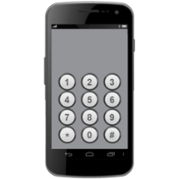

Who wrote this report?

- Yvette Maker
- Jeannie Marie Paterson
- Bernadette McSherry
- Lisa Brophy
- Anna Arstein-Kerslake
- Alex Callahan
- Eugene Teo

We are researchers

Researchers look for answers to problems

We work at Melbourne University

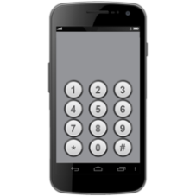 | Sometimes people with cognitive disabilities have problems when they buy  - a phone or tablet  - a phone or tablet plan  - an internet service  This is because the websites of  phone and internet companies can make it  - hard to understand  - hard to get help  Phone and internet companies sell  - mobile phones  - phone and tablet plans  - iPads and other tablets  - home phones  - internet services
Phone and internet companies

have to make things better for people with cognitive disabilities because it is the rules

The rules come from

- Telecommunications Consumer
Protections Code

- human rights

The rules say companies should

- give clear information

- help customers make decisions

- make websites that all people can use

- respect people’s decisions

We looked at the websites of 9
phone and internet companies to see
if they follow the rules

This is the report about how easy
the websites are to

- understand

- use
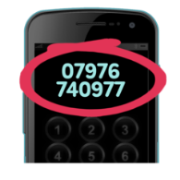 | What makes a good website  - not much writing  - easy to read  - writing is clear and big  It is easy to find cheap  - phones  - tablets  - plans  It is easy to find help  - the right phone numbers  - web chat
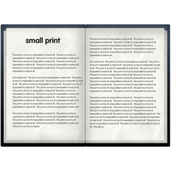 | Some problems with websites  - too much writing  - writing is too small  - you have to scroll or click too much  - different information on different pages  - hard to get help for questions or problems
We have 12 ideas to help fix websites to make them easier to use

We talked to

- People with Disability Australia

- Victorian Mental Illness Awareness Council (VMIAC)

They helped us with these ideas

Our ideas

- ask people with disabilities about their ideas on how to make the website easier to use
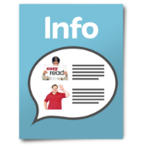 | - use pictures to tell stories
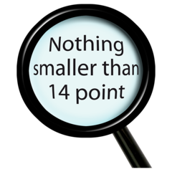 | - make webpages clear and easy to read
 | - make it easy for customers to find what they want
 | - make sure cheap phones tablets and internet are easy to find
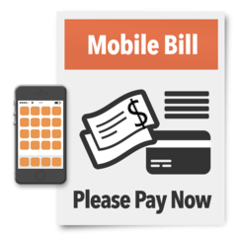  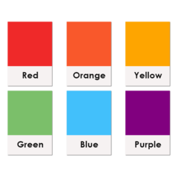 | - make sure information is easy to find  on the total price  on any extra charges  - write information in different colours  - write information in big size words
 | - see products side to side to make choices easier
- use plain language

- explain hard words

- offer lots of ways to get help

live chat

phone numbers

email

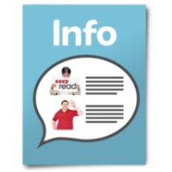  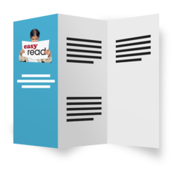 | - make important information accessible  in plain language  in easy read  We have made some factsheets to show how to make information accessible
- give information in different ways

poster

online guided tour

- let people choose what information
they want
- change all parts of the company

teach staff about disability

More information

You can talk to us
- if you want to know more about the project

- if you want the full report

Melbourne Social Equity Institute

03 8344 7603

social-equity@unimelb.edu.au

This easy read paper was made for the University of Melbourne

By the Intellectual Disability Rights Service

Hard words
accessible information

information that is easy for many people to understand

people with cognitive disabilities mean people who sometimes find it hard to

- learn

- concentrate

- remember

- communicate

- make decisions

extra charges

extra money you might have to pay on a plan

human rights

the rights and freedoms that should happen for every person in the world

internet service

you pay for this so you can use the internet at home

live chat

a way to talk to a company by typing on the computer

plan is a contract you sign to agree to buy phone or internet

- usually paid monthly
you can ask to pay weekly or fortnightly

fortnightly is every 2 weeks

tablet

a flat, hand held device like
- iPad
- Samsung Galaxy
- Microsoft Surface

Telecommunications Consumer Protection Code

the rules for phone and internet companies

