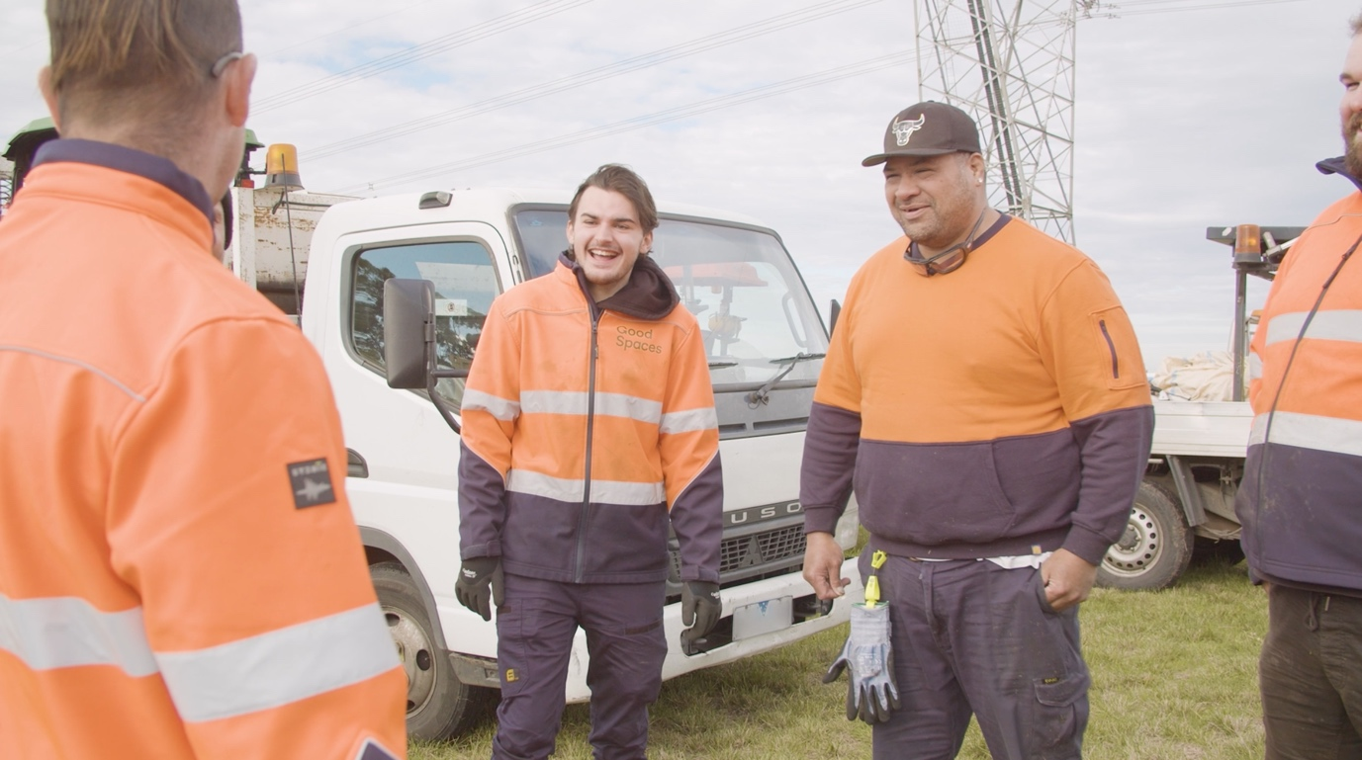

Insights Report
  - Building a Taxonomy of Jobs-Focused Social Enterprise in Australia: The Key Characteristics of Work Integration Social Enterprise (WISE)


Front cover photo description: A group of Good Spaces team members smiling and talking at a job.
Photo credit: Pure Production, Good Cycles.
  - Acknowledgement of Country
The authors acknowledge the Traditional Owners of Country throughout Australia and their continuing connection to land, waters and community. We pay our respects to their Cultures, Country and Elders past and present.
Acknowledgement of participants: The authors thank the 128 people who generously completed the survey in support of this work. We also acknowledge Social Enterprise Australia and White Box Enterprises as co-hosts of the Social Enterprise Jobs Summit 2025, where the survey took place.
Funding acknowledgement: This insights report is part of a three-year research project, ‘Activating Employment Futures Through Work Integration Social Enterprise’. The project is funded by the Australian Research Council (LP220100323) and collaborating partners: White Box Enterprises, Westpac Foundation, Outlook Australia, and STREAT.
Suggested citation: Khan, C., Barraket, J., McGann, M. (2026). Building a Taxonomy of Jobs-Focused Social Enterprise in Australia: The Key Characteristics of Work Integration Social Enterprise (WISE). University of Melbourne, Australia.
Contact: Corresponding author, Professor Jo Barraket AM, email: jo.barraket@unimelb.edu.au
More information: Visit the ‘Activating Employment Futures Through Work Integration Social Enterprise’ project website for more information.


Photo description: Magic the Therapy Dog giving some love and support at STREAT
Photo credit: STREAT

  - Table of contents
Introduction and background 4
Snapshot of WISE 5
WISE in Australia – a taxonomy 5
Survey results 7
Organisational form 7
Ownership structure 7
Main focus and activities 8
Compensation for participants/employees 9
Revenue sources 10
Sources of government funding and income 10
A note on methods and limitations 11
Implications and conclusions 12
Reference list 13
Appendix 1: Survey instrument 14

Introduction and background
There are an estimated 12,000 social enterprises operating across Australia. Together, they contribute $21.3 billion to the Australian economy, representing approximately 1% of GDP (Social Enterprise Australia, 2022).
Because of challenges of identification and different methods used in different studies, it is unclear how many are work integration or jobs-focused social enterprises. However, national studies suggest that just over a third of social enterprises in Australia aim to “creat[e] meaningful employment opportunities for people from a specific group”, noting that some social enterprises have multiple purposes (Barraket et al., 2016: 18).
Work integration social enterprises (WISEs) are diverse, and this diversity is not well-understood by policymakers and funders (Sykes et al., 2024). With increasing attention being paid to WISE in government reforms to employment services in general and inclusive employment in particular, better understanding of the characteristics of WISE and the diversity of WISE models is needed.
Drawing on a short survey of participants conducted at the 2025 Social Enterprise Jobs Summit hosted by Social Enterprise Australia and White Box Enterprises, this report – the fourth in a series arising from the Australian Research Council Linkage project, Activating Employment Futures Through Work Integration Social Enterprise (WISE) (LP220100323) – presents a taxonomy of the key characteristics and differences of WISE in Australia. You can read more about the project by visiting the project website.
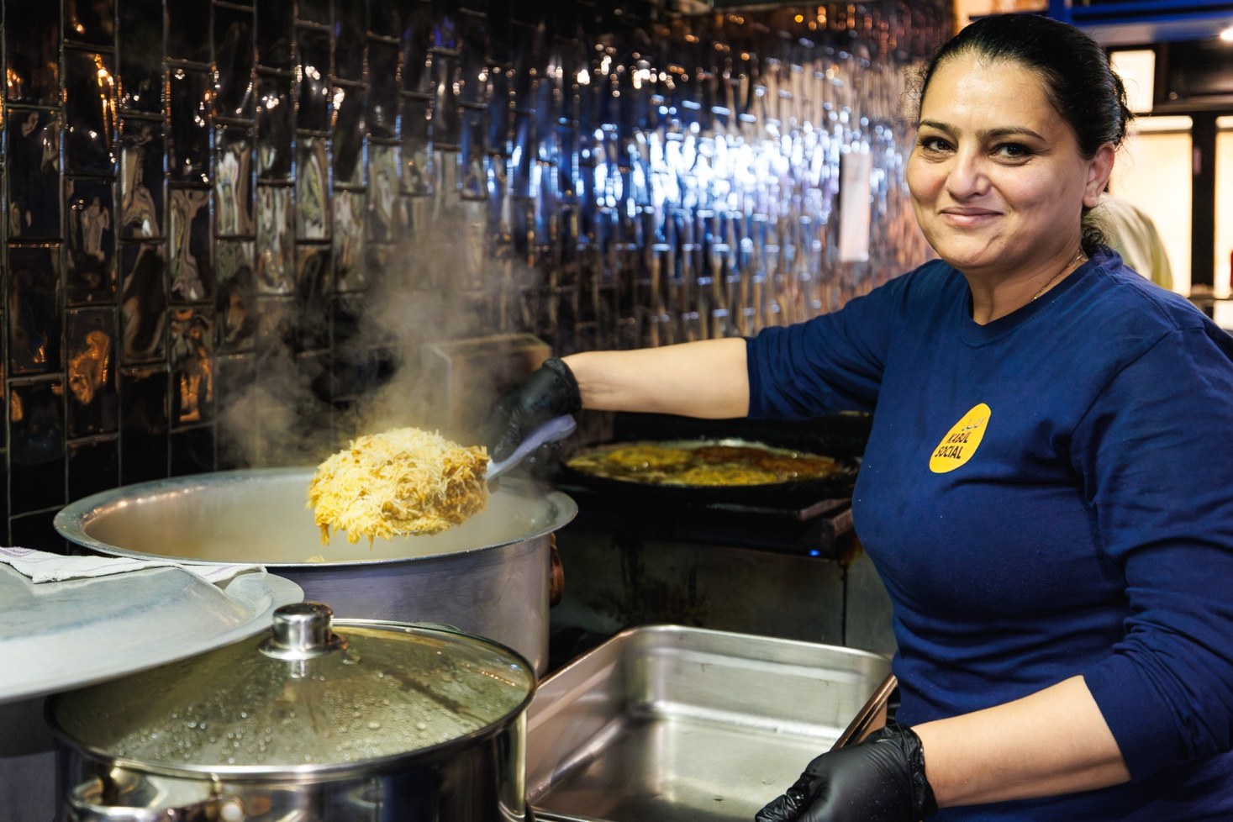
Photo description: Roya Moeen. Roya is the Head Chef at Kabul Social. The menu is inspired by her family’s recipes and celebrates the rich flavours and traditions of Afghan cuisine.
Venue: Kabul Social, March 2025. Photographer: Serhat Karakas

Snapshot of WISE
The survey results suggest:
- WISE activities range from building people’s employability, programs that support people to transition into the mainstream labour market, and creating permanent employment within WISE and/or their parent or subsidiary organisations.
- Most WISEs are not-for-profit, but there is a meaningful minority of for-profit businesses and entities that operate as nested/hybrid structures.
- The WISE sector is almost evenly split between standalone enterprises and business units embedded within larger organisations.
- Compensation of people WISE seek to support is mixed. Industrial award wage employment is common, but many WISEs also compensate through unpaid training and supported wage arrangements.
- While some government funding is a common part of WISEs’ revenue mix, this is not universal and comes from multiple levels of government.
“WISEs are trading organisations that use business activity to create more inclusive
employment outcomes for people and places excluded from mainstream labour markets”

WISE in Australia – a taxonomy
This taxonomy is derived from the project survey and informed by past research led by members of the research team. It should be interpreted as comprehensive but not definitive; a tool for conversation within and beyond the WISE sector.
See infographic on following page.
You can download, save or print a copy of the infographic by clicking this link or by scanning the QR code below.

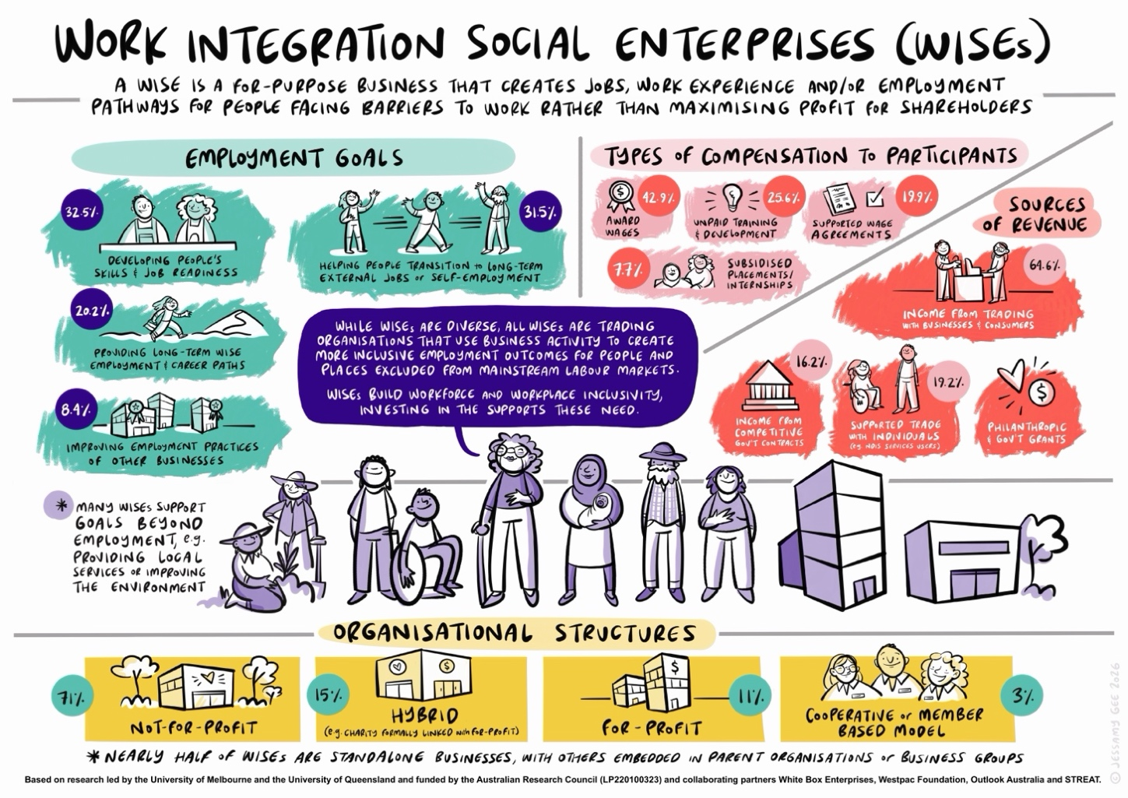

Survey results
One hundred and twenty-eight responses to the survey were received. Results are based on analysis of the 99 responses deemed consistent with a definition of social enterprises as being purpose-led organisations that derive a substantial portion of their income through trade (see methods and limitations section).

Organisational form
When asked, “What is the organisational structure of your jobs-focused social enterprise?”, results indicate a near-even split, with around 47.5% operating as a standalone social enterprise, and 50.5% operating as a business unit or enterprise within a larger organisation or business group.
Answer | Percent | Count
A standalone social enterprise | 47.5% | 47
A business unit/enterprise within a larger organisation or business group | 50.5% | 50
Other | 2% | 2
Total | 100% | 99
Figure 1: Organisational forms graph
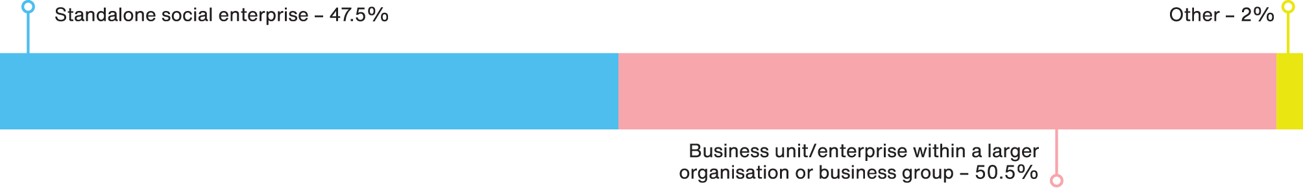

Ownership structure
Seventy-one percent of surveyed WISEs are incorporated as not-for-profit companies or associations, while 15% operate as a for-profit business formally linked with a charitable entity (that is, a “nested” or hybrid structure), 11% as a for-profit company or partnership and 3% as a cooperative or member-based organisation.
Answer | Percent | Count
A not-for-profit company or association | 71% | 70
A for-profit company or partnership | 11% | 11
A for-profit business formally linked with a charitable entity  i.e. a ‘nested’ or hybrid structure | 15% | 15
A cooperative or member-based organisation | 3% | 3
A sole trader | 0% | 0
Other | 0% | 0
Total | 100% | 99
Figure 2: Ownership structure graph
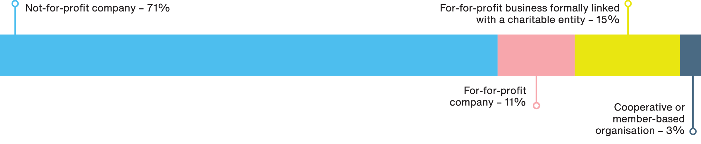

Main focus and activities
The most common focus of participating WISE activities was on building employability and supporting pathways into sustained work, particularly developing people’s skills and job-readiness (32.5%), and enabling people’s transition into long-term work with other employers or self-employment (31.5%). A smaller proportion provide long-term employment in our business (20.2%) while 8.4% prioritise improving employment practices of mainstream businesses and 7.4% seek to improve our local economy and place.
Answer | Percent | Count
Developing people’s skills and job-readiness, e.g. through work experience or training | 32.5% | 66
Enabling people’s transition into long-term work with other employers or self-employment | 31.5% | 64
Providing long-term employment in our business | 20.2% | 41
Improving our local economy and place | 7.4% | 15
Improving employment practices of mainstream businesses | 8.4% | 17
Total | 100% | 203
Figure 3: Main focus and activities graph
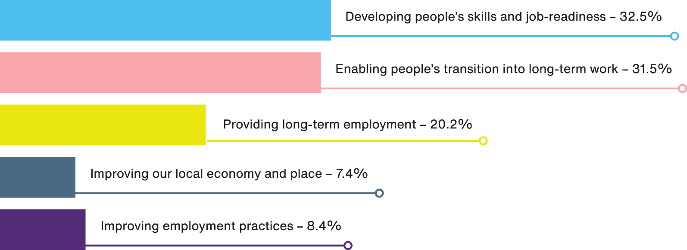

Compensation for participants/employees
Providing paid employment is the predominant way participating WISEs compensate the people they seek to help, alongside a smaller but notable reliance on unpaid training and supported arrangements. Around 43% remunerate their participants through industrial award wages, while around a quarter of respondents provide unpaid training and development opportunities, and around 20% pay participants through supported wage agreements. Around 8% compensate participants via subsidised placements and internships and approximately 4% offer them shared ownership/membership in the business.
Answer | Percent | Count
We provide unpaid training and development opportunities | 25.6% | 40
Participants are financially supported through subsidised placements and internships | 7.7% | 12
Participants are paid through industrial award wages | 42.9% | 67
Participants are paid through supported wage agreements | 19.9% | 31
Participants have shared ownership/membership in our business | 3.9% | 6
Total | 100% | 156
Figure 4: Compensation for participants/employees graph
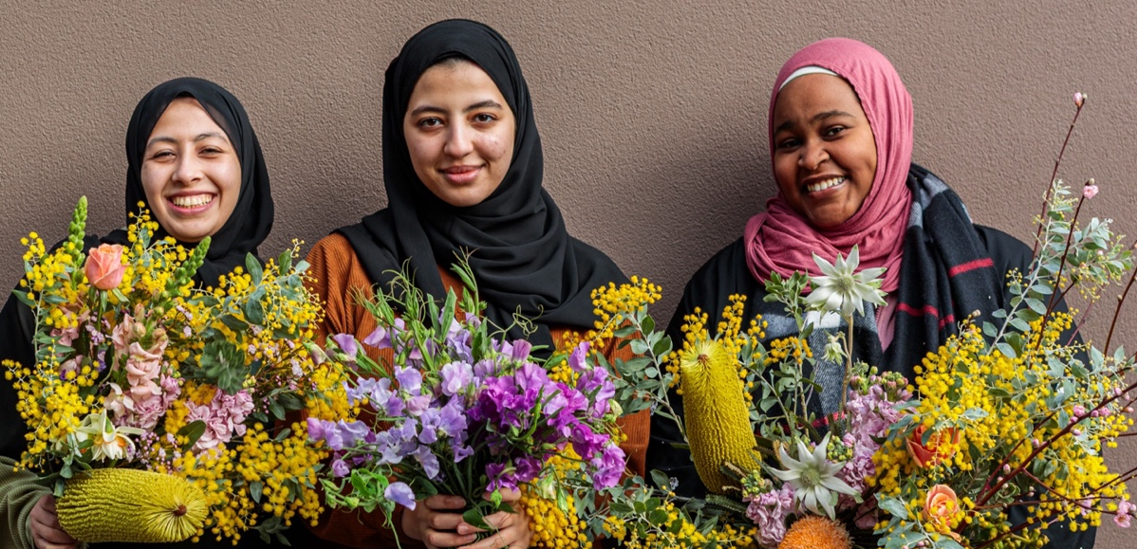
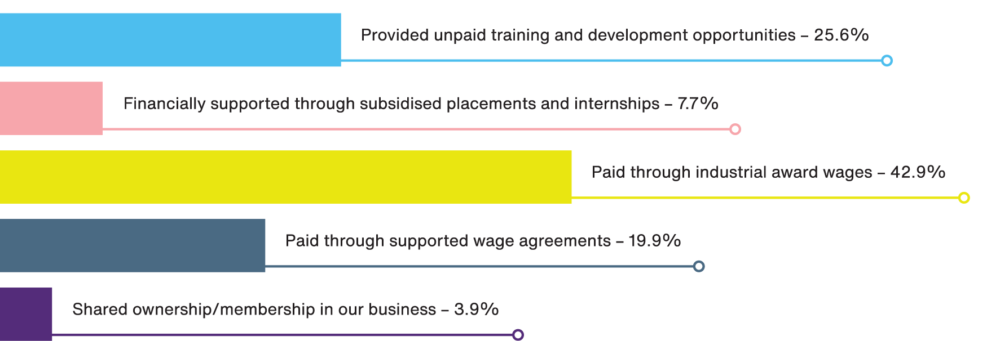
Photo description: Trainees at The Beautiful Bunch with seasonal bouquets.
Photo credit:
Francois Marx.

Revenue sources
The most common primary revenue source for responding WISEs was contracts with businesses (34.3%), followed by open trade with individual customers (30.3%). Around 19% were majority resourced through supported trade with individual customers (e.g., NDIS clients), while around 16% were primarily resourced through contracts with governments. Philanthropic and government grants play an important role in the WISE revenue mix. However, because this analysis adopts a definition of social enterprise that prioritises trading, organisations for which grants were the main source of revenue were excluded from the survey results (see methods and limitations section).
Answer | Percent | Count
Majority contracts with governments | 16.2% | 16
Majority contracts with businesses | 34.3% | 34
Majority open trade with individual customers, e.g. B2C retail | 30.3% | 30
Majority supported trade with individual customers, e.g. NDIS services users | 19.2% | 19
Total | 100% | 99
Figure 5: Revenue sources graph
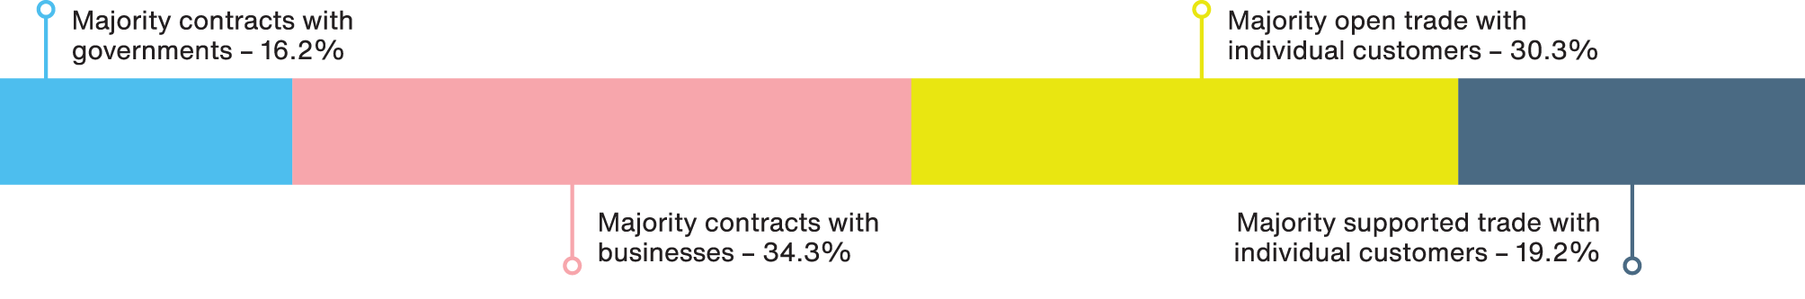

Sources of government funding and income
Around 63% of respondents indicated they receive income from government in the form of either grants or contracts. Among these, the main source was the Australian Federal Government (46%), followed by state or territory governments (39.7%) and local governments (14.3%).
Answer | Percent | Count
Australian Federal Government | 46% | 29
State or Territory governments | 39.7% | 25
Local governments | 14.3% | 9
Total | 100% | 63
Figure 6: Sources of government funding and income graph
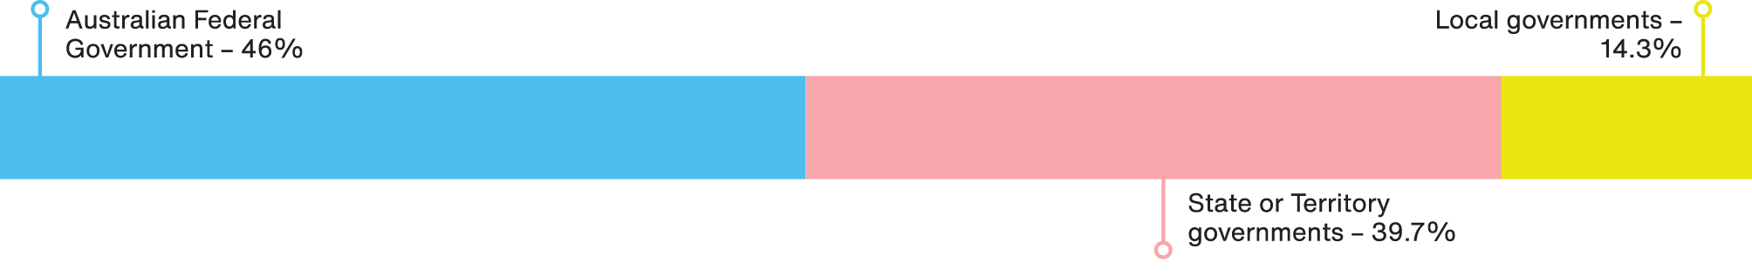

A note on methods and limitations
The short survey was designed by the research team to capture information from participating organisations about their core structural and operating features. The full survey instrument can be found in Appendix 1.
The survey was disseminated to 380 attendees at the inaugural Social Enterprise Jobs Summit 2025 as part of a keynote presentation. This activity was purposefully brief to capture contributions during a large event. The survey was completed in full by 128 attendees who self-identified as WISE operators, representing a third of event attendees (34%). However, 29 of the 128 completed surveys (22.7%) were excluded because respondents reported that their primary revenue source was either government grants (rather than contracts) or philanthropic grants/donations, indicating that a substantial portion of their income was not derived from trade (Barraket et al., 2010).
The survey respondents self-selected and identified as WISE operators and were participants at a specific event. Because of this, the respondent pool may not represent the full WISE sector. The taxonomy also relies on self-reported rather than verified information. Despite this, the survey helped capture information from a large and diverse live participant pool. It is novel in providing specific insights into the WISE sector in Australia.
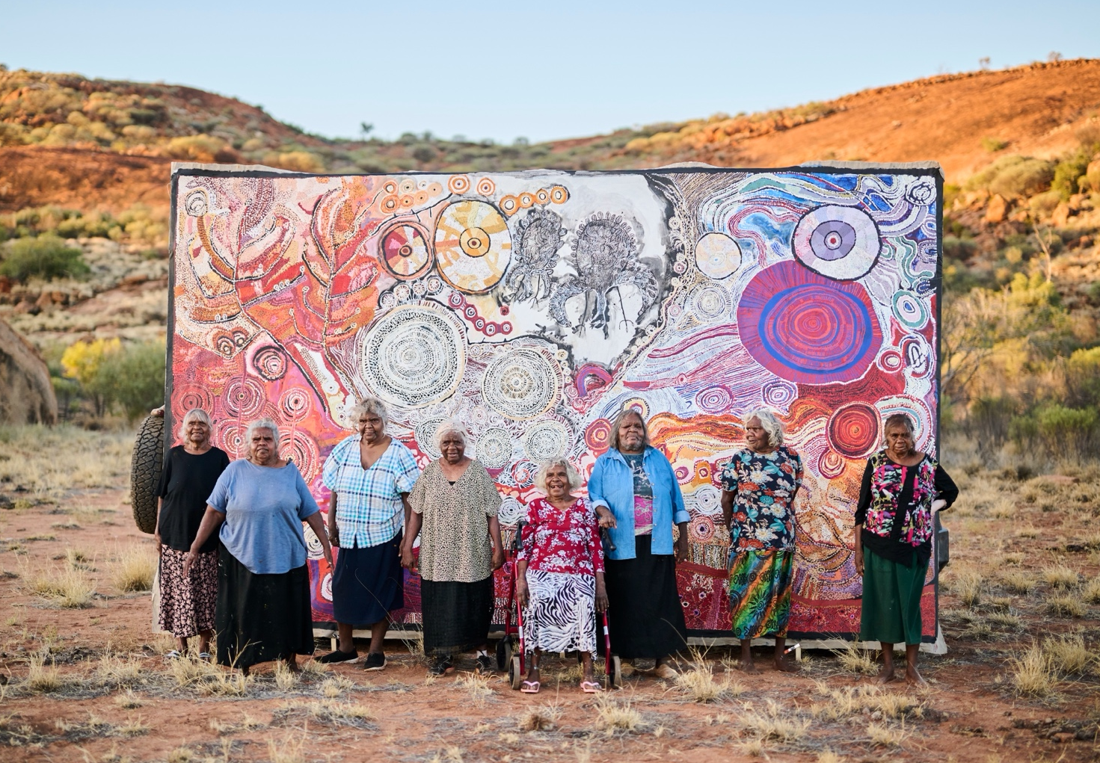
Photo description: Senior artists from the Anangu Pitjantjatjara Yankunytjatjara Lands – Maringka Burton, Tuppy Goodwin, Sylvia Ken, Betty Muffler, Iluwanti Ken, Betty Chimney, Puna Yanima and Betty Pumani with their collaborative artwork from the artist-led project Ngura Pulka (Epic Country), taken just outside the remote community of Mimili in 2023. Photo credit: Photo by Rohan Thomson. Courtesy APY Art Centre Collective.

Implications and conclusions
This survey suggests the WISE sector is organisationally diverse but predominantly structured as not-for-profits.
The presence of nested, for-profit, and cooperative models indicates that the sector encompasses a range of organisational and legal forms, and highlights the need to recognise the WISE sector’s diversity.
In addition to organisational diversity, surveyed WISEs most commonly emphasised improving job-readiness, pathways into long-term work with other employers, and direct long-term employment within their operations, indicating that their activities and interactions with the people they aim to help vary widely.
Industrial award wages appear to be the most prevalent form of compensation in the WISE sector. This finding indicates that the sector typically recognises that ‘decent work’ includes fair pay. However, the results also indicate that a substantial share of the opportunities provided by WISEs are through lower-paid or unpaid arrangements, such as unpaid training and supported wage agreements. The prevalence of these arrangements reaffirms that WISEs operate work-integration activities with different groups of people and across a spectrum, from improving employability to providing paid employment.
The survey results suggest that government funding is not universal across the WISE sector and, when present, is part of a broader revenue mix rather than a funding base. Among those receiving government income, the federal government was the most common source, but this was not the dominant source of revenue across the sector as a whole.
This brief report focused on the characteristics of WISEs to improve understanding of the field and definitions adopted to support WISE and the outcomes they create.

Photo description: Leigh, an employee of Beacon Laundry, a jobs-focused social enterprise based
in Bangalow, NSW. Photo credit: Beacon Laundry

Reference list
- Barraket, J., Collyer, N., O’Connor, M. and Anderson, H. (2010). Finding Australia’s Social Enterprise Sector: Final Report, Social Traders and The Australian Centre for Philanthropy and Nonprofit Studies, Brisbane.
- Barraket, J, Mason, C and Blain, B (2016). Finding Australia’s Social Enterprise Sector 2016: Final Report, Centre for Social Impact (CSI) Swinburne & Social Traders, viewed 6 January 2026. Click here to download the PDF.
- Social Enterprise Australia (2022). Business for good: The size and economic contribution of social enterprise in Australia, Social Enterprise Australia, viewed 14 March 2026. Click here to download the PDF.
- Social Traders (2022). PACE22: Profile of Australia’s Certified Social Enterprises, Social Traders, viewed 16 March 2026. Click here to download the PDF.
- Sykes, C., McGann, M., Marston, G., Khan, C. and Barraket, J. (2024). The Role of Work Integration Social Enterprise (WISE) in Employment Services Reforms: Perspectives from the Ecosystem. University of Melbourne, Australia.
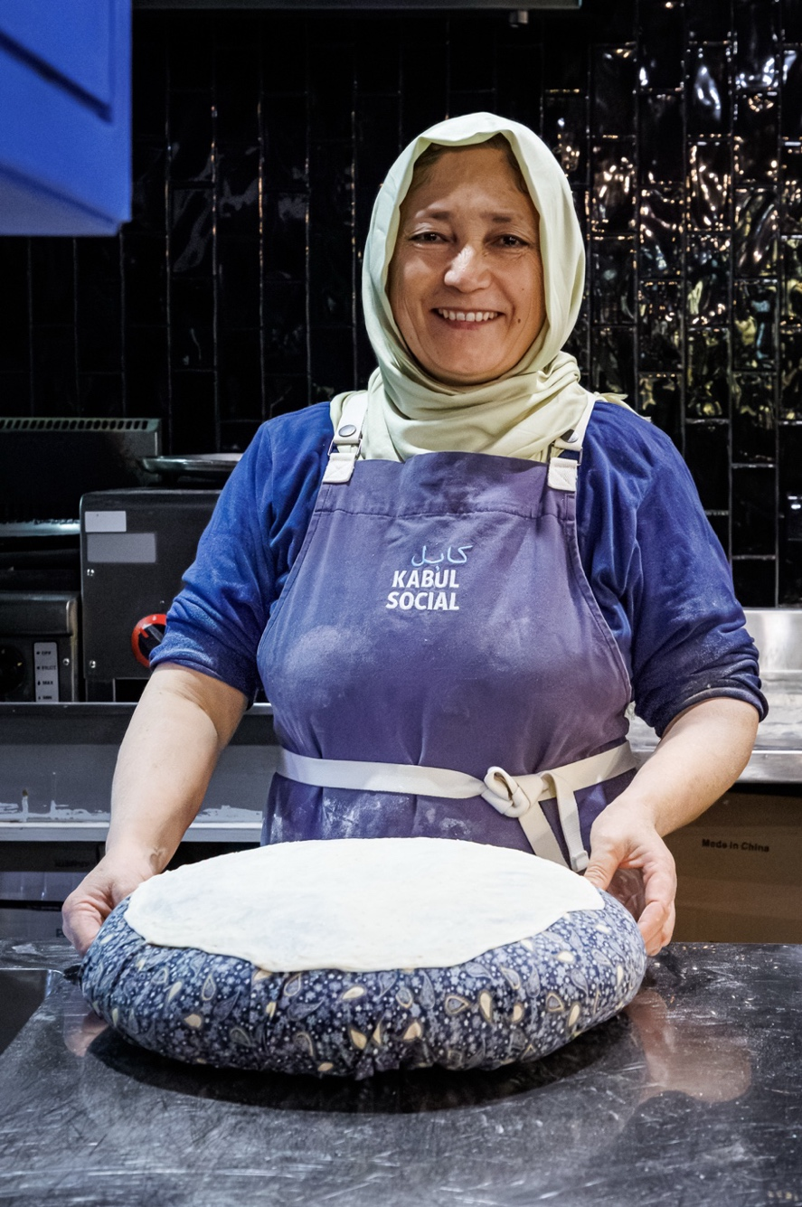
Photo description - left: Yakut Hamayoun. Yakut is known as the “Chief of Bread” at Plate It Forward, making every flatbread by hand each day. Venue: Kabul Social, March 2025. Photographer: Serhat Karakas.

Appendix 1: Survey instrument
Dimension | Survey question (verbatim) | Response format | Response options/fields captured
Organisational form: | What is the organisational structure of your jobs-focused social enterprise?  Please select one option. | Single select | - Standalone social enterprise  - Business unit/enterprise within a larger organisation or business group  - Other.
Organisational form: | Please describe the organisational structure of your jobs-focused social enterprise. | Open text | - Free-text elaboration of organisational structure.
Ownership structure: | How is ownership structured in your jobs-focused social enterprise?  Please select one option. | Single select | - Not-for-profit company or association;  - For-profit company or partnership;  - For-profit business formally linked with a charitable entity (“nested”/hybrid structure);  - Cooperative/member-based organisation;  - Sole trader;  - Other.
Ownership structure: | Please describe the ownership structure of your jobs-focused social enterprise. | Open text | - Free-text elaboration of ownership structure.
Main focus within jobs-focused/work integration activities: | What is the main focus of your jobs-focused social enterprise?  Please select up to three options. | Multi-select  (up to 3) | - Developing skills/job-readiness (work experience/training);  - Enabling transition into long-term work with other employers or self-employment;  - Providing long-term employment in our business;  - Improving local economy/place;  - Improving employment practices of mainstream businesses.
Compensation model for participants/employees: | How does your jobs-focused social enterprise compensate those you seek to help?  Please select all relevant options. | Multi-select (select all that apply) | - Unpaid training/development;  - Subsidised placements/internships;  - Paid via industrial award wages;  - Paid via supported wage agreements;  - Shared ownership/membership in the business.
Primary revenue source: | What is your current revenue mix?  Please select one option that best fits your main revenue source. | Single select | - Majority contracts with governments;  - Majority contracts with businesses;  - Majority open trade with individual customers (B2C retail);  - Majority supported trade with individual customers (e.g., NDIS users);  - Majority philanthropic grants/donations;  - Majority government grants.
Government  funding profile: | If your social enterprise receives government funding (whether grants or contracts), which level of government does this mainly come from?  Please select one option that best fits your current government funding arrangements. | Single select | - Australian Federal Government;  - State/Territory governments;  - Local governments;  - Not applicable.
(Optional add-on): | Are there any other organisational characteristics we should consider in developing a high-level taxonomy of jobs-focused social enterprises?  Please provide further details below. | Open text | - Free-text suggestions for additional taxonomy variables.

Participants could select up to three responses
Participants could select all relevant options.

