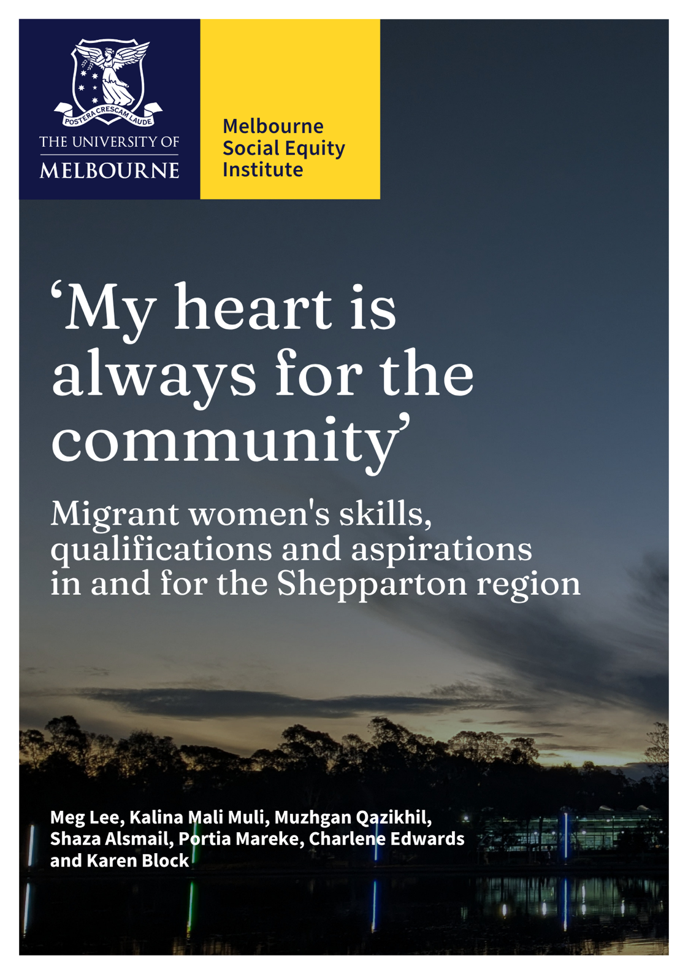
Meg Lee, Kalina Mali Muli, Muzhgan Qazikhil, Shaza Alsmail, Portia Mareke, Charlene Edwards, and Karen
Block
All images supplied by the authors.
Date: September 2026
Melbourne Social Equity Institute, The University of Melbourne, VIC 3010
Suggested citation:
Lee, M., Muli, K.M, Qazikhil, M., Alsmail, S., Edwards, C., and Block, K. (2026). ‘My heart is always for the community’: Migrant women’s skills, qualifications, and aspirations in and for the Shepparton region. Melbourne Social Equity Institute, University of Melbourne.

Acknowledgements
We acknowledge the Traditional Owners of the unceded lands on which this research took place, the Yorta Yorta People and Wurundjeri Woi-wurrung People, and pay respect to Elders past, present and emerging. We recognise that migration to this continent has historically taken place, and continues to occur, under the condition of continued Aboriginal and Torres Strait Islander custodianship of the lands and waterways. We also recognise First Nations people as the first to be impacted by racism and structural inequities on this continent; inequities that continue to affect the lives and careers of First Nations people, including women. We acknowledge the leadership of Aboriginal and Torres Strait Islander People in community-based approaches to social change, and the important role for First Nations knowledges and leadership shaping sustainable regional migration into the future.
Thank you
We extend our heartfelt thanks to the women, community members, and stakeholders who generously gave their time and shared their stories for this project. We acknowledge their strength in doing so.
Funding
This project was made possible by funding from the Melbourne Social Equity Institute and a University of Melbourne Community Impact Grant.

Table of Contents
Table of Contents 3
Table of figures 3
Executive Summary 5
Background, aims and approach 5
Methods and participants 5
Findings 5
Recommendations: What would help? 6
Conclusion 7
About this research 8
Methodology 10
A community-based approach 11
Ethical considerations 13
Participants 13
Findings 19
Being 'the bridge for the gap where communication is broken': Values, aspirations, and social connectedness 19
Health 20
1.0 English language and communication 22
2.0 Skills, qualifications, and employment experiences 27
3.0 Family, care, and time 32
4.0 Financial situation 35
5.0 Rural geographies of opportunity 39
6.0 Structural considerations and inequities 41
Recommendations: What would help? 45
Conclusion 48
References 50
Appendices 51
Appendix 1: Research Survey Questions 52
Appendix 2: Research Summary 72
Appendix 3: Relevant community services and initiatives in the Shepparton region 75
Appendix 4: Wise Well Women program information 77

Table of figures
Figure 1. Survey participant information: Cultural background 17
Figure 2. Survey participant information: Age 17
Figure 3. Survey participants: English language assistance 18
Figure 4. Survey participant information: education level 19
Figure 5. Survey participant information: employment by sector 19
Figure 6. Survey participant information: Years in Shepparton 20
Figure 7. Survey participant information: migration or visa status 20
Figure 8. Multiple option survey question: Have any of the following made it difficult for you to pursue your aims or aspirations in Shepparton? (select all that apply) 26
Figure 9. Multiple option survey question: What would make it easier to pursue your aims or aspirations in Shepparton? (select all that apply) 27
Figure 10. Multiple option survey question: Have any of the following made it difficult for you to pursue your aims or aspirations in Shepparton? (select all that apply) 31
Figure 11. Have any of the following made it difficult for you to pursue your aims or aspirations in Shepparton? (select all that apply) 35
Figure 12. Multiple option survey question: What would make it easier to pursue your aims or aspirations in Shepparton? (select all that apply) 36
Figure 13. Multiple option survey question: What would make it easier to pursue your aims or aspirations in Shepparton? (select all that apply) 41
Figure 14. Multiple option survey question: What would make it easier to pursue your aims or aspirations in Shepparton? (select all that apply) 42

Executive Summary

Background, aims and approach
This project began with researchers from the Melbourne Social Equity Institute asking migrant and refugee community members and community leaders, and a range of community organisations in Shepparton, what research would be useful to migrant women and the Shepparton community. From these consultations, it was agreed that research focused on gaining a deeper contextual understanding of migrant women’s aspirations, careers and life trajectories was needed. While recent research has identified migrant women as a group whose strengths are frequently under-utilised in Australia, including in regional communities, the need for place-based knowledge and initiatives to address such issues is also increasingly recognised.
An Advisory Committee comprising local stakeholders, community leaders and researchers, including women from migrant and refugee backgrounds, provided guidance throughout the research. Central to the project was employment of three Community Researchers from Pasifika, Afghan and Arabic speaking (Syrian) communities in Shepparton. The Community Researchers are migrant women living in Shepparton and trusted community interpreters and connectors in these communities. They were involved in all key stages of the research, supporting recruitment, communication with community members, interviewing, transcribing and interpretation of findings.
Through this research, we aimed to contribute to a locally relevant, community-informed evidence-base about the aspirations, skills, experiences and qualifications of refugee and migrant women in Shepparton. We sought to understand women’s existing skills and expertise, their career and life aspirations, and the factors that may support or hinder their ability to achieve these aspirations. The project also considered the potential opportunity costs to women, the community and the wider region associated with underutilising women's skills and capabilities.

Methods and participants
We employed a mixed-methods, community-based research approach, combining semi-structured interviews with a survey. Interviews were conducted with 56 migrant women and community stakeholders in Shepparton and 213 migrant women completed surveys. We aimed to ensure that participants represented a diverse range of experiences across cultural background, age, visa status, occupation, qualifications, length of time in Australia, and family or household structure.

Findings
Analysis of interview and survey data revealed six themes concerning the constraints and opportunities that shaped migrant women’s experiences related to using and/or developing their skills, expertise and qualifications to achieve aspirations. As well as discussing barriers, we highlight examples of current good practice and initiatives in Shepparton that support women’s wellbeing and progress towards life goals. The themes, discussed in detail in this report are:
- English language and communication
- Skills, qualifications, and employment experiences
- Family, care, and time
- Financial situation
- Rural geographies of opportunity
- Structural considerations and inequities
Two key concepts cut across and infused these themes. The first concerned women’s values, aspirations and desire for social connectedness and to give back to the community; and the second concerned mental and physical health.
Perhaps the strongest value and aspiration that underlaid participants' responses in this study was the desire to help and connect with others in the community. Older women articulated a desire to create a more connected, inclusive community for future generations to flourish, and younger women often spoke about wanting to connect with others and give back to their community. These desires came through in the aspirations women expressed, and the kinds of lives they described building. Work and study were often discussed in terms of living a meaningful life, 'developing' or 'bettering' the self, supporting the health and aspirations of family, rather than a means to financial or material accumulation. Supporting younger generations, particularly women, to access educational opportunities, and more generally improving access to opportunities for self-efficacy and choice for future women migrants to Shepparton was a strong priority.
Health and mental health for women and their families also underpinned many participants' responses, shaping what was possible or imaginable in their lives. Many interviewees described living with chronic health conditions or caring for family members with health issues, which sometimes structured the movements and temporal rhythms of their daily lives.

Recommendations: What would help?
Based on our findings, we developed the following recommendations, all of which should be implemented in partnership with migrant women.
Social connection and services
- Accessible information/ signage (pictorial, map-based) indicating what support can be found where. This could be displayed in places like Centrelink, language schools, doctors, TAFE/ schools.

- Building on existing services and initiatives that work well: Learner driver support; Community Hubs; family programs; intercultural events. Culture Kitchen was highlighted as a program that has worked well for older women as well those with children.

- Support for existing migrant women’s networks and initiatives (e.g. Door Bells, Tongan church and other faith-based groups) currently providing information, support, and connection.

- Support for migrant women to lead the development of accessible, welcoming spaces in the broader Shepparton community where different groups (migrants and non-migrants) can connect. These can be linked to information about support/services, education and employment opportunities.

- Accessible, welcoming spaces (or programs) for young women from migrant backgrounds, supporting social connection. These should be linked to information and support/services around education, training, employment, and careers advice. They should be developed in consultation with communities to ensure family and community support.
  - Community Hubs were identified as a successful model by participants in this study. African House was also seen as a safe and welcoming space.

- More affordable childcare options, including time-flexible childcare.

- Improved public transportation, including more frequent bus services.
English language and education
- A wider range of English language programs, including more flexible class timing and structures. Address specific needs for:
  - ‘Practical English’ for use navigating services and attaining employment
  - More social/everyday English
  - English at a higher level for those seeking professional employment

- Internship-based study and training courses, connected to English language programs and employment pathways.
  - Recent initiatives by WomenCAN Australia and the Ethnic Council of Shepparton and District may provide useful models.
Social inclusion
- Longer-term, sustained anti-racism education, awareness raising, and upstander training in the Shepparton community. This work should be carefully designed to centre First Nations as well as migrant leadership and expertise, while avoiding placing the burden for changemaking on communities experiencing racism.
  - Such efforts should include education about ‘cultural load’ where racialised community members are unfairly expected to provide ‘cultural’ services for free.

- Education for local employers, educators, careers advisors and services about different cultures and faiths.
Employment and qualifications
- Improved recognition for women’s prior qualifications, skills, and experience.
  - More accessible pathways for recognition of women’s prior qualifications, supported by local education and training providers and employers.
  - Mechanisms, such as certificates, to support local employers in recognising women’s skills and experience in areas including interpreting and translation, leadership, organisation, volunteering, event management, catering, mentoring, and advocacy.
- Recognise, compensate and (where appropriate) formalise the work women are already doing by employing migrant women in areas such as:
- Interpreting and translation: employ bilingual staff in health services, settlement services, and education/training.
- Program/event design and delivery for areas including social spaces/events, youth opportunities, applied English language programs, internships, cultural awareness building/training, jobs and careers counselling, family support).
- Peer support, mentoring, and advocacy.

- A wider range of locally available tertiary education courses and access to fee support or flexible payment options.

Conclusion
Our research highlights the wealth of skills and qualifications that migrant women bring to the Shepparton region, and that they continue to develop their skills and qualifications in Australia. Some of their most notable contributions to the community, however, appear to be associated with unpaid work and unrecognised or uncompensated skills and qualifications. These contributions include interpreting, translation, and intercultural communication, settlement support, leadership, mentorship and advocacy, volunteering, caring work, and community organising. Women's values and worldviews were generally central to the way they approached their role as active community members and conceptualised their aspirations for themselves and the Shepparton community. The strongest value and goal that animated participants' responses in this study was the desire to help and connect with others in the community. These desires came through in the aspirations women expressed, and the kinds of lives and communities they were already building. The right resources, support and skills development for both migrant women and the wider community, can ensure that migrant women, their families and the wider Shepparton community can thrive together and reap the benefits that migrant women's vision, skills and expertise can contribute.

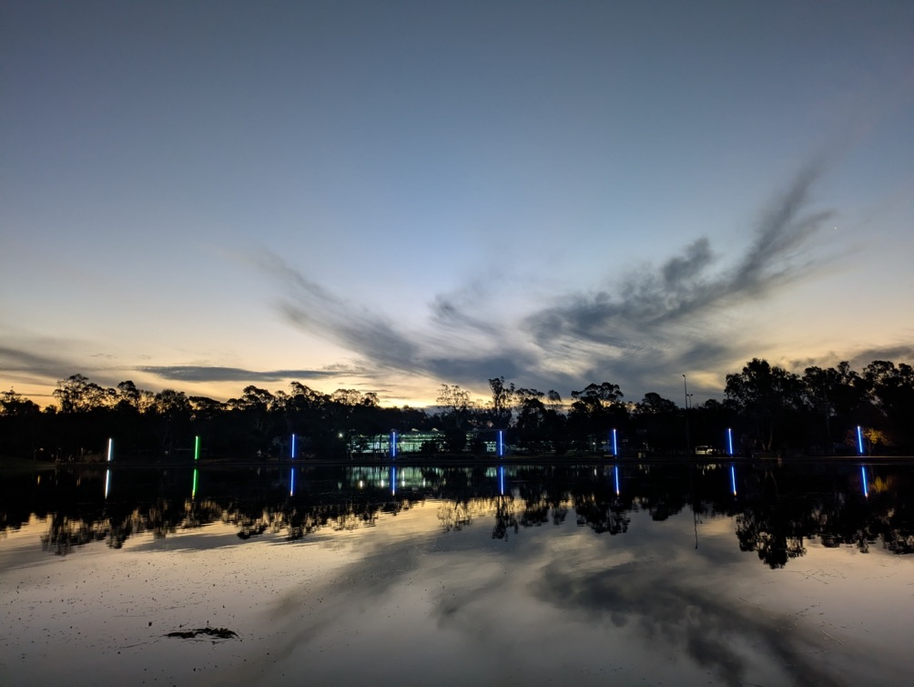

About this research
The project was developed in response to consultations with migrant and refugee community members and community leaders, and a range of community organisations in Shepparton, Victoria. Through these consultations, the University of Melbourne research team sought suggestions for research that would be useful to migrant women and the Shepparton community, with migrant women’s aspirations, careers and life trajectories emerging as an agreed topic. While recent research has identified migrant women as a group whose strengths are frequently under-utilised in Australia, including in regional communities (Australian Multicultural Women’s Alliance and Settlement Services International, 2026; Van Kooy et al., 2025) the need for place-based knowledge and initiatives to address such issues is also increasingly recognised in research and policy (Radford et al. 2025; Tan et al. 2026; Victorian Government, 2023).
Through this research, we aimed to contribute to a locally relevant, community-informed evidence-base about the aspirations, skills, experiences and qualifications of refugee and migrant women in Shepparton. We sought to understand women’s existing skills and expertise, their career and life aspirations, and the factors that may support or hinder their ability to achieve these aspirations. The project also considered the potential opportunity costs to women, the community and the wider region associated with underutilising women's skills and capabilities.
A community-based approach was central to the project. The University of Melbourne research team were in the fortunate - and perhaps, unusual - position of securing research funding that enabled community priority setting and relationships to be developed, without a specific research project already having been identified. This enabled a genuinely community-led agenda to be established. An Advisory Committee comprising local stakeholders, community leaders and researchers, including women from migrant and refugee backgrounds, provided guidance throughout the research. Community Researchers from migrant and refugee backgrounds were also involved in key stages of the research, supporting recruitment, communication with community members, interviewing, transcribing and interpretation of findings.
The study aims | (1) to understand refugee and migrant women’s employment aspirations, skills, experiences and qualifications;  (2) to strengthen community capacity to address employment and education barriers and support advocacy for policy and practice change; and  (3) to consider the opportunity costs associated with underutilising women’s skills and capabilities.

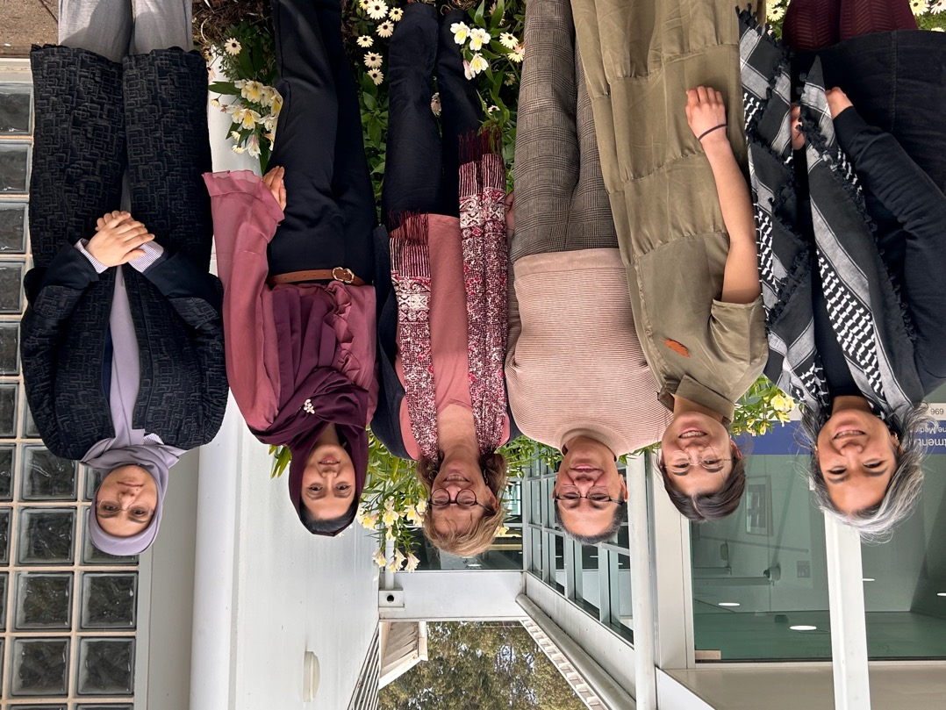
Methodology
The study scope:  The what, how, and why of migrant women's experiences | As a qualitative inquiry, the study aimed to provide rich, detailed insights into the nature of participants’ experiences and perspectives. Findings are not intended to be generalisable to the experiences of all migrant women in the region. Rather, the findings are illustrative of key experiences of migrant women and offer a unique depth of understanding made possible through in-depth, community-based qualitative research.
We employed a mixed-methods, community-based research approach, combining semi-structured interviews with a survey. The research was exploratory, meaning that it sought to achieve understanding of participants' experiences and priorities.

A community-based approach

Advisory Committee
The project design and implementation were informed by regular consultations with an Advisory Committee. Comprising 15 stakeholders including service providers, community leaders, researchers, and advocates working with migrant women in the Shepparton region, many members of the Advisory Committee were themselves women from migrant backgrounds. Through these consultations, the research team sought critical feedback, guidance and advice about the research aims, methodology and relevance of the research for the Shepparton community.
Based on Advisory Committee feedback, the research team particularly sought to understand how the findings could complement existing efforts in the community to improve migrant women's access to opportunities in the region. Aligned with this aim, information about relevant local services and initiatives is provided in the Appendices Section of this report.

Recruitment and data collection: The role of the Community Researchers
Central to this research project was the role of three Community Researchers from Pasifika (Tongan), Afghan and Arabic speaking (Syrian) communities in Shepparton. Community Researchers were migrant women living in Shepparton and trusted community interpreters and connectors in these communities. They were employed as Melbourne University Staff and provided with ongoing training and support in qualitative research skills, with a focus on research methods (interviewing, surveys), data analysis and ethical considerations of researching in their own community.
Community Researchers' culturally informed, local knowledge guided the research team's decisions around research design, as all other researchers in this project were based in Melbourne (travelling periodically to Shepparton). A guide for semi-structured interviews was developed by the research team as a whole, where Community Researcher's input informed the inclusion of specific prompts. These included prompts for topics the team felt women may wish to speak about but require support to broach (e.g. around their financial situation and around racism). Community Researchers played a central role in engaging potential participants through their established social and community networks. These included grassroots initiatives, faith- and culture-based communities and other community networks.
Recruitment materials, including flyers and Plain Language Statements (PLS), were distributed through community settings such as libraries, sports facilities, religious communities and places considered appropriate by the research team. Translated versions of recruitment materials, produced by the Community Researchers in Arabic, Dari/Hazaragi and Tongan, were also made available where appropriate. Prospective participants could also contact the University research team or Community Researchers by telephone or email to express their interest in taking part.
We also facilitated family-friendly community information sessions, providing opportunities for community members to learn about the research, meet the research team, review plain-language information (English, Arabic, Dari/Hazaragi, or Tongan) about the study and ask questions before deciding whether to participate. The Melbourne-based researchers worked to complement Community Researcher's networks by sharing the research information with other stakeholders and migrant communities in Shepparton through email and telephone conversations.
Data collection with migrant women were largely undertaken by Community Researchers, whose status as trusted and known community members and interpreting skills (English and Arabic, Dari, Hazaragi, and Tongan) meant they were ideally positioned for this work. Some research activities, including interviews, were completed by Melbourne-based researchers. This occurred where interviewees preferred to speak to someone from outside the Shepparton community and where interviewees were stakeholders from different cultural backgrounds to the Community Researchers.

Interviews
Semi-structured interviews lasted approximately 20–50 minutes. Fifty-six interviews were conducted and audio-recorded in participants' preferred languages, including Arabic, Dari, English, Hazaragi, and Tongan. Independent interpreting services were also offered, although no participants chose to use these services. Participants could also bring a trusted relative or friend for support, subject to appropriate consent arrangements. Three participants chose to complete a group interview instead of individual interviews.
Interviews took place at locations and times convenient to participants, including the University of Melbourne Shepparton Campus, public libraries, community centres, and interviewee's homes. Most interviews conducted by Melbourne-based researchers took place on Zoom. All interviewees who were not participating as part of their paid work, were reimbursed for their time with $60 groceries vouchers. Many interviewees from migrant backgrounds expressed 'enjoying' or 'feeling good' about the interview, as an opportunity to have someone 'just listen' to their experiences, challenges, and hopes.
Secure transcription software was used to generate transcripts for interviews conducted in English and Arabic, which were checked by the interviewers. For some Arabic interviews which did not translate clearly (for instance, due to cultural or personal differences in expression or dialect variation), this process involved a Melbourne-based researcher working closely with a Community Researcher to generate summaries of the transcripts to guide analysis and clarifying key quotes for use in publications. This process enhanced opportunities for iterative and collaborative analysis. For interviews in other languages, community researchers translated and transcribed interviews where possible. However, due to the significant time demand of this work, external support from other bilingual university researchers was sought for some interview transcripts.
As interviews for this project occurred over a period of several months, the research team revisited, expanded upon, and refined key themes as they emerged. Key themes were developed in dialogue between Melbourne- and Shepparton-based researchers, during transcription processes, and in conversation with the Advisory Committee. As such, no clear distinction can be drawn between ‘data collection’ and ‘data analysis’ in this study. Analysis was not a single step but an ongoing, relational process and an integral part of research activities throughout.
Following research activities, the research team undertook some further analysis. This analysis also involved listening back over interview recordings and reading transcripts, attending to how experiences and ideas were communicated—with which emotions—as well as what was said. Through these processes, we identified certain themes as weightier, more recurrent, more emotionally laden and/or more elaborated, than others, which is reflected in our report of the findings. In this report, where key themes or ideas are evident in participant quotes, we have added emphases (bolded text) to highlight these ideas to readers.

Surveys
Themes identified through the interviews informed the development of the survey. In consideration of Community Researchers' time capacity, and the need for specific skills in survey design, the survey was primarily designed by the Melbourne-based researchers and revised according to Community Researcher feedback.
Community Researchers supported participants who wished to complete the survey, providing verbal translation. Full written translation of the survey was not possible due to budget constraints, and Community Researchers also advised that interpreting support would better meet the needs of those respondents who were not literate in their first language(s), and some who required IT assistance.
The survey received 213 responses and was administered through an online survey platform (Qualtrics). It took approximately 15 minutes to complete and included multiple-choice and short-answer questions. The survey included predominantly optional questions and as a result the response rate varied between questions. Participants were reimbursed for their time with $20 grocery vouchers.

Ethical considerations
A key ethical consideration was the dual role of Community Researchers as both members of the communities they worked with and members of the research team. Existing relationships and trust within communities could potentially influence individuals’ decisions about whether to participate, including the possibility that prospective participants might feel pressured to take part.
To address this, Community Researchers received training in research ethics and informed consent and were encouraged to remain aware of potential conflicts of interest and power imbalances, and to discuss these with the wider research team where they arose. The information sheet and recruitment information emphasised that participation was entirely voluntary and that choosing not to participate would not affect participants’ existing relationships with Community Researchers.
Participants were also given the option of contacting members of the Melbourne-based research team directly if they preferred to discuss their participation with someone outside their local community. At the same time, we recognised that many community members would likely feel more comfortable discussing participation with Community Researchers whom they already knew and trusted.
Written consent or verbal consent was obtained for all interviews. Interview participants were provided with the choice of using their real first name or a pseudonym, while ensuring they understood the potential audience for research outputs and implications of being named. The survey did not record participants' names. Decisions around the inclusion of details about participant age, background, occupation, and aspects of their stories, were taken with care on a case-by-case basis, seeking to balance participant privacy with their own expressed desires for their stories to be told.

Participants
Women from migrant and refugee backgrounds aged sixteen years and over who were not born in Australia were eligible for inclusion in the research. Thirteen interviews were also conducted with employers and other community stakeholders, including local business owners, leaders and advocates in the Shepparton community. Eight stakeholders were migrant women and five were other community members born in Australia. While we recognise that migrant women should be regarded as the primary stakeholders regarding their own lives, for clarity, we use the term 'stakeholder' to refer specifically to people who described working with migrant women in paid or unpaid capacities in Shepparton.
We aimed to ensure that participants represented a diverse range experiences. Diversity was considered across cultural background, age, visa status, occupation, qualifications, length of time in Australia, and family or household structure. Nevertheless, it is unavoidable that the composition of the research team (limited to three Community Researchers due to budget constraints) and their social connections influenced recruitment. The Community Researcher’s strong networks with Pasifika (particularly, Tongan), Arabic speaking (particularly, Syrian), and Afghan communities, meant that these groups—the three largest migrant communities in Shepparton—were the most strongly represented in interviews and the survey.

Cultural Background
Most interview and survey participants came from Pasifika, Afghan, and Arabic speaking backgrounds. Participants from Pasifika backgrounds included those born in, or with parents born in, Tonga, Samoa, Papua New Guinea and Vanuatu. Participants from Arabic speaking backgrounds included participants from Syria and Iraq. The study also included participants from other regions, namely South and Southeast Asia, Sub-Saharan and North Africa, and Europe, thereby capturing a broader range of migrant and refugee experiences.
Most participants from Arabic speaking and Afghan backgrounds identified with the Islamic faith, while most participants from Pasifika and other backgrounds identified with the Christian faith.
Most participants lived with family members, either with a partner and children, their parents, or other members of their extended family.
Figure 1. Survey participant information: Cultural background

Age and life stage
Both survey and interview participants ranged in age from 16 to over 56 years. To protect privacy, the ages of individual participants have not been provided in this report. The surveys including a higher proportion of young women (40% under 25 years) and interviews including a higher proportion of older women (more than 50% over 30 years).
Figure 2. Survey participant information: Age

Language and English Proficiency
Reflecting the diversity that characterises Shepparton's migrant population, the women involved in this study had a wide range of linguistic backgrounds and experiences. Most interviewees spoke at least two languages and many described undertaking unpaid interpreting and translation work for their families and linguistic communities.
Of 213 survey respondents, over 70 per cent indicated they spoke at least one other language aside from English, with a total of 28 different languages identified across responses. The survey included a relatively high proportion of Arabic speaking respondents (38%). Other main languages spoken by survey respondents, apart from English, were Dari/Hazaragi (related dialects, here included as one language group), Tongan, Bislama, and Kurdish.
English proficiency varied across participants, often reflecting their migration pathway. Participants who arrived in Australia through refugee or humanitarian pathways generally reported lower levels of English proficiency (in the past and at the time of research) than participants who migrated on other visas such as skilled work visas. Notably, interviewees frequently raised English language proficiency and communication as powerfully shaping their experiences.
Based on the interview findings, survey questions asked about English language and communication. As the survey was not statistically representative of the population, it did not aim to measure English language proficiency amongst migrant women, but rather to understand its effects on women's experiences. For the purpose of our analysis, we used a proxy question as an indicator of respondent's English: 'Are you completing this survey by yourself or with the help of a translator or research team member?' In our analysis, we have understood respondents who selected 'by myself' to have moderate to high English proficiency, and those who responded 'with assistance' to have lower proficiency in English.
Figure 3. Survey participants: English language assistance

Qualifications and Employment
Participants reported a range of educational backgrounds, qualifications and employment experiences. Most participants had some level of education, training or qualification prior to migrating to Australia. Several were also enrolled in education or training in Australia at the time of participating. These included English-language courses, trades and technical or service-based training, and university-level study.
Figure 4. Survey participant information: education level

Employment experiences varied across participants. Older participants from refugee backgrounds were less likely to be employed, with many having caregiving responsibilities for their children. Participants who were employed worked across a range of sectors, including health and hospitals, retail, education and childcare, trades and food production, and migrant and community services. Of the 213 survey respondents, 50 indicated they were employed and 160 indicated they were not employed (three respondents declined to answer this question).
Figure 5. Survey participant information: employment by sector

Immigration status and duration of residence in Australia
Most interview and survey participants had permanent residency or citizenship at the time of research and had lived in Australia for more than five years.
Figure 6. Survey participant information: Years in Shepparton

Interview and survey participants had migrated to and remained in Australia on a range of visas including humanitarian (temporary and permanent categories), work and skilled work, tourist, PALM (Pacific Australia Labour Mobility) and NZ citizen or family visas.
Participants from Arabic speaking and Afghan backgrounds had predominantly arrived through refugee or humanitarian pathways, with many subsequently holding permanent residency or citizenship. Many participants from Pasifika backgrounds had migrated from New Zealand and held New Zealand citizenship. Some Pasifika participants held or had arrived on work or PALM scheme visas.
Figure 7. Survey participant information: migration or visa status



Findings

Key concepts  - Values and social connectedness  - Health | Our research findings are structured by these two overarching and interrelated priorities expressed by all migrant women during interviews and affirmed by survey responses.  These priorities were often the 'common thread' that held together the stories of individual women, as well as interweaving the stories of different women. Because of their central importance across many aspects of migrant women's lives, these priorities have not been developed as separate ideas in this report but are instead considered across key aspects of experience.  Below, we include some illustrative examples of how values and social connectedness, and health shaped migrant women’s lives in Shepparton, before outlining the key findings sections.

Being 'the bridge for the gap where communication is broken': Values, aspirations, and social connectedness
Perhaps the strongest value and aspiration that underlaid participants' responses in this study was the desire to help and connect with others in the community. Older women articulated a desire to create a more connected, inclusive community for future generations to flourish, and younger women often spoke about wanting to connect with others and give back to their community. These desires came through in the aspirations women expressed, and the kinds of lives they described building. Work and study were often discussed in terms of living a meaningful life, 'developing' or 'bettering' the self, supporting the health and aspirations of family, rather than a means to financial or material accumulation. Supporting younger generations, particularly women, to access educational opportunities, and more generally improving access to opportunities for self-efficacy and choice for future women migrants to Shepparton was a strong priority. Of course, participants recognised, at the same time, that their possibilities for converting their skills to income for financial stability affected their ability to pursue their aspirations. Heliala's comments encapsulate this worldview of sustainable, intergenerational community building:
I'd love to be a bridge that I could connect my people to services… A lot of us in our community don't know where to go or don't know or can't get somebody to help them translate their stuff or be their voice at court cases… or direct them, go through this, you will get food from there. So, I want to be the door, the bridge, for the gap where communication is broken. Whether it's just showing them the direction… But I want also not just to start [providing support for my cultural community] but to start a hub where if somebody [from any background] needs something, they come and I'm there, or somebody that speak both languages [can] be there to write a letter or do a CV or help with an interview. So that's my dream, if there is funding to make things happen. – Heilala, Pasifika background
Other participants highlighted cultural differences between their own values and those of the community around them as a source of potential stress or alienation. Anna spoke about trying to balance her identity and need to 'fit in' for social connection:
...I remember there was a time where [my friend] would ask me if I'm religious and for my culture, God comes first. And then I remember that she didn't see eye to eye with that belief of mine. And being so young, you don't know what to do. ...So, it's kind of learning how to stand on my own two feet and like say that that's what I believe in. If you don't like it, we don't have to be friends. But also, being the young kid, you just want to fit into this new environment that you're put in. – Anna, Pasifika background
Stakeholders from non-migrant backgrounds also understood the importance of social connection as a key part of successful supports and services for migrant women. Susan spoke about opportunities she saw for peer support programs and welcoming spaces offering social connection, based on experience with recent initiatives:
[Something] that I think would assist [migrant] women in particular [is] around being a peer supporter, [for instance] with the parenting programs... those who went through it and received great information and were trialling techniques of working with their kids at home and all of that. But they needed an ongoing space in which to continue those conversations. And so, we got some funding for peer supporter training and to run some peer support groups, but it was very time limited. But... it helped build up the relationships between those women who had participated. ...some of them have become friends when they weren't friends before, you know? … Those sort of low key connections I think really support people settling well, and whether it's around the topic of parenting or whether it's around the topic of disability... I think it would be really beneficial to get more of [these] more circles of friendship in a sense, even within [language communities] because it's about 'oh, that happened to me too, and I did this, and this didn't work, but that did work,' But it's hard to do that without it being supported because people haven't got the confidence and they don't have access to spaces to do it – Susan, (non-migrant) stakeholder, community services
Susan's comments highlight how social spaces, within cultural or linguistic communities and in the broader local community, can enable women to form and maintain essential networks of mutual support and information to address (and prevent) challenges to building lives in Shepparton. Such spaces and networks ultimately complement, extend, and reduce the burden on existing services and programs, while providing a starting point for women to build towards individual or shared aspirations that would help the community.
Indeed, many migrant women's aspirations came from a desire to address the challenges or barriers they faced or observed, so that others do not have to:
I built a passion to do more in hospital, like in a nursing area, because I did notice that lots of the migrant women, they were bit upset to express their health situation. So a part of that is language barrier, [but] some of them, they communicate quite well, but they feel a bit shy to explain how they been through. So if I start to do nursing… then I'll be in a great place to support them. So through me, if I will start this then maybe, probably, maybe the next person will also get interested then another... and this number will increase every day so it will be more and more easy to give them good care in the right time and right way. So they will not feel, they will not suffer in pain, they will not suffer with unexplained health. – Nepo, (migrant background) stakeholder, community support

Health
Health and mental health for women and their families underpinned many participants' responses, shaping what was possible or imaginable in their lives. Many interviewees described living with chronic health conditions or caring for family members with health issues, which sometimes structured the movements and temporal rhythms of their daily lives.
Bakht, from an Afghan refugee background, explained how health issues and vision impairment constrained her access to opportunities such as TAFE English classes, and precluded her learning to drive. Her account illustrates how skills development and employment pathways designed to guide migrant settlement can be inaccessible to women living with health challenges and disability, including former refugees.
I cannot see properly because of my health issues. ...The job seeker service is also following up with me to study and learn driving, but I cannot do these things because of my health issues.
...I would like to go [to TAFE English classes], but I cannot because of my health conditions. I would like to go three days a week, for example, but I have to take my medicine in the morning, and then I cannot go because I fall asleep there. If someone could come and teach me at home, that would be better.
Bakht had lived in Shepparton for over 10 years.
Pre- and post- migration experiences of violence also affected migrant women’s lives and careers. For some women, racism and family or domestic violence impacted their health, mental health and feelings of safety in Australia. A small number of interviewees discussed past experiences of family and domestic violence (pre- and post- migration to Australia), and over 40% of survey respondents indicated personal experience of family and domestic violence.
Framing key aspects of experience  - English language and communication  - Skills, qualifications, and employment experiences  - Family, care, and time  - Financial situation  - Rural geographies of opportunity  - Structural considerations and inequities | The findings are organised around six main themes, or aspects of experience, that shaped possibilities for migrant women to use their skills and qualifications and achieve their aspirations. Each enabled or constrained migrant women's opportunities in qualitatively different ways, often associated with different barriers and supports.  It is important to note that the challenges faced by migrant women often emerged at the interface between different aspects of experience. Where openings or resources were experienced as disconnected or incompatible, the 'gaps' that Heilala sought to 'bridge' limited opportunities. Attending to such ‘gaps’ will be critical for enhancing women’s potential to achieve their goals and for the Shepparton community to benefit more fully from their skills, qualifications, and aspirations.

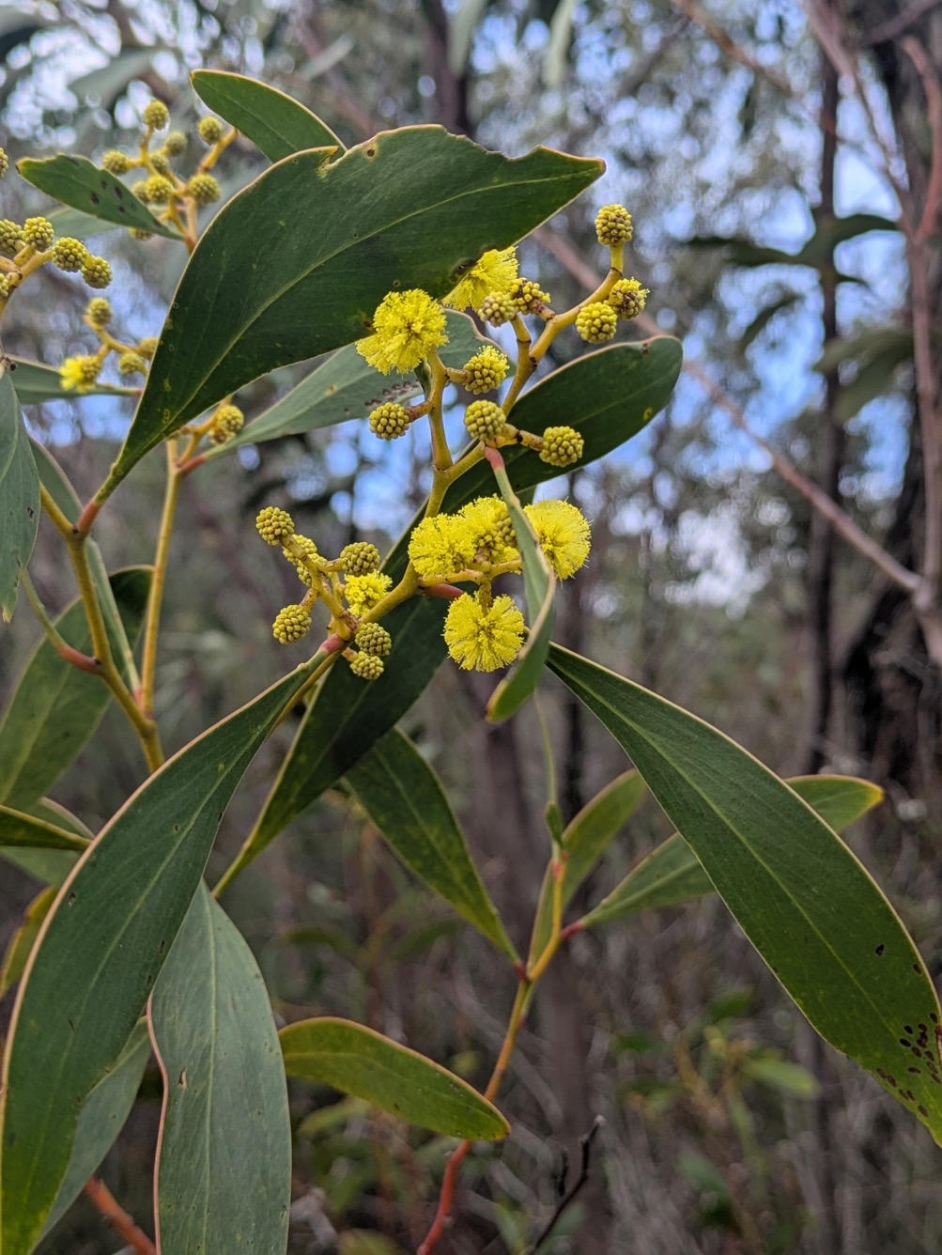

1.0 English language and communication
Many participants, including a high proportion from Pasifika backgrounds, spoke English fluently and had migrated to Australia from English speaking countries such as New Zealand. Others, including a high proportion from Arabic speaking and Afghan backgrounds, had arrived in Australia with little or no English language, often as refugees. A minority of participants, who were university educated and fluent in multiple languages including English, had led transnational lives involving work and study in a range of countries before arriving in Australia. Across interviews, the theme of English language and communication was discussed as a topic that variously shaped women's possibilities and aspirations in Shepparton, both for themselves and the wider community. As shown in Figure 8 below, our survey findings reflected the importance of English language in shaping the potential for migrant women to use their skills and qualifications and pursue their aspirations.
Figure 8. Multiple option survey question: Have any of the following made it difficult for you to pursue your aims or aspirations in Shepparton? (select all that apply)
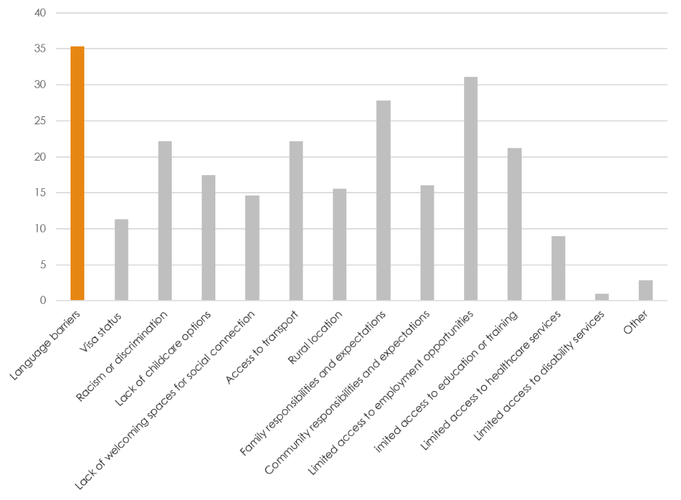
Below, we outline four main ways English language and communication shaped migrant women's experiences.

1.1 English language classes as a point of connection to community
English language classes were discussed by women who had arrived in Shepparton with little English; predominantly women from refugee backgrounds. Classes were often one of the first points of contact they had with the Shepparton community, representing an important meeting place for many migrant women. Speaking about English language classes at TAFE, and (to a lesser extent) at the Shepparton English Language School, many women highlighted social interactions and the formation of new social connections as a valuable outcome of their attendance.
For Maryna from a European background, who did not have access to other support services because of her visa status, TAFE classes had been her main opportunity to interact with others in the Shepparton community when she arrived. The social connection from TAFE was something she missed now that she no longer attended the classes.
Here [in Shepparton], my life [is] work, home, work, Coles, home, that's it.
...When I studied at TAFE, I was even like a [student] representative, something like this. And every month we got meetings and talk about what we can improve for... the students. And it was so great for me. Yeah, it was so interesting.
Maryna had progressed through all available TAFE English classes and gone on to study an Australian certificate and diploma, as well as an international certification, in her professional field, for which she had attained a Master's level qualification prior to migration. However, she still was not confident in her spoken English. She identified that this was preventing her from progressing her professional career and building her social life. Finding no advanced spoken English classes and limited opportunities to converse with native speakers beyond the workplace, she worked hard to maximise incidental opportunities to practise. Maryna saw participating in a research interview as one such opportunity to practise her English.
Even, you know, when I talk with some people and I ask every time, guys, if I say something wrong, just stop me and improve me. ...It's important for me... I need more time for start talking...You know, it's a lot of work of myself. It's psychological. Yeah. It's just hard work.
... even now I can work, I can do paperwork because actually my writing skill [is] more better than my speaking. ... I can do paperwork, risk assessments, everything.
– Maryna, European background
Maryna felt that she needed to develop her professional English in order to attain employment in her field of expertise. For this, access to opportunities for discussion outside of her current workplace was necessary:
I don't feel then I can talk with people in professional language. I need professional language because it's specific. ...In my work, we have just only just small talk about nothing, about the weather... That's it. You know, just use easy words. So I feel I'm regressed now. Yes, it's true. When I was studying, of course, I used a lot of information. I read legislation, acts, everything, a lot of documents...
– Maryna, European background
A desire to learn and develop skills was expressed by all women we interviewed, particularly around English language. Like Maryna, most interviewees discussed English language as a means of connection to community and progression towards their aspirations for a meaningful life in Shepparton, rather than an academic pursuit. In connection with these interview findings, our survey found that the three highest priority needs selected by respondents in multiple choice responses were 'more flexible English language classes' (36.8%), 'more opportunities to practise English in the community' (32.6%), and 'more welcoming spaces for social connection and networking' (33.5%) (Figure 9).
Figure 9. Multiple option survey question: What would make it easier to pursue your aims or aspirations in Shepparton? (select all that apply)
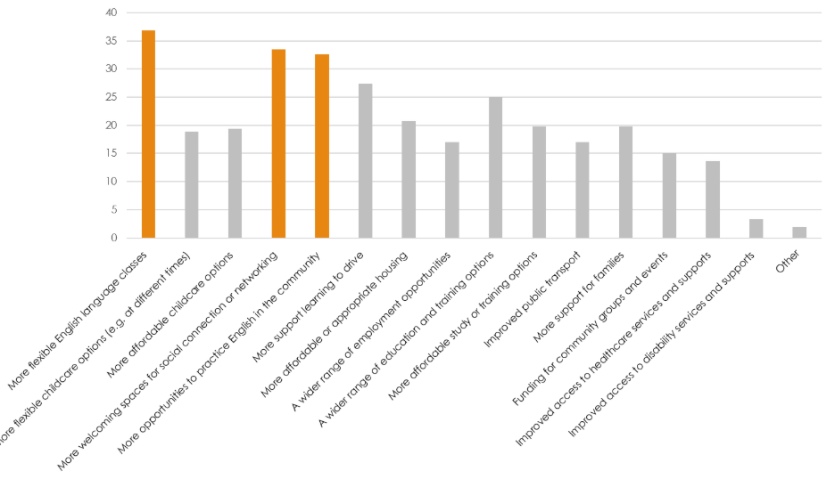

1.2 English language classes: format and content
Other interviewees, particularly those from refugee backgrounds who had previously lacked opportunities for formal education, emphasised their desire around being able to pursue long-held aspirations for study in Australia. However, for many in this group and for others, the format of study at TAFE was inaccessible. Living with caring responsibilities, chronic health issues and pain, many women found themselves unable to access educational opportunities. Aisha, who worked with the Afghan community and other migrants in Shepparton, highlighted this situation:
when I came as a migrant, like my hope was... to study more. And I did not have much opportunity when I was in my country.
[TAFE was]...the whole day from nine to three o'clock sitting in the class. It was fine for me because I was young and I did not have [small] children. … But because I do work with migrants, and many people, they say the whole day sitting in the classes is very hard for them. And on top, Centrelink also pushes them to, you know, go for a study and improve their English. It is a bit hard for them. Sometimes they say, okay, if we have [medical conditions] you know, pain, and we cannot sit the whole day for study. And they should be a little bit flexible, like five days and less hours.
– Aisha, Afghan background
Being required to focus for long periods in class was also challenging for women dealing with ongoing mental health challenges including stress associated with their lives in Shepparton or fear about family members they 'left' behind in situations of war or persecution. Particularly for those with little prior experience of formal education, class structures challenged their potential to meaningfully participate in English language programs.
Fahima, also from an Afghan background, felt that it was her own failing to be a good student that meant she was unable to learn English. This situation undermined her sense of capability, self-belief, and ultimately her ability to aspire as she believed she simply couldn't learn English - the essential skill required to 'do anything' in Shepparton:
My problem is the language. Once I learn the language, I can do anything. I have problem with the language I can’t learn the language.
[Interviewer: are you attending TAFE?]
Yes I am going to GOTAFE. They do put lots of effort, but it is our fault that we are not learning. I am not saying it is the teacher’s fault. I have no problem with them those poor teachers teaching us, but we are the one don’t want to learn if we work hard ourselves, we will learn.
[Interviewer: From your opinion you are not working hard or there is another problem?]
...our memory, due to our mental worries. Two of my daughters have been left in Afghanistan and I am worried about them. These are the problems, for being a mother I have many worries.
– Fahima, Afghan background
Fahima also attributed her slower learning pace to her age (over fifty), however she felt unable to communicate her challenges to the teacher in a class where she was one of only two older women. Invited by a Community Researcher to imagine how she would feel if there was a class for older women, she expressed that she 'might learn quicker there because all of us will be at the same age, we will understand each other’s problems'. Her comments echo the reflections of other older interviewees who described facing specific age-related challenges, particularly technology-related barriers to participating in TAFE and other classes.
Stakeholders also recognised the importance of English language, particularly spoken English, as a crucial first step without which migrants could not progress their lives in Shepparton. The close relationship between English language confidence and proficiency, social connectedness, and access to opportunities was emphasised by many interviewees who worked with community. Many stakeholders also discussed challenges that migrant women can face accessing English language classes, associated with scheduling and transportation (discussed under Family, Care, and Time).
Opportunities for English language learning | A suggestion put forwards by several interviewees– both migrant women and stakeholders– was for the development of English language programs that were more targeted, integrating real-world applications beyond the classroom. For instance, an English language program to support employment might be structured around opportunities for practical application such as writing applications, resumes, and general workplace or even industry specific language and communication. Other areas might include English for navigating the healthcare system, social English, and classes for older women. Such an approach might lessen the burden on learners to develop the skills required to become a ‘good’ academic student and support them to develop the skills required to achieve their employment or career aspirations. Such tailored programs could employ a more flexible approach with reduced class length and a less academic format that supports, rather than challenges, adult learners' ability to manage their own needs.  Flexible social spaces where women could connect with each other and practise speaking English were also highlighted as valuable supports for migrant women’s skills development, confidence, and access to opportunities. Such spaces currently accessed by women included Community Hubs as well as intercultural programs and events such as Culture Kitchen.

1.3 English proficiency and education, training and employment
Survey responses revealed key similarities and differences between respondents who had completed our survey (in English) independently or with translation and interpreting assistance. While there was little overall variation between these groups in overall employment and satisfaction with their employment, differences emerged around study or training undertaken in Australia. Eleven out of fourteen (79%) respondents who completed the survey with language assistance and indicated completing study or training in Australia, identified the purpose of study/ training in Australia as gaining employment. Only sixteen out of 120 (13%) respondents who had completed the survey independently, and indicated completing study or training in Australia, identified employment as their reason for doing so.
Of the 160 respondents who indicated they were not currently employed, over two thirds expressed that they wanted employment, with this proportion even higher among those who completed the survey independently (95%). Interestingly, there was little difference between groups in the proportion of respondents who indicated that 'language barriers' challenged their ability to pursue their aspirations. One possible explanation may be that the term 'language barriers' or 'communication barriers' appeared to be used by migrant women predominantly to describe challenges associated with intercultural communication, racism or a lack of inclusivity, as occurred in some interviews.
Anna, who was born in New Zealand and a native English speaker, described,
I just remember going to school and kind of just sitting there and you're like looking around for someone who looks like you... and having to try find ways to make friends with these people. Like, you know, communication would be different. They wouldn't understand what I was saying. And I guess like understanding their cultural values... so hard to explain... we have different beliefs, what we find important may not be as important for them, and it's ...trying to find like something to bond with them, I guess.
– Anna, Pasifika background

2.0 Skills, qualifications, and employment experiences
Migrant women who participated in this study possessed a wide range of skills, qualifications, and expertise. Interviewees most commonly spoke about skills associated with community building and organising, social skills, language and communication; and skills associated with the 'domestic' sphere such as cooking, cleaning, childcare, and caring for other family members. Many emphasised a love of learning or the value of education for themselves or their children. Interviewees had a wide range of qualifications and work experience, in areas including healthcare, research, education (from early childhood through to university level), financial services, business and organisational/workplace management, writing, leadership, and entrepreneurship. Volunteering was also an important part of participant’s lives and an important arena for the use and development of their skills. For instance, interview and survey participants named volunteering at church (particularly, the Tongan church) as an opportunity to learn and apply skills in music, childcare, cooking, event management, pastoral care or youth work, and social skills.
Survey respondents indicated a diversity of skills, with more common areas including teaching, community organizing, maths, health, food, music and the performing arts. For employed survey respondents, the main areas of employment were healthcare (23%), trades or agriculture/food processing (21%), hospitality and retail (19%), and education and childcare (15%). Free text survey responses identified personal aspirations around education, employment and career pathways in a diversity of areas, including healthcare and community services, science, teaching, and professional sport. Survey respondents (whether completing independently or with assistance) overwhelmingly disagreed with the statement, 'I am satisfied with the amount of money I earn', as over 80% responded 'no'.
As shown in Figure Ten, survey findings support interview findings that access to employment opportunities was a challenge for migrant women, with 31.1% identifying 'limited access to employment opportunities' as a challenge, second only to 'language barriers'. Respondents also indicated that a wider range of education and training or employment options would be helpful. However, this number (17.0%) was comparatively less compared to the percentage that indicated access to employment opportunities was a barrier to achieving their aspirations (31.1%). This discrepancy may reflect that women recognised that it was their own access to opportunities, rather than the range of options in Shepparton, that constrained their lives and careers. This may also be read in conjunction with language barriers and discrimination affecting access to opportunities.

Figure 10. Multiple option survey question: Have any of the following made it difficult for you to pursue your aims or aspirations in Shepparton? (select all that apply)
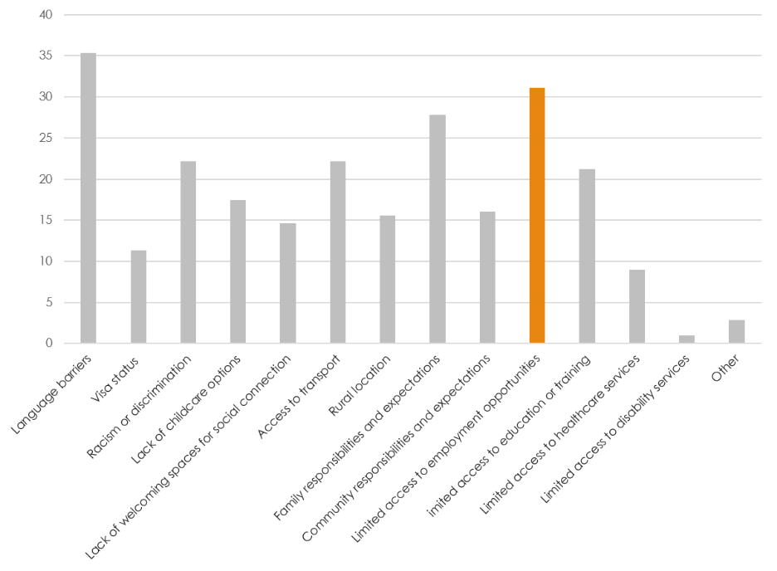
A common theme across interviews was that women faced compounding challenges in attaining recognition for their skills and qualifications, and in converting these into employment or a means of supporting themselves, their families and their aspirations. Importantly, values and aspirations shaped the way that women understood and sought to use their skills and qualifications. For instance, although many women expressed individual aspirations, interviewees generally articulated being motivated by a broader underlying desire to contribute to the development and improved social connectedness of the Shepparton community as a whole. As such, the particular skills, qualifications, and experiences of migrant women should be understood as generally framed and directed by values and aspirations around social connectedness in Shepparton.

2.1 'I don't have skills': What skills are valued, and what are we missing?
Many interviews conducted in Arabic, Hazaragi, and Dari with women from refugee backgrounds began with women expressing a lack of 'useful' skills or a lack of skills altogether, often citing limited formal education. Across these groups, most had not completed secondary schooling. Yet, many participants from refugee backgrounds were skilled community organisers and connectors, event planners, and regularly helped new migrants settle into Shepparton. Others could provide childcare, cook to feed 100 people or more, were (or had been) entrepreneurs, tailors, religious and/or youth group leaders, skilled musicians or dancers. Community Researchers played a crucial role translating our question, 'what skills do you have?', into a question that these women felt able to answer; prompting them to consider skills they regarded as more mundane or 'everyday'. In the process, we learnt that migrant women tended to perceive the question as asking about the kinds of skills named in job advertisements, job-ready programs and classrooms: English language literacy, IT skills, technical expertise or academic subject knowledge. Community Researchers prompted them to consider the skills they used in daily life such as cooking, childcare, bookkeeping, interpreting or translation. Other skills, particularly those associated with the domestic sphere and traditionally feminised areas of labour (including emotional and social labour), were often overlooked as just the skills that 'everyone' had. These insights shaped our survey design, which explicitly asked respondents about their involvement with migrant communities and the Shepparton community more broadly.
We found that, of all survey respondents:
- 38.6% had ‘helped lead a network, an organisation or community group or to organise community events’ in Shepparton
- 36.3% had ‘volunteered in Shepparton’
- 32.1% had ‘helped other migrants settle into Shepparton’
The plethora of Shepparton-based initiatives and networks led or co-facilitated by migrant women such as The Migrant Women's Doorbells Network, Point of Difference Studio, Culture Kitchen, Wise Well Women, ethno-culturally specific or faith-based groups, is illustrative of the strong role that migrant women play weaving and strengthening the social fabric of Shepparton. This role was emphasised by stakeholders working with migrant women, who understood the success of multiculturalism in Shepparton to hinge, in no small part, on the work (both paid and unpaid) of migrant women in building and maintaining vital connections between communities, services, and institutions.

2.2 Essential but unrecognised: Intercultural communication, translation and interpreting
Many interviewees described undertaking essential interpreting and translation work for their families and linguistic communities. This work was informal, unpaid and often unrecognised by interviewees themselves until prompted by Community Researchers. A lack of formal interpreting services in Shepparton meant that women with strong English skills felt they had little choice but to perform this work.
Anna and Nepo described a need for more interpreting services and intercultural communication support in places such as Centrelink and healthcare services, which can be experienced as stressful settings for migrant women and families even without accounting for language barriers:
...some [parents] drag along their sons or their daughters to translate because they can't understand. Let's use Centrelink as an example. ...there'd be times where I'm sitting in there and they're struggling to understand each other and it's such an important thing for that family to have those finances to help but... the son's not old enough to understand to translate and in good sense... People don't have translators, I feel like that's such an important thing especially for Shepparton ...there's so many different ethnic groups here that not having translators in such an important workplace, they fall short on it and it really doesn't help the community at all. – Anna, Pasifika background
So there are lots of other [migrant] women who have been working here for a long time, but due to the language barrier and due to the cultural barrier and due to the religious barrier, are feeling isolated. And even in the hospital, if they go to the hospital, they can't explain how they are feeling and how they have been suffering. They are even scared to express themselves. And they feel nervous. They haven't built the confidence. – Nepo, Southeast Asian background
Interviewees like Nepo and Anna clearly articulated the harm caused and the opportunities missed as a result of inadequate interpreting services in Shepparton. These impacts extended to migrant women's physical and mental health, access to financial support, and other essential supports that women and their families required in order to live, let alone aspire.
Further, the project Advisory Group, migrant women, and other stakeholders also discussed a lack of recognition, support, or compensation for informal interpreting work as an issue thatnegatively impacted migrant women's lives and careers in Shepparton. Stakeholders emphasised that following COVID-19 pandemic and 2022 Goulburn Valley floods, it has become increasingly clear that the work of community interpreters and translators is essential for the safety and wellbeing of regional communities and contributes to community development.

2.3 'Career drainage': Recognition of prior qualifications and experience
When I first came, I had a [Master’s] degree in economics, but it was hard to get a job in economics, I think, I found, because sometimes they don't recognise the degree when we do it from another country. Yeah, so we need to do more studying, extra studying, or I have to change my subject. – Sarah (migrant background) stakeholder, health services
Women with prior experience and qualifications often struggled to find work in their field due to a lack of recognition of their skills, qualifications and knowledge. This occurred at both institutional or structural levels (state, national, and institutional policies) as well as at the interpersonal or community level. This report focuses predominantly on the latter level of recognition, in connection with its community-based research approach and focus on local solutions.
Nepo, who held a Master's level qualification, had lived in Shepparton for over six years and was involved in formal and informal migrant women's community groups alongside her paid work. She explained how non-local experience was not valued by local employers. In her experience, it was not a lack of jobs, but a lack of recognition, that prevented migrant women from getting work in their field and left them 'feeling drained'. She pointed towards the negative impacts of 'career drainage' on migrant women's career pathways, life trajectories and overall wellbeing:
If I applied for any job, they say you don't have local experience and we can't value, we don't value your international experience. Doesn't matter, you have a Master's degree or PhD degree, but you don't have local experience. So... if I don't get that job, then how do I show my local experience?
And some [migrant women] they... haven't got a chance to utilize their expertise, and they have nearly 15 years’ experience [for instance] in every part of the banking sector like loan department like credit department like customer service department, so many... but they haven't got a chance to utilize their own experiences here and some of them are working in a cleaning job, some of them are working in a cafe job, which is a completely different world.
...they can't go back to [the country they left] because it's already eight, nine years they spend in Australia and it's difficult for them to go back and again start their career from the beginning...
– Nepo, Southeast Asian background
Nepo described 'career drainage' experienced by migrant women, where they 'felt drained' and 'lost' time (years), financial resources, emotional investment and energy as their hard-earned careers leaked away through gaps in recognition in Australia for their prior skills, qualifications, and experience. More than a drain on individual careers and families, this drain affects entire sectors of employment and the wider Shepparton community which misses significant opportunities to benefit from the (sometimes highly specialised or advanced) skills, careers, and participation of migrant women.

2.4 The crucial link between social connectedness, confidence, skills and aspirations
How women spoke during research interviews, as well as what they said, provided critical information for interpreting the data. Interviewees often spoke most confidently about their skills when they described times these skills had been valued by others in the community, and when their skills were linked to strong and supportive social relationships. This was particularly the case for women who saw themselves as having strong social and communication skills in areas such as service delivery, education, leadership and management. Stakeholders, particularly those from migrant backgrounds, emphasised the importance of social connection to address isolation and support migrant women’s confidence. They understood this as an essential starting point without which migrant women could not access opportunities for learning, employment, or broader social participation, as well as forming and pursuing aspirations.
Our survey data also highlighted the importance of social connectedness as a necessary condition to support migrant women’s aspirations. Asked, 'what is a hope or aspiration you have for the Shepparton community?' free text responses overwhelmingly identified social connectedness and inclusion as the most common aspiration, with over 44% of answers using phrases like, 'having space to gather', 'feeling welcome', 'communicating with others', 'friendly', and 'inclusive'. This can be read in tandem with the survey findings around a need for spaces to practise English in the community, and more welcoming spaces to gather. A number of survey respondents and interviewees specifically suggested that more Community Hubs, or more places like Community Hubs, would be helpful.
The importance of relationships and connections with people with shared cultural backgrounds and different backgrounds was also illustrated in the interview data. Nepo was one of many interviewees who highlighted how social connection and connection to culture could support migrant women's sense of confidence and self-efficacy:
I feel as long as we are rooted in our own background, we will be a more and more confident and more strong version [of ourselves] to introduce ourselves in a community. So, as a migrant woman, as an active community member in the Migrant Women's Network, I feel I can contribute bit different. So those who are especially coming from [my country] they will get more connected and more empowered and get more enabled from each other. So they will not feel isolated. This research will be a fantastic chance to advocate what is better... equitable and inclusive. – Nepo, Southeast Asian background
‘Door openers’:  a crucial  role | Some migrant women who had built careers in professional roles described the crucial role played by one or two key individuals (often non-migrants) who were willing to give them a chance. They recognised that such decisions had involved a conscious effort, or 'risk', associated with going against the grain of workplace and broader social cultures favouring 'local experience' and biases against racialised groups (e.g. people from Pasifika or black African backgrounds).
Jane, who had completed secondary school prior to coming to Australia over ten years ago, started her career in Shepparton in a reception role and had 'worked [her] way up' to managerial roles. She recounted the vital role a key mentor— importantly, also a woman—had played in her skills development and career trajectory by supporting her to take a managerial role:
I had to work harder than everyone else because with the, you know, firstly, I didn't have the qualification. Secondly, I think there were times when they look at me as my colour. And if I'm going to be bold, I will probably say sometimes they did consider the fact that I have a lot of children... there was no working from home at that time so things like that...
Where my breakthrough came was, I had [a new leader in my workplace and] ...she literally, I feel, opened the door for me, made me realize that I do have what it takes and I don't need a piece of paper to do the job. ... it had to be a woman, too. She came along, and she believed in me, and she gave me the opportunity.
... I applied for a manager role. And she interviewed me and interviewed a whole lot of other people, obviously. And then I just thought, I will have no chance ...But I remember when she called[and]... she told me, she's going to offer me the role because my vision that I see for the team aligns with hers. However, she did say, 'I'm going to have to work with you very closely. Because I can't just throw you in there.' And ...she did work with me very closely... like when she gave me directions, she would not only just tell me what to do, but she would provide me a template. [she would say] 'you need to watch this. You know, you need to listen to this podcast. You need to read this book.'... So [she was] also a mentor at the same time... – Jane, Pasifika background
Sarah, who had studied at university prior to and following her migration to Australia, worked in professional and voluntary roles with women in the local community, including women from migrant backgrounds. She saw an opportunity for ‘more internship programs’ in Shepparton, that could support women to build practical work experience skills, professional and social networks alongside technical or academic expertise. Rather than having an internship as the final part of a tertiary qualification, she suggested integrating workplace exposure and on-the-job learning from an earlier stage to support women to develop professional communication and other employable skills, and to develop social networks that could bridge study and employment. Like most interviewees, she linked social connectedness and real-world learning to women's improved wellbeing and improved life and career pathways. While some past and ongoing initiatives in the region have sought to make internship or work experience style opportunities available to migrants, these have generally been offered as part of employment programs rather than in connection with training and education institutions.

3.0 Family, care, and time
Most participants lived with family, including parters and children or parents and siblings, and sometimes other family members. Life stage and family formation powerfully shaped the way migrant women thought about their aspirations and priorities, with different freedoms and constraints associated with younger and older ages. Survey findings showed that 27.8% of respondents identified 'family responsibilities and expectations' as something that had 'made it difficult to pursue [their] aspirations in Shepparton' (Figure 11)
Figure 11. Have any of the following made it difficult for you to pursue your aims or aspirations in Shepparton? (select all that apply)
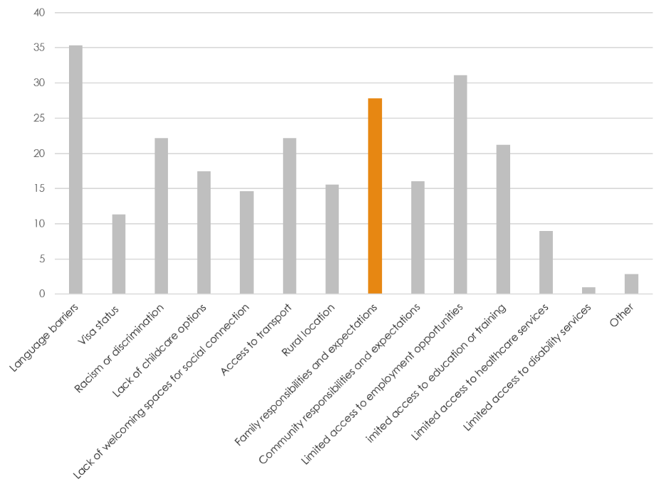
Of the survey respondents who had children, most had multiple children, with four or five being relatively common. In interviews with service providers and migrant women, women's caring responsibilities were often raised in relation to financial strain, access to education opportunities, and childcare. Family was also discussed in terms of gendered expectations. These were negotiated in families and communities, and for some women, these expectations were connected to constrained possibilities for independent movement around town and associated access to opportunities and supports.

3.1 Caring and scheduling
Caring responsibilities were frequently identified by interviewees as the main reason they could not attend classes or take up employment. For instance, Kifah, from an Arabic speaking background, explained that she was unable to attend a class because it finished at school time, and she had to pick up her children from two separate schools. She asked if she could leave class one hour early, however this was not allowed and as a result she could not participate in the course. Kifah's story suggests that survey findings around a need for flexible English classes might be connected to women's caring responsibilities.
Our survey findings show that more flexible childcare, more affordable childcare, and more support for families were each selected by approximately 20% of respondents as changes that would make it easier to pursue their aspirations in Shepparton (Figure 12).
Figure 12. Multiple option survey question: What would make it easier to pursue your aims or aspirations in Shepparton? (select all that apply)

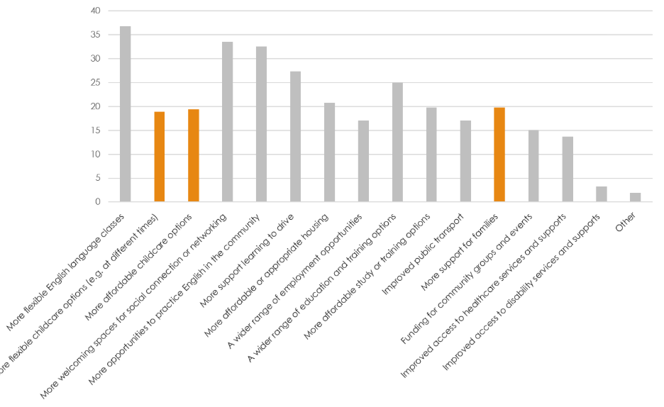
Both interview and survey findings indicated that women saw a need for more flexible spaces for social connection where women could bring their children. As Aisha highlighted,
I work with the community and I heard from them ... if we could have, you know, a bit more community activities... community hub, we can say... Many people, you know, can go [there] flexible with their kids and they do something instead of isolating their self at home.

3.2 Childcare
Interviewees expressed a range of views relating to childcare. Some, such as Aisha, saw childcare as an appropriate, though largely inaccessible solution to migrant women's challenges accessing education, training and employment opportunities.
They have children... there is not much support to go and learn [English]..like we have TAFE but I think it's not enough... we need more childcare workers – Aisha, Afghan background, service provider, community worker.
While some interviewees articulated that lower cost or free childcare, offered at a wider range of times, would make much-needed childcare accessible for families, many did not appear to consider childcare as an option. Several, such as Leka, explicitly expressed a preference to care for their children themselves.
At this point in time, I have lots of kids. Nearly four to five years I have not been able to work because of the kids... I am looking right now to use the skill from school– cooking– to try to use to get some money to help the family. ... I have not looked at [childcare]. In my own thoughts, I do not trust them [childcare providers]... [My children] are my blessings given to me to look after them. ... I will try to look for available time to do some work [working around caring responsibilities] to help my family. – Leka, Pasifika background, housewife
For some interviewees, these values and beliefs were also shaped, in part, by their own skills, qualifications and experience as Early Childhood Educators.
Thinking about childcare solutions | These findings indicate that choice and flexibility must be central to solutions that can successfully support migrant women to balance caring responsibilities with their needs and aspirations. They also highlight an opportunity for migrant women to contribute to solutions in the area of childcare in Shepparton. Indeed, one way that migrant women sought to increase their access to opportunities and manage their burden of care was by working together with others in the Shepparton community. Approximately one third of survey respondents had provided support to other family members or community members with childcare or transportation, and some interviewees spoke about providing childcare for friends. One University and TAFE qualified interviewee ran a successful childcare service from her home, which was used by several families, including those sharing her linguistic background.

3.3 Younger women
For younger women, who often lived with parents and siblings, different responsibilities and expectations shaped their experiences. Financial conditions and cultural expectations influenced many women to live with family into their twenties and thirties. Consequently, the importance of social spaces for young migrant women, beyond home, education and work, was emphasised by many with a diversity of backgrounds and experiences. Community leaders and service providers emphasised that such spaces could be connected to supports such as careers advice. Those working with young women also highlighted a need for careers advice that was culturally informed, to avoid problems such as students being encouraged into nursing pathways without awareness that requirements to treat male patients during placement may create barriers for young women from some communities. Further, some participants in this project identified a need for women-only student accommodation. Such suggestions illustrate a need for culturally informed infrastructure to support young women’s education and career development.

3.4 'Not for myself': Caring and aspiring for others
For many women involved in this research, individual aspirations were not a topic they had previously discussed or even thought much about in Shepparton. This finding emerged particularly from interviews with women from refugee backgrounds. For many of these women, the safety of their family, particularly children, and access to opportunities including education for their children, were the aspirations that motivated their migration. They described focussing on caring for family and ensuring their children's access to opportunities in Shepparton, and sometimes spoke about keeping their own aspirations to more modest goals such as improving their English.
Women who were mothers spoke about their own pursuits and aspirations, such as study or training, hobbies, and employment, as squeezed between non-negotiable caring responsibilities for family. These responsibilities frequently structured their time, their movements, and their physical and emotional capacity for other activities. As such, the starting point for their aspirations and access to opportunities was often their available time, even before financial considerations came into play (we also saw this with Kifah's classes, above). Tiva, from a Pasifika background, articulated how care for her children was her first priority; employment opportunities had to come second. Like many interviewees, Tiva understood opportunities as available or not available to her based on the time of day they occurred.
No matter what I do, I have to pace all my stuff according to my kids, around my family. I don't want my kids to get troubled and things like that. I'll do everything for them. So when I go, so when I go to work, I make sure that I am like, I am not just like giving my child to anyone. So they asked me [to teach]... but that doesn't work because he said 11, and I got a child at home. ...And it's like, I would love to, but is my child okay.
My child will grow up. So that's the reason why I... So that's the reason why I'm trying to study while I am home with her. ...When she sleeps at night, I have time to do study things. And that's why I was juggling around try to find something to do at this time. – Tiva, Pasifika background
Other women who were mothers expressed appreciation for the interview setting where they were supported to think about their own aspirations. Several described interviews with Community Researchers as a happy 'first time' they had been able to tell someone about their feelings and desires for their lives in Shepparton. Aspirations they expressed often related to social connectedness and helping others in specific cultural communities and the broader Shepparton community, particularly supporting younger generations to live well. Passing on specific skills, such as dance, sewing, and language to younger generations was sometimes discussed by interviewees. Even more strongly conveyed was women's desire to share their values and way of life with the Shepparton community as a whole, and to offer socio-emotional support, guidance, and mutual connection to others– not just migrants but women and girls more generally. Younger interviewees generally articulated clearer aspirations for themselves, which often related to tertiary education or training and social connection.
These findings were reflected in our survey, where about 30% of respondents to the question, 'what is a hope or aspiration you have for yourself' answered with a hope or aspiration for others, such as their children or the community. A distinction can be made between younger respondents (aged 16-25 years) and older respondents (26+), for whom the percentage of aspirations expressed for others was approximately 10% and 40% respectively.

4.0 Financial situation
Migrant women's financial situation shaped what was possible for them, and what they could imagine being possible for them into the future. As discussed above, women often put the needs and aspirations of family before other aspirations, including their own dreams for helping the Shepparton community. Study was a key area where financial stress limited what was possible for migrant women seeking to build their skills and knowledge. For those who sought to employ their existing skills and qualifications, financial challenges associated with starting a business or social enterprise were a key barrier.

4.1 Supporting family here and there
A diversity of participants mentioned their financial situation as a barrier to aspirations. This was frequently discussed in relation to caring responsibilities which limited women's capacity to access employment opportunities while also demanding financial and material resources, often for large families.
Parvana described growing up in a large family, struggling to get by on Centrelink, and taking work to help support her family as soon as she finished school. Her experience was also shaped by gendered expectations and ideals in her family about work.
I've had a lot of financial crises happen through my life. For example, as soon as I finished school, I decided to work and study. And I did that. Dad didn't let us work... in a restaurant while he was studying [at that time], he was kind of like ashamed for us to [have to] work. And surviving on Centrelink payment was hard. I didn't have a phone until [after] I worked one year, then the second year after finishing school, I was able to buy just a phone to be able to get into my job. I worked at four different jobs... getting by walking from one place to another place. ...So financially, we did struggle. – Parvana, Afghan background
Financial challenges were identified particularly by Pasifika interviewees. Discussion and collaborative analysis with Community Researchers led to the explanation that this difference can be associated with responsibilities or expectations that Pasifika women send money to family in countries of origin (e.g. parents). Although expectations around remittances affect a diversity of migrant communities, Community Researchers understood these expectations as particularly prevalent for Pasifika communities, for whom opportunities to earn more in Australia, and use earnings to support families in countries of origin, could be a motivation to migrate.
At the same time, interviewees from Pasifika backgrounds were among those who expressed a strong desire to contribute to the sociocultural development of the Shepparton community. Indeed, like many migrant women, their aspirations were often driven, not by a desire for capitalistic accumulation but instead to help the community as a whole. Here, an income was not the aim of their aspirations but a necessary condition for them to do the community work they wanted to do. Tiva explained her values around collective living and aspiration as different to values in Australia, using humour in an example about cultural expectations around sharing food:
I had to adapt to this kind of lifestyle. You don't just show up to someone else[‘s house]... give something [food] to someone that you don't know because they was like, ‘who are you? Trying to poison me or something?’ , you know, things like that [laughing]. But where I grew up, it's all about sharing, helping each other, and try to lift up together. Anyone, you know, if you see someone needs help, if you see, if I need help, I just ask, you know. And if I have a lot, I share it. To everybody, not just like this is mine and this is mine. ...Like in our neighbours, after my Mum and my Dad cooked the food they put it in a bowl and said, okay, take it to this neighbour, take it to that neighbour. And then we only cook one food. And by the time we eat, it's like three, four different meals because it's a bowl from this family, a bowl from that family. And that makes a big meal for the whole family. You know, that's what I missed. – Tiva, Pasifika background
Tiva's example might also be considered as a metaphor for resource sharing more generally, reflecting Pasifika values around what it means to live well in community.

4.2 Whose aspirations?
A barrier to aspirations that affected women from a diversity of backgrounds was the financial costs associated with study. This included women with existing qualifications and experience who had little choice but to undertake additional study in Australia to attain qualifications that would be recognised by local employers. Some women spoke about the way financial support in Australia was not enough to support their children’s and their own study, even though their own study would ultimately reduce their need for financial support in the long term.
I want to do a Bachelor of Education because I want to teach at the primary schools. [but] I can't afford it.
Like if there's any help… an organization that says you know, we can help you pay this and pay that and once you get qualified and started teaching... Because having kids and work the same time and try to achieve something for that is, it's really hard. ... Because that's a lot of us that wanted to continue, like wanted to continue to study, to study and know and get more, like get more qualifications so that we can improve ourselves and then challenge ourselves. ... I don't want to see my kids going the same path
–Tiva, Pasifika background
Younger women appreciated the sacrifices their parents had made and the financial pressure they had dealt with in order to see their children access educational opportunities that had not been possible for them. However, for those whose visa status restricted their access to student loans, financial strain continued, as Ada explained:
We don't have the benefits of student loans and other benefits that Australians get, which makes sense, but at the same time it would be nice if we did. And which has put more pressure for myself, my parents. And it's been a challenge to work and study, being a full-time student. – Ada, European background

4.3 Financial situation and access to opportunities
Many interviewees, particularly those working with the community, described a need for free or more affordable services including childcare, learner driver support, and targeted English language or training and education programs.
[it would help migrant women] if they can provide free driving lessons, because driving lessons are really costly. [Migrants face] financial constraint [when they arrive as they] are not working. ... free English learning skills or something, computer skills... and childcare —Sarah, (migrant background) stakeholder, health services
Such needs were sometimes described alongside a need for more affordable or appropriate housing and transportation as necessary material conditions to support migrant women's pursuits. Survey findings reflected a need for more affordable services, education and training opportunities, and housing, as 20% of respondents indicated a need for each: 1) 'more affordable childcare options'; 2) 'more affordable or appropriate housing' and 3) 'more affordable study or training options' (Figure 13).
Figure 13. Multiple option survey question: What would make it easier to pursue your aims or aspirations in Shepparton? (select all that apply)
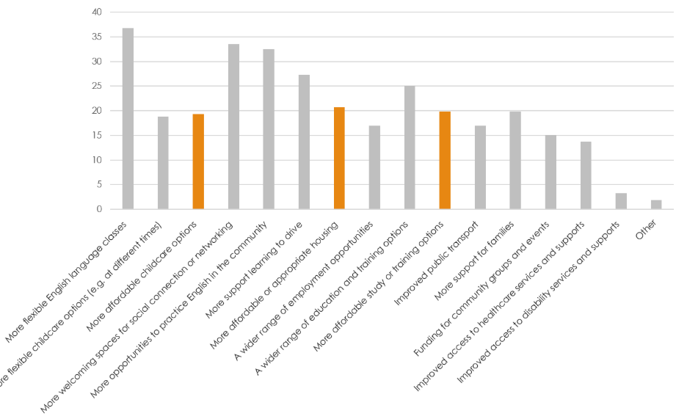
At the same time, many women provided free services and support to the Shepparton community through unpaid interpreting work for individuals, services and institutions; providing settlement support; childcare; cultural and religious leadership and education; and organising (intercultural) events. Some stakeholders reflected on how migrant women's work was not valued enough by local decision makers and institutions, particularly around interpreting and cultural load where women were frequently expected to perform unpaid work:
... problem I've seen is the expectation that the women will provide services or support or whatever, but not get paid for it, which is a real trap. And it's the same with the Aboriginal and Torres Strait Islander community that people expect a lot from them, but it's not that paid support. So there's lots of different occasions where, and I've overheard conversation, I will get someone from Wise Well Women to come along and either do the interpreting or da da da. But [they] never think about incorporating payment... I just think that's... not sustainable and you just can't use the women up like that. They're very skilled at what they do. Their knowledge and skills should be valued more than that. – Carmen, (non-migrant) stakeholder, education and training

5.3 'Being a door-opener': Skills rich, resource poor
Many women we interviewed had a wealth of skills and experience in specialised areas including sewing, tailoring and crafts, business skills, leadership, the performing arts, health, theology, youth work, childcare and education. Their areas of expertise were appropriate for entrepreneurial practice, and many interviewees expressed a desire to start a small business or nonprofit enterprise. However, while they had the skills, they lacked the funds to get their enterprise off the ground.
Many of the 'dreams' women expressed were driven by values of social connection and inclusion, and a desire to strengthen the Shepparton community. For instance, Moon, from an Arabic speaking background, wished to start a holistic school, where in '[her] dream, the school would be everything like cooking, language, training, wellbeing training, everything.'
Heilala, from a Pasifika background, wished to start a nonprofit as a source of cultural connection and support for the Pasifika community in Shepparton.
[I am] struggling to find a [space] where I can teach and pass on the skills... I could teach our dance, teach our language, or even if it's just through songs or through reading, but to preserve that. But I can't do it because I need funding to run it, to find a space. To find materials to, you know, to run something, there are things that you need to pay for to get things going.
[Interviewer: Does this aspiration feel possible? Why or not?]
Yes, it feels very possible because I have the skills. ...I'm sitting here with the skills, but I don't have the funds...
I did a diploma in [humanities area]. And then I did other courses in New Zealand... various certificates relating to accounting... And then [in Australia] so many small courses to upgrade [my] skills... what's in my heart [is], helping people make lives better... being able to be a door opener for people to make life easier for them... part of it as well is building the bridge for the next generation and hopefully, they'll do better and there will be better opportunities for them. – Heilala, Pasifika background

5.0 Rural geographies of opportunity
Interview and survey findings reflected challenges particular to regional areas in Australia, such as limited resources and opportunities, and difficulties connected to distance and transportation. Indeed, driving and transportation was a key issue frequently raised as one of the first opportunity barriers faced by migrant women, sometimes before even language barriers. Limited availability of more 'culturally specific' foods, goods and services was also an issue affecting some women. Limited education options, and to a lesser extent, employment options, were generally understood as a feature of life in Shepparton for women and their family members, particularly those with specialised qualifications or aspirations for tertiary study.
Survey findings reflected these views as 25% of respondents identified that 'a wider range of education and training options' was needed to support their aspirations, and 27.4% selected 'more support learning to drive' (Figure 14).
Figure 14. Multiple option survey question: What would make it easier to pursue your aims or aspirations in Shepparton? (select all that apply)
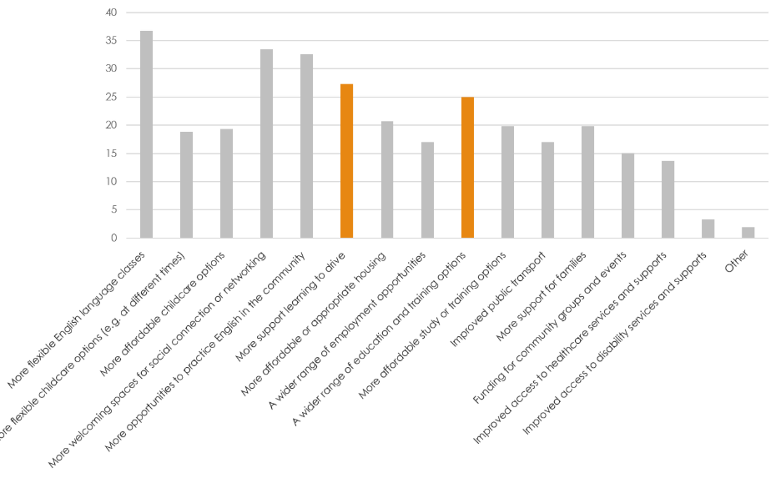

5.1 Distance and transportation
Public transport was generally not regarded as a viable means of transport by women in this study, particularly those with small children. Parvana described:
The problem in here: the buses, you wait 45 minutes. It's better to walk rather than to actually wait for a bus. – Parvana, Afghan background.
Learning to drive and obtaining an Australian driver’s licence was, therefore, a priority for migrant women when they came to Shepparton, particularly those from refugee backgrounds who may not have had prior opportunities to learn driving. Indeed, Malak, who aspired to be a nurse or interpreter, named driving as her goal even before her 'first' goal of learning English. This may have reflected how she had to be able to physically get to English classes for them to be an option.
Currently, my goal is to learn driving lessons and the first thing is the [English] language. Next, something I love.
... for a year and a half I have wanted to train to get a driver's licence. I tried to register at an office and they haven't contacted me for four months. If I give money to someone who wants to train me, I will put myself in a pressured situation because... I do not have enough money to enrol in driving courses and things like that. — Malak, Arabic speaking background.
Learning to drive was challenging or beyond reach for many women, due to the financial resources and time required. Navigating the systems associated with driver’s licenses and tests was also a challenge. Additionally, for women like Bakht living with health issues and/or disability such as back pain and vision impairment, driving was even less attainable. Furthermore, even when women could successfully learn to drive, they sometimes lacked access to a car as their partner or husband took the car to work each day.
Kifah, from the Arabic speaking community in Shepparton, described having to walk everywhere before she learnt to drive. She recounted being 'isolated' and stranded at home with her children who she was unable to take to childcare because her husband left with the car at six in the morning, not returning until the evening.
Physical mobility, and particularly, access to a car and driver’s licence, was thus associated with freedom, independence, and access to opportunities. Local bus services were seen as unsafe ('no one' uses them except those with no choice) and impractical (due to their infrequency and unsuitability for women with small children). Thus, access to place-based services and support, including healthcare and mental health services, as well as other services and supports (for instance, parenting support, women's health including domestic or family violence support) was understood to hinge on women's access to independent transport in the form of a car. Community Researchers and migrant women working with the community also explained how family expectations that women stay home with children could limit independent travel for some women.

Limited options
Like access to funding or English classes, access to relevant education or training and material resources were vital building blocks without which women could not progress towards their aspirations. Many women looked to Melbourne for the resources or opportunities they could not find in Shepparton, with some seeking to relocate in pursuit of educational opportunities for their children, or educational or employment opportunities for themselves. Others sought a way to bring the resources or opportunities they required to Shepparton, however it was often challenging to know 'where to find' support or assistance in their endeavours, which frequently aimed to supplement existing migrant or multicultural services and programs.
There's not that many opportunities that open for us migrant people who moved to regional areas. Like there will be more in Melbourne, but here it's not a lot. ... Sometimes they run the class during daytime [but] people are working. ...there are no night classes. In New Zealand you have night classes in high schools ...But here I don't see anything like that is available for us who are mature that we can attend and learn. – Heilala, Pasifika background
I have skills in handicraft. I love handicraft. I can’t really use it here as the materials to create things are not all available here. If shown any pattern to create things, I can do it – Asinate, Pasifika background
When asked, ‘do you plan to move away from Shepparton in the future?’, most survey respondents (almost 60%) indicated they were not sure if they would move away from Shepparton in the future. For the 10% who indicated they planned to move away from Shepparton, reasons for moving included access to educational opportunities for themselves or their children, career opportunities, or to be closer to family and friends.

6.0 Structural considerations and inequities
Structural factors that affected what opportunities were available to migrant women to use their skills and qualifications, or pursue aspirations included visa status, racism or discrimination, intersecting and gender-based inequities. Many migrant women and stakeholders emphasised the need to strengthen and develop advocacy skills and awareness about racism and discrimination in the Shepparton community. This was linked to women’s efforts and aspirations to build connection and understanding across the community.

6.1 Visa status
Most of the participants in this study had permanent residency or citizenship status. This can be largely explained by the migration pathways of the three main participant groups. Participants from Afghan and Arabic speaking backgrounds generally came on humanitarian visas with permanent residency status, and many from Pasifika backgrounds came with New Zealand citizenship or family status. It is also possible that women experiencing fear and uncertainty around visa status, and women without a valid visa, would have been less willing to be interviewed about their experiences due to concern their participation may affect their employment, safety, or ability to stay in Australia.
Nonetheless, some participants on temporary or precarious visas such as bridging visas shared their experiences. For Rose, who had been on work and PALM visas and had a bridging visa at the time of interview, her visa precluded many opportunities. Her notably short interview involved her explaining that she could not use her skills due to her visa status, and her aspiration was to get a visa that allowed her to progress her life in Australia. With little power over her situation, she placed her faith in God to help her with her dream:
The dream I have is to get my visa for work so I can move on and be able to work to help my family, to bring them here to get better opportunities. – Rose, Pasifika background
Other participants spoke about the toll that past visa processes had taken on their mental health and quality of life and took the opportunity of participating in this research to advocate for migrant women continuing to experience visa uncertainty. Some who were themselves in precarious visa situations also wished to advocate for others in similar circumstances, such as Pat, who had come to Australia on a tourist visa on the advice of her former partner:
So, for me at the moment, I've got work rights and I've got my study rights. So what I'm doing is every year I'm trying to utilise these rights while I still have it and give back for myself and also for the community... I want to serve because my heart is always for the community. — Pat, Southeast Asian background
She explained how her own and her children's opportunities were constrained by their visas:
[Our] visa that we're on does not allow our children to go to university... despite their capacity. ...That's a basic human right that is being deprived of us. ...And [my son] when he was [in secondary school], he wanted to do some casual position, just some part-time income, and he was declined that position because of his visa [even though] the visa says you have full study and work rights.
...anything can happen to us. There's no communication beforehand… I will have to have a backup plan. And I'm here alone with my two kids... And I've supported people in the community who have lost their work rights overnight. They get one email and say, we've refused your visa, and so no work rights, no study rights…
— Pat, Southeast Asian background
Pat's efforts to support other migrants in vulnerable situations reflect the values of mutual support, collective aspiration, and social connection expressed by other participants from Pasifika, Afghan, Arabic speaking, and other backgrounds across many areas of life and aspiration.

6.2 Intersecting racism and gender-based discrimination experienced by migrant women
Some participants spoke about racism or ‘racial profiling’ in interviews, where employers, real estate agents, or service providers discriminated against them based on racialised prejudice. Others described a more generalised feeling of being stared at or ignored, made to feel unwelcome, or refused service. Such alienating experiences negatively impacted women's mental health and drained their mental and emotional resources and their time.
We would be shown only the dilapidated houses… Until we asked, oh, why are we just being shown [these ones]? …So if you do not stand up for yourself, you are always sidelined …for being an immigrant. – Zoe, African and international background
Sometimes, discriminatory or even hostile treatment at work led them to leave their jobs.
[A co-worker] was like... pushing, pushing. ...rushing me.... And then I heard some other people [experienced] that same thing. They said that's why a lot of girls always quit, they didn't want to work in that place because of the way she treated people. ...From that time, I struggled.... then I went to talk to the manager and then she said, okay, we will talk to her. And then after that, things never changed. And then I found out it was her [relative]. – Tasi, Pasifika background
The manager [at work] gave me good treatment, but the staff who worked with me, I felt like I was strange, sticking out between them. I felt ignored. And they looked differently at me, not friendly. I didn't like the way they looked at me. That's why I left the job. – Kifah, Arabic speaking background
English language and communication was another area where racism and discrimination was experienced. For instance, in the context of employment, women who spoke English fluently or as a first language were sometimes told that they were difficult to understand and even denied work on this basis. Some women described others expressing disbelief at their English language skills and English-medium qualifications. Zoe, a qualified health professional who had been fluent in English since kindergarten, described such an experience:
I had one person ask me, 'are you a [health professional]?' I said, 'yes, I am.' And she said, 'are you qualified? Did you learn it in English? Did you do the degree in English?' – Zoe, African and international background
Survey responses reinforced these findings around a need for more welcoming and inclusive spaces in Shepparton. While only 25% of survey respondents indicated that 'racism or discrimination' had 'made it difficult to pursue [their] aims and aspirations in Shepparton', insights from Community Researchers and stakeholders tell us that many women in Shepparton are hesitant to name racism for fear of social sanctions or stigma associated with doing so. It is also telling that in the majority of interviews, women did not mention racism until asked if this was something that affected them. At this point, participants typically acknowledged racism in Shepparton towards other migrants from similar and different backgrounds (often with anecdotes), with some sharing personal experiences of interpersonal or structural racism. Some emphasised the racism faced by First Nations people in Shepparton as something that troubled them. Importantly, racism was variously experienced in intersection with gender-based inequities.
Healthcare settings were a site of compounding discrimination for migrant women. Rosemary, from a Pasifika background, described being asked to pay over ten thousand dollars at the hospital, in advance, for her medical care during her pregnancy and birth. She decided not to return to the hospital until she was in labour. Fortunately, however, a trusted family member intervened and helped her access support from a service that advised her she should not have to pay in advance. She was then able to receive the care she needed.
Maree, who described herself as 'white', provided several examples of how she saw discrimination occur as migrant women, particularly hijabi women, were frequently ignored or dismissed by employers and service providers. She recounted observing discrimination in her role in community services and in day-to-day life in public spaces such as reception areas of local institutions and services. In one such location, she
[I] observed white young men being responded to [at the front desk] with support and… understanding. And then I noted young men of colour, or young men that I presume have come from a diverse background, and that patience and kindness was completely absent. And then I observed women who I presume come from a diverse background, women wearing hijab, and the dismissal and the out-and-out racism was just gut-wrenching. [I knew that] ...any women that were going to come to our program [and many others] would be relying on access to [the institution or service]. It just highlighted to me the additional barriers ... the structural stuff that was in place when they came to the front desk to ask for support. – Maree, (non-migrant) stakeholder, community services
Maree also described a situation where migrant women she was supporting were rudely ignored by a prospective employer until she intervened.
And then when they came back into my office, they both said to me, 'Maree, it's racism. This happens all the time.' Now that is an employer, that is an employer who has made a commitment [to help employ migrant women] – Maree, (non-migrant) stakeholder, community services
Maree's comments highlight how the effectiveness of support services and programs for migrant women will be limited until the intersecting discrimination and inequities affecting migrant women are addressed. Ensuring that social and cultural conditions in Shepparton mean migrant women can be heard when they speak, recognised when they act, and respectfully engaged with, is necessary if the community is to fully benefit from their strengths.

7.3 'The courage to stand for themselves': Women’s leadership, advocacy skills and aspirations
Some participants, including migrant women and stakeholders from migrant and non-migrant backgrounds, spoke about a need for girls and women to be supported to build communication skills to enable their full participation in the Shepparton community.
Some Australian-born stakeholders, such as Phoebe, explained these needs in terms of a lack of confidence speaking English, despite high proficiency:
...sometimes their English is excellent and they [migrant women] can understand everything that you're saying but they're not confident enough to carry on like a detailed conversation. ...And it is just a confidence thing because they can hear it and understand it perfectly well. They can understand everything that I'm saying. And I sometimes talk at a rate of knots, but they're still keeping up with me. ... But they do have… a lack of confidence sometimes in actually speaking it back. – Phoebe, (non-migrant) stakeholder, community services
Migrant women, including stakeholders in positions of leadership and advocacy in migrant communities and the wider community, tended to refer to a need for broader self-advocacy and self-efficacy skills. Their comments were shaped by the understanding that women and girls—and some emphasised they meant women and girls of any background— often face difficulties or feel unable to speak up for themselves when faced with challenging, unsafe, or discriminatory situations. Sarah summarised this point:
[We need to] teach them... how to talk in front of people. I think that's a very important skill. So just how to talk freely, with freedom. Like if they're facing something, so they are aware and they can go and go to someone to say something. ... not only for migrant women, for the for all the girls and young women… If they're facing anything, any problems in their family or anything... the workplace, wherever they find something they should speak up... For themselves and for others as well, if they have got the capacity. But yeah, the courage to stand for themselves. – Sarah, (migrant background) stakeholder, health services
Anna, from a Pasifika background, was part of the younger generation of migrant women in Shepparton and she spoke about developing the skills to 'stand on [her] own two feet' with the support of older women in her family. She credited their suggestions and encouragement as the reason why she applied for, and successfully attained, a leadership role in the community. She described having felt that leadership roles were not available to her because of pervasive stereotypes about 'Islanders' in Australia. However, ultimately, she was able to become a role model for other 'Islander' young people in Shepparton:
...with me becoming a [leader], like within the Islanders, they were more confident to actually go for the role. I remember sitting there towards the end of my final year, I was asking around like the group, I was like, 'oh, is anyone gonna take over... after me?' And I remember we went from having no applicants– like no one would ever try to become a leader– to so many of like the younger kids going for [leadership roles]... I think that was a really good turning point for us and [our mentor], she sat me down and she just said, it really just takes one person to just take that step. And I feel like that's the only way that we can change stereotypes is just at least one person, take that courage to show them that we don't have to believe what they say. [We don't] have to live by it. –Anna, Pasifika background
While Anna's story provides a promising example of how change is possible, it also provides an opportunity for reflection about the role of the wider Shepparton community in shifting stereotypes and changing the social conditions in which migrant women aspire. How might the efforts and aspirations of migrant women to foster a more inclusive community be better supported by local leaders, employers, institutions and cultures, and what might, then, be achieved?



Recommendations: What would help?
What is working well? | Welcoming spaces: Community Hubs were identified as a successful model by some participants in this study. Other welcoming spaces or communities included The Door Bells: Migrant Women’s Network, African House, Family Haven, local churches, and some intercultural events.  Programs and services  Primary Care Connect, Wise Well Women, learner driver support programs, and free skills classes (e.g. computer skills, sewing) were among the programs and services that participants identified as particularly helpful, when available.  Culture kitchen was highlighted as a program that worked well for older women and as an intergenerational space.

Social connection and services
- Accessible information/ signage (pictorial, map-based) indicating what support can be found where. This could be displayed in places like Centrelink, language schools, doctors, TAFE/ schools.

- Build on existing services and initiatives that work well.

- Support for existing migrant women’s networks and initiatives (e.g. Door Bells, Tongan church and other faith-based groups) currently providing information, support, and connection.
- Support for migrant women to lead the development of accessible, welcoming spaces in the broader Shepparton community where different groups (migrants and non-migrants) can connect. These can be linked to information about support/services, education and employment opportunities.

- Accessible, welcoming spaces (or programs) for young women from migrant backgrounds, supporting social connection. These should be linked to information and support/services around education, training, employment, and careers advice. They should be developed in consultation with communities to ensure family and community support.

- More affordable childcare options, including time-flexible childcare.

- Improved public transportation, including more frequent bus services.
English language and education
- A wider range of English language programs, including more flexible class timing and structures. Address specific needs for:

  - ‘Practical English’ for use navigating services and attaining employment.

  - More social/everyday English.

  - English at a higher level for those seeking professional employment.

- Internship-based study and training courses, connected to English language programs and employment pathways.

  - Recent initiatives by WomenCAN Australia and the Ethnic Council of Shepparton and District may provide useful models.
Social inclusion
- Longer-term, sustained anti-racism education, awareness raising, and upstander training in the Shepparton community. This work should be carefully designed to centre First Nations as well as migrant leadership and expertise, while avoiding placing the burden for changemaking on communities experiencing racism.

  - Such efforts should include education about ‘cultural load’ where racialised community members are unfairly expected to provide ‘cultural’ services for free.

- Education for local employers, educators, careers advisors and services about different cultures and faiths.
Solutions centring migrant women | To ensure the appropriateness, effectiveness, and sustainability of actions to improve migrant women’s access to opportunities, it is essential that migrant women are centrally involved in processes of design and implementation. Where possible, migrant women with appropriate expertise should be supported to lead these efforts.

Employment and qualifications
- Improved recognition for women’s prior qualifications, skills, and experience:

  - More accessible pathways for recognition of women’s prior qualifications, supported by local education and training providers and employers.

  - Mechanisms, such as certificates, that support local employers in recognising women’s skills and experience in areas including interpreting and translation, leadership, organisation, volunteering, event management, catering, mentoring, and advocacy.

- Recognise and compensate (where appropriate) and formalise the work women are already doing by employing migrant women in areas such as:

- Interpreting and translation: employ bilingual staff in health services, settlement services, and education/training

- Program/event design and delivery for areas including social spaces/events, youth opportunities, applied English language programs, internships, cultural awareness building/training, jobs and careers counselling, family support).

- Peer support, mentoring, and advocacy.

- A wider range of locally available tertiary education courses and access to fee support or flexible payment options.

Conclusion
This study aimed to understand migrant women's skills, qualifications, and aspirations in Shepparton and the Goulburn Valley. It sought to explore how migrant women can be better supported to utilise their skills and qualifications and reach their aspirations, and how the region can benefit more fully from migrant women's participation.
Our research highlights the wealth of skills and qualifications that migrant women bring to the region, and that they continue to develop their skills and qualifications in Australia. Some of their most notable contributions to the community, however, appear to be associated with unpaid work and unrecognised or uncompensated skills and qualifications. These contributions include interpreting, translation, and intercultural communication, settlement support, leadership, mentorship and advocacy, volunteering, caring work, and community organising. Women's values and worldviews were generally central to the way they approached their role as active community members and conceptualised their aspirations for themselves and the Shepparton community. Perhaps the strongest value and aspiration that animated participants' responses in this study was the desire to help and connect with others in the community. These desires came through in the aspirations women expressed, and the kinds of lives and communities they were already building. The right resources, support and skills development for both migrant women and the wider community, can ensure that migrant women, their families and the wider Shepparton community can thrive together and reap the benefits that migrant women's vision, skills and expertise can contribute.

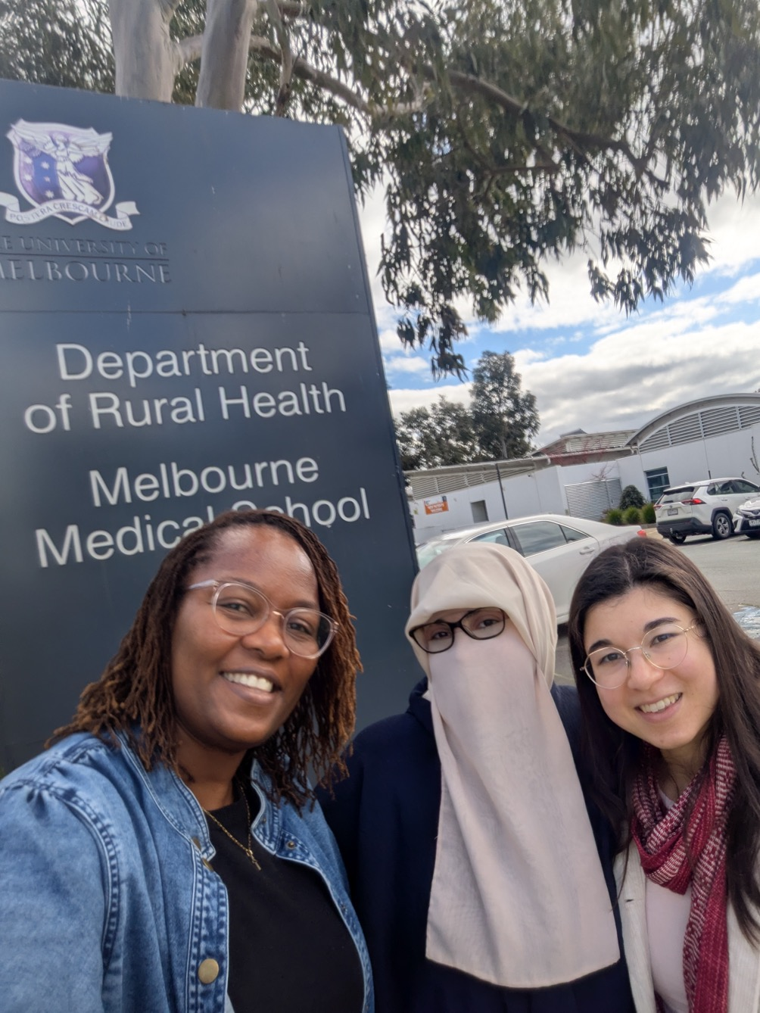

References
Aberdeen L., Reid, C. & Ibrahimi, H. (2022). Evaluation of Wise Well Women Community Health Educator Program. Report. Culture and Rural Health, Department of Rural Health, The University of Melbourne.
Angelucci, M. (2023). Interpreter Mentoring and Professional Advancement Regional Opportunities. Report. Action Lab and Monash Intercultural Lab. https://sites.google.com/monash.edu/imparo/home/about-the-project/report rt
Australian Multicultural Women’s Alliance and Settlement Services International Limited. (2026). Activate Her Skills: Harnessing the economic potential of migrant women through better skills recognition. ActivateHerSkills https://activateaustralia.org.au/wp-content/uploads/2026/04/ActivateHerSkillsReport.pdf Report.pdf
Radford, D., Tan, G., Hetz, H., Krivokapic-Skoko, B., & Hassani, A. (2025). A whole-of-community approach: local community responses to refugee settlement–integration in rural Australia. Australian Geographer, 56(1), 83–103. https://doi.org/10.1080/00049182.2023.2251627
Tan, G., Klocker, N., Radford, D., Golebiowska, K., Faulkner, S., & Dun, O. (2026). Rural and regional settlement of former refugees and humanitarian migrants: a place-based perspective. Australian Geographer, 57(2), 237–249. https://doi.org/10.1080/00049182.2026.2690738
Regional Australia Institute. (n.d). Regional migration experiences. https://www.regionalaustralia.org.au/Web/Web/Research-Policy/Research-Paper/Regional_Migration_Experiences.aspx Accessed September 2026.
van Kooy, J., Ahmed, S., Rioseco, P., & Marshall, D. (2025). Economic participation of humanitarian migrants in Australia. Research report. Australian Institute of Family Studies, Australian Government.
Victorian Government. (2023). A framework for place-based approaches. https://www.vic.gov.au/framework-place-based-approaches

Appendices
Appendix 1: Research survey questions
Appendix 2: Research summary for community members
Appendix 3: Relevant community services in the Shepparton region (list)
Appendix 4: 'Wise Well Women' program information

Appendix 1: Research Survey Questions
Migrant women in Shepparton: Understanding skills, qualifications, and aspirations
Survey Flow

Thanks for your interest in this survey. Please read the below information before deciding if you want to complete the survey. After reading, you can select 'next' below, if you would like to continue to start the survey.
This survey is part of the Migrant Women in Shepparton: Understanding Skills, Qualifications, and Aspirations research project. Our research team includes Melbourne University based researchers and Shepparton-based community researchers who are themselves from migrant and refugee communities. The purpose of the survey is to learn from migrant women in Shepparton about their experiences trying to achieve their career and life goals.
What does the survey involve, and is it private? The survey will take about 15 minutes of your time. Most questions are multiple choice (choose from options). The survey will not include your name in any results. We will use the survey to learn about how many women share particular experiences, situations, or views. So, we are interested in overall responses to each question, not individual responses. This protects your privacy.
If you complete the survey, you will receive a $20 gift card as thanks for your time.
You can do the survey by yourself or with the help of a translator or research team member. The research team includes:
Kalina Mali Muli (English, Tongan) T: 0420 394 906 E: kalinamali.muli@unimelb.edu.au
Muzhgan Qazikhil (Dari, Hazaragi, English, Persian) T: 0449 584 367 E: muzhgan.qazikhil@unimelb.edu.au
Shaza Alsmail (Arabic, English) T: 0490 492 014 E: shaza.alsmail@unimelb.edu.au
Melbourne-based researchers:
Prof. Karen Block Tel: +61 3 8 3440 862 Email: keblock@unimelb.edu.au (lead researcher)
Dr Meg Lee (English), University of Melbourne T: 0431 005 250 E: meg.lee@unimelb.edu.au
Charlene Edwards (English), University of Melbourne E: charlene.edwards@unimelb.edu.au
What are the possible benefits? There are no direct benefits to you for participating in this research, but we hope you will enjoy the opportunity to share your experiences and ideas. Your participation will help us understand the best ways to improve migrant women’s access to opportunities to reach their goals.
What are the possible risks? The survey asks about your experiences, hopes, and challenges to achieving your aspirations, which some people may find upsetting. You do not have to answer any questions if you do not want to. If the research brings up issues that are difficult for you, there are a list of support services below that you can contact for help.
Do I have to take part? No. Participation in this project is your own decision and is completely voluntary.
Will I hear about the results of this project? Yes. The results from this project will be shared through presentations to the Shepparton community where the research team shares what they found. Written summaries of the results will also be made available in online and print versions. As well as sharing what we find with you, we will also share our research with people who work in policy at services and organisations that support migrant women and employers.
What will happen to information about me? We will publish a research report on our website and write one or more journal articles and present the research findings at conferences as well. The information collected in this research project may also be used by members of this research team in the future, if they are working on a similar topic that can be supported by this information. All of the information we collect from you will be kept securely at the University of Melbourne for five (5) years. If you are younger than eighteen, then it will be kept for fifteen (15) years from the date you turn eighteen. After this time, the information will be destroyed.
Who is funding this project? This project is funded by the Melbourne Social Equity Institute and supported by a Civic and Community Impact grant from the University of Melbourne. For more information about the Melbourne Social Equity Institute, visit https://socialequity.unimelb.edu.au/. Where can I get further information? If you would like more information about the project, please contact the researchers, whose details are listed at the top of this page.
Who can I contact if I have any concerns about the project? This project has human research ethics approval from The University of Melbourne [Project ID: 33433]. If you have any concerns or complaints about the conduct of this research project, which you do not wish to discuss with the research team, you should contact the Research Integrity Administrator, Office of Research Ethics and Integrity, University of Melbourne, VIC 3010. Tel: +61 3 8344 1376 or Email: research integrity@unimelb.edu.au. All complaints will be treated confidentially. In any correspondence please provide the name of the research team and/or the name or ethics ID number of the research project.
Support services: If taking part in this research causes any distress, you can contact the support services listed below for help and support:
Kids Help Line Phone: 1800 55 1800 Web: https://kidshelpline.com.au/ Provides information and support for young people aged 5 to 25. Includes a phone service and online chat service.
Beyond Blue Phone: 1300 22 4636 Web: www.beyondblue.org.au Provides information and support for anxiety, depression and suicide prevention. Includes a phone service and online chat service.
1800 RESPECT Phone: 1800 737 732 Web: https://www.1800respect.org.au/ 1800 Respect is the national domestic, family and sexual violence counselling, information and support service.
For local support contact your local doctor (General Practitioner) to discuss ways to access ongoing mental health care.
In the case of a mental health emergency contact 000 immediately.
I have read the above information and would like to complete the survey.
If you would like to complete in the survey, please indicate your consent below and click ‘next’.
I agree that by selecting ‘next’, I am consenting to participate in this survey.
- next

Page Break

End of Block:

Start of Block:

Screening questions (respondents who did not fit the criteria for age, gender, and locality were not permitted to progress to the survey)
End of Block:

Start of Block:

What is your gender identity?
- Woman
- Man
- Nonbinary
- Other __________________________________________________

Were you born in Australia?
- Yes
- No

Are you aged 16 years or older?
- Yes, I am older than 16 years (16+)
- No, I am aged 15 years or younger

Do you live in the Shepparton region? If you regularly commute (travel for work, study, or other commitments) to Shepparton but and live in the Goulburn Valley, you can select 'yes'.
- Yes
- No

End of Block:

Start of Block:

Q2 Are you completing this survey by yourself or with the help of a translator or research team member?
- By myself
- With assistance

Q3 Which country were you born in?
________________________________________________________________
________________________________________________________________
________________________________________________________________
________________________________________________________________
________________________________________________________________

Q4 How would you describe your cultural identity? (e.g. Iraqi, Samoan, Tongan, South Sudanese, Australian, Afghan, Hazara etc. You may also name a combination of identities)
________________________________________________________________
________________________________________________________________
________________________________________________________________
________________________________________________________________
________________________________________________________________

Q5 What languages do you speak?
________________________________________________________________
________________________________________________________________
________________________________________________________________
________________________________________________________________
________________________________________________________________

Q6 What year did you arrive in Australia?
________________________________________________________________
________________________________________________________________
________________________________________________________________
________________________________________________________________
________________________________________________________________

Q8 How many years have you lived in the Shepparton region?
- Less than 1
- 1-2
- 3-5
- 6-10
- More than 10

Q9 What is your migration or visa status?
- Australian citizen
- Permanent resident
- Temporary resident (e.g. work, protection, partner or visitor visa)
- Undocumented
- Do not know
- Prefer not to answer
- Other (please describe)

Q10 Do you plan to move away from Shepparton in the future?
- Yes
- Not sure
- No

Display this question:
If Q10 = 1

If yes, what is your reason for wanting to move? (please describe)

Q12 What is your age?
- 16-19
- 20-25
- 26-30
- 31-35
- 36-45
- 46-55
- 56-65
- 66+

Q13 Who do you live with? (select all that apply)
- My husband or partner
- My parent/s
- My child/ren
- My partner’s family
- Other family members
- Others __________________________________________________
- I live by myself

Display this question:
If Q13 = 3

Q16 How old are your children? Please list the age of each child.
________________________________________________________________
________________________________________________________________
________________________________________________________________
________________________________________________________________
________________________________________________________________

Q15 Do you have caring responsibilities in Australia for (select all that apply) (do you look after)
- Children
- Elderly parents or parents-in-law
- Family members living with disability
- Others (please describe) __________________________________________________
- No, I do not have caring responsibilities

Q17 What is your religion?
- Buddhism
- Christianity
- Islam
- Hinduism
- No religion
- Prefer not to say
- Other – please describe__________________________________________________

End of Block:

Start of Block: strengths, skills and qualifications

Q18 What are three things that help you feel connected, supported, and confident in your life in Shepparton?
________________________________________________________________
________________________________________________________________
________________________________________________________________
________________________________________________________________
________________________________________________________________

Q19 What kind of skills and/or experience and/or knowledge do you have? (Select all that apply).
- Community organising
- Childcare
- Teaching
- Business management
- Accounting
- Maths
- Engineering
- Health
- Research
- Food
- Hospitality
- Aged care
- Disability support
- Digital and/or technology skills
- Creative arts, crafts, design (e.g. painting, drawing, weaving, sewing, etc)
- Music
- Dance
- Public speaking
- other (please describe) ________________________________________________

Q20 What is the highest level of education you have completed?
- Never attended school
- Started primary school
- Finished primary school
- Started secondary school
- Finished secondary school
- Trade or technical qualification beyond school
- University degree
- Other (please describe) __________________________________________________

Skip To: Q.27 If Q20 = 1

Q22 Where was this education completed?
- In Australia
- In another country or countries (please name) __________________________________________________

Skip To: Q.27 If Q22 = 1

Display this question:
If Q20 = 6
And Q20 = 7
And Q20 = 8

Q23 What course or qualification did you complete? (please name)
________________________________________________________________
________________________________________________________________
________________________________________________________________
________________________________________________________________
________________________________________________________________

Q25 Is your technical/trade/university qualification recognised in Australia?
- Yes
- No
- not sure

Q26 Have you been able to find work using this qualification in Shepparton?
- Yes
- No – prefer to undertake different work
- No – Other reasons (please describe) __________________________________________________

Q.27 Have you undertaken additional study or training in Australia?
- No
- Yes

Skip To: End of Block If Q.27 = 1

Q28 What course or qualification did you undertake? (please name)
________________________________________________________________
________________________________________________________________
________________________________________________________________
________________________________________________________________
________________________________________________________________

Q29 Have you completed this study or training?
- Yes
- No

Q30 Why did you undertake study or training? (select all that apply)
- I wanted to build my knowledge and skills
- I wanted to update my qualifications or pursue a career or goal in a new area
- It was the best or only way I could access services or stay in Australia
- It was the best or only way I could have a chance to get employment

End of Block: strengths, skills and qualifications

Start of Block: employment

Q32 Do you currently have employment (work)?
- Yes
- No

Skip To: Q36 If Q32 = 3
Skip To: Q36 If Q32 = 3

Display this question:
If Q32 = 1

Q33 What is the name of your job or occupation?
________________________________________________________________
________________________________________________________________
________________________________________________________________
________________________________________________________________
________________________________________________________________

Display this question:
If Q32 = 1

Q34 Please select all that apply to you
- I am working in my preferred occupation (job)
- I would prefer to work in a different occupation (Please describe)
- I am self employed
- I want more employment
- I want to work less hours/days
- I am satisfied with the amount of money I earn

Display this question:
If Q32 = 1

Q35 Do you use your skills and qualifications in your current work or employment?
- Yes, as much as I would like
- Yes, but not as much as I would like
- Not sure
- No

Display this question:
If Q32 = 3

Q36 I do not have a job or occupation,
- but I want employment
- I don’t want employment
- I am occupied with unpaid work (e.g. caring responsibilities, volunteering etc.)

End of Block: employment

Start of Block: community

Q37 Have you done any of these things in Shepparton? (select all that apply)
- Been part of a Board or Committee
- Helped lead a network, an organisation or community group or to organise community events
- Helped with childcare or transportation for another community or family member
- Helped other migrants settle into Shepparton
- Volunteered
- Contributed to community consultation processes
- Undertaken other leadership roles (please describe) __________________________________________________

Q39 What factors, organisations or people have helped you to settle in Shepparton and to pursue your goals (please list three)
________________________________________________________________
________________________________________________________________
________________________________________________________________
________________________________________________________________
________________________________________________________________

End of Block: community

Start of Block: challenges

Q40 Have any of the following made it difficult for you to pursue your aims or aspirations in Shepparton? (select all that apply)
- Language barriers
- Visa status
- Racism or discrimination
- Lack of childcare options
- Lack of welcoming spaces for social connection or networking
- Access to transport
- Rural location
- Family responsibilities and expectations
- Community responsibilities and expectations
- Limited access to employment opportunities
- limited access to education or training opportunities
- Limited access to healthcare services and supports
- Limited access to disability services and supports
- Other __________________________________________________

Q41 What would make it easier to pursue your aims or aspirations in Shepparton? (select all that apply)
- More flexible English language classes
- More flexible childcare options (e.g. at different times)
- More affordable childcare options
- More welcoming spaces for social connection or networking
- More opportunities to practice English in the community
- More support learning to drive
- More affordable or appropriate housing
- A wider range of employment opportunities
- A wider range of education and training options
- More affordable study or training options
- Improved public transport
- More support for families
- Funding for community groups and events
- Improved access to healthcare services and supports
- Improved access to disability services and supports
- Other __________________________________________________

End of Block: challenges

Start of Block: aspirations

Q42 What is a hope or aspiration that you have for your own life? (e.g. a dream for your life five years into the future)
________________________________________________________________
________________________________________________________________
________________________________________________________________
________________________________________________________________
________________________________________________________________

Q43 What is a hope or aspiration that you have for the Shepparton community? (e.g. a dream for how the community might be, five years into the future)
________________________________________________________________
________________________________________________________________
________________________________________________________________
________________________________________________________________
________________________________________________________________

End of Block: aspirations

Start of Block: other considerations

Q45 Have you personally experienced any of the following (select all that apply):
- Disability
- Family violence
- Mental health challenges
- Forced migration
- None
- Prefer not to say

End of Block: other considerations

Start of Block:

Q46 Anything else you’d like to tell us?
________________________________________________________________
________________________________________________________________
________________________________________________________________
________________________________________________________________
________________________________________________________________

End of Block:

Start of Block: After-survey gift
Display this question:
If Q2 = 2

Appendix 2: Research Summary
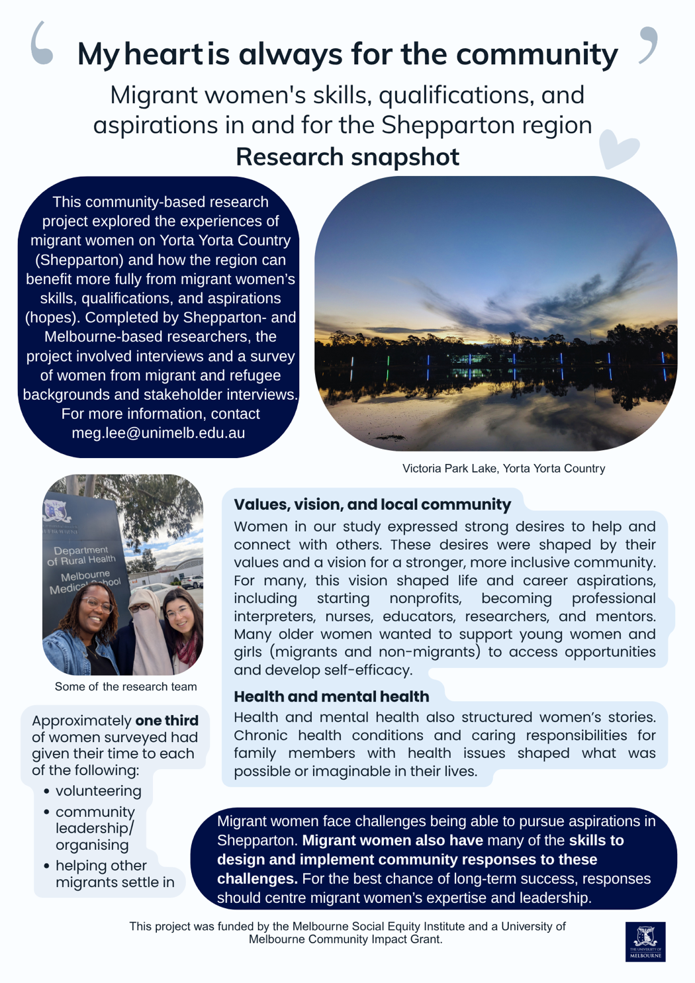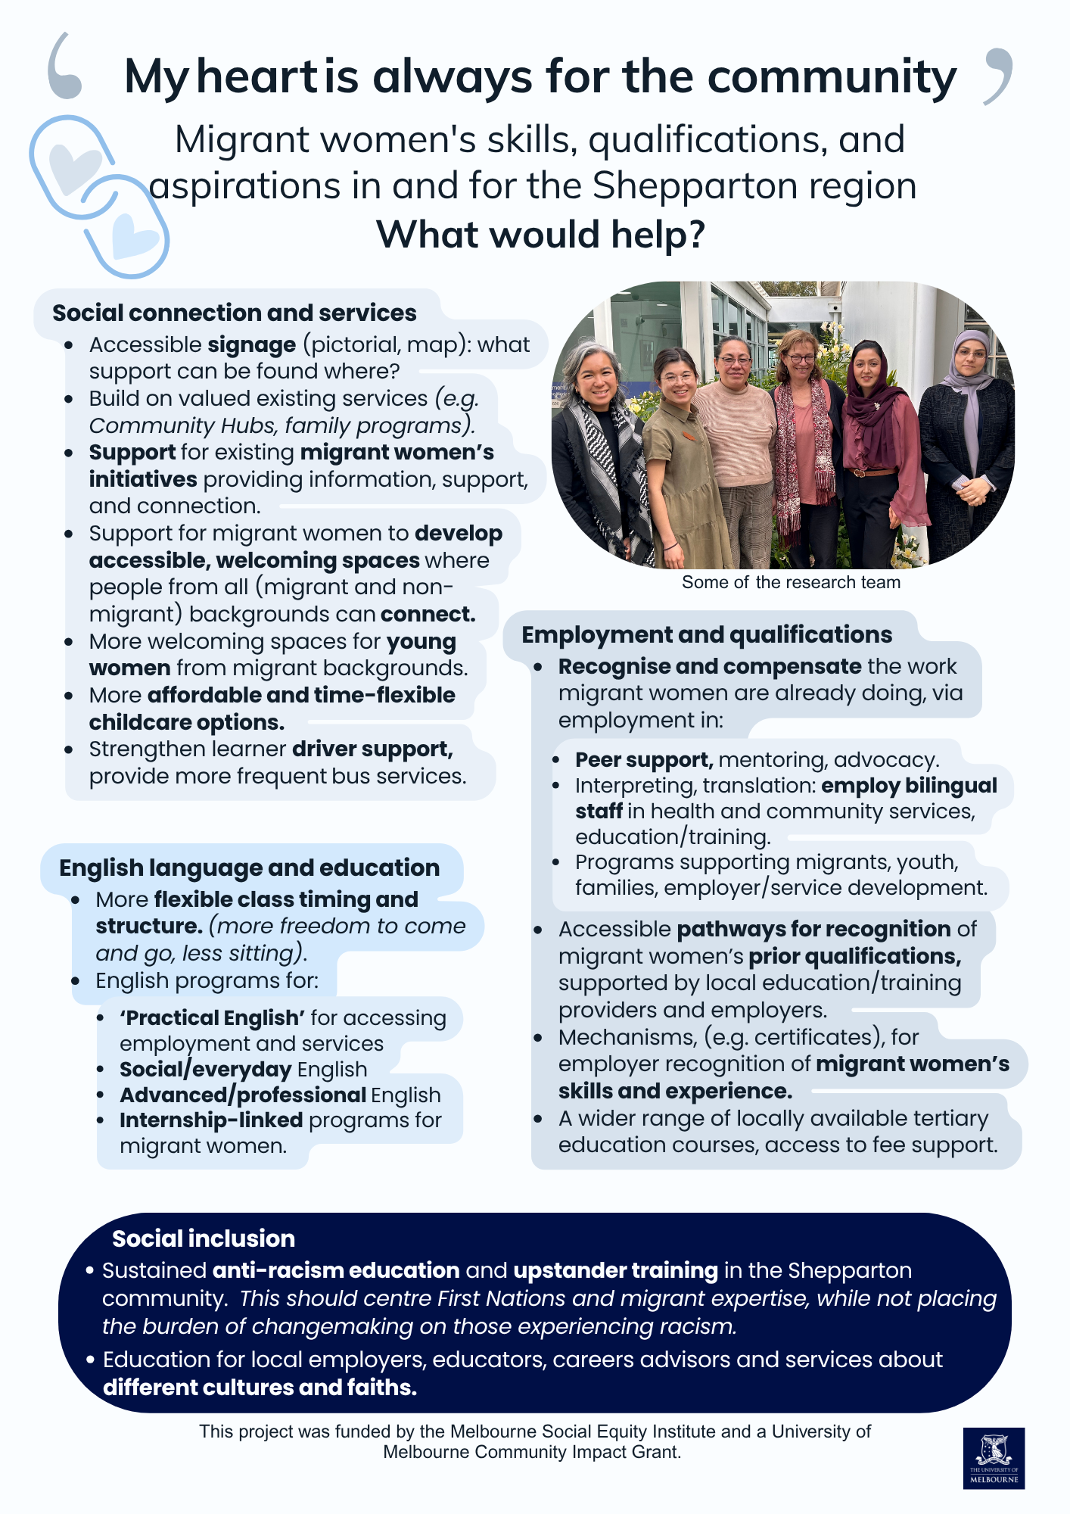

Appendix 3: Relevant community services and initiatives in the Shepparton region
Below is a list of community services, programs and initiatives put together based on the advice of migrant women and stakeholders involved in this research. The list includes existing local services and initiatives supporting migrant women to utilise and/or develop their skills and qualifications, and to pursue their aspirations in Shepparton. The list also includes resources and information for stakeholders working with migrant women, such as employers.
Welcoming spaces and initiatives
- The Bridge Youth Service: 25 St Georges Rd, Shepparton, (03) 5831 2390, shepparton@thebridge.org.au
  - Walk-in youth service providing a space for young people.

- Lighthouse Project Community Hubs: info@gslp.com.au, 0419 555 939
  - Welcoming spaces for families from diverse backgrounds, particularly women with young children
  - Three locations: Mooroopna Park Primary School, St Georges Road Primary School and Wilmot Road Primary School

- PODS | Point of Difference Studio: 1300 158 773, admin@pointofdifference.org.au
  - Programs for young people, training and advocacy
  - Professional People of Colour and culture (PPoCC) network

- Shepparton Culture Kitchens - Activities in the Park
  - Group cooking and socialising for all ages, in community languages.
Families and relationships
- The Bridge Youth and Family Services: 25 St Georges Rd, Shepparton, (03) 5831 2390, shepparton@thebridge.org.au
  - A range of services for young people and families: housing, school and education support, health, family relationships, and more.

- FamilyCare: 03 5823 7000, centralintake@familycare.net.au
  - Multicultural parenting programs in community languages including Tuning into Kids, Tuning into Teens, Parenting in a New Culture
  - Other programs and support for mothers and children
  - Support for carers

- The Goulburn Valley Domestic and Family Violence Alliance:
  - Relationships Australia: (03) 5820 7444, shepparton@rav.org.au, 634 Wyndham St, Shepparton
  - Orange Door: 1800 634 245, goulburn@orangedoor.vic.gov.au, 210 Corio St, Shepparton
  - FamilyCare: 03 5823 7000, centralintake@familycare.net.au, 19 Welsford St, Shepparton
  - The Bridge Youth and Family Services: (03) 5831 2390, shepparton@thebridge.org.au, 25 St Georges Rd, Shepparton
Education and training
- GOTAFE tertiary education provider (including English language adult classes): 1300 468 233.

- Shepparton English Language Centre: (for children): 03 5821 3383, st.georges.road.ps.shepparton@education.vic.gov.au, St Georges Road Primary School, 120 St Georges Road
Support for jobseekers, employees, and employers
- Committee for Greater Shepparton (C4GS) Community Connector Program: 0499 351 441, communityconnect@c4gs.com.au
  - Support for professionals who migrate for work, and their families.

- Ethnic Council of Shepparton and District: 5831 2395
  - Programs, resources, and information for migrant and refugee communities and stakeholders working with migrants and refugees, including:
  - An employer’s guide to working with refugees

- Goulburn/Murray jobs coordinator (Faye): 0491 080 457, faye.dhelin@goulburnmurraylocaljobs.com.au

- National or state-wide services:

- CVGT Employment: 132 848
- Inclusive Employment and Support Services - WISE: 1800 685 105, enquiries@
wise.org.au
- Inclusive Employment Australia Shepparton Employment Services | atWork Australia: 1300 080 856, 1/308 Maude Street, Shepparton
- Qualify Training and jobseeker support: 1800 365 599, enquiries@qualifytraining.com.au
Social connection, advocacy and community education
- The Door Bells: Migrant Women’s Network: On Facebook and Instagram @thedoorbells

- Ethnic Council of Shepparton and District: 5831 2395
- PODS | Point of Difference Studio: 1300 158 773, admin@pointofdifference.org.au
  - Programs for young people, antiracism education, networks, and more.

- Faith-based groups or ethnically/culturally specific groups, such as the Tongan Church, GV Afghan Women’s Association Shepparton, and others.
Health
Primary Care Connect: 03 5823 3200, 399 Wyndham St, Shepparton
Disability support
- ConnectGV: (03) 5821 2466, reception@connectgv.com.au, ndis@connectgv.com.au

Appendix 4: Wise Well Women program information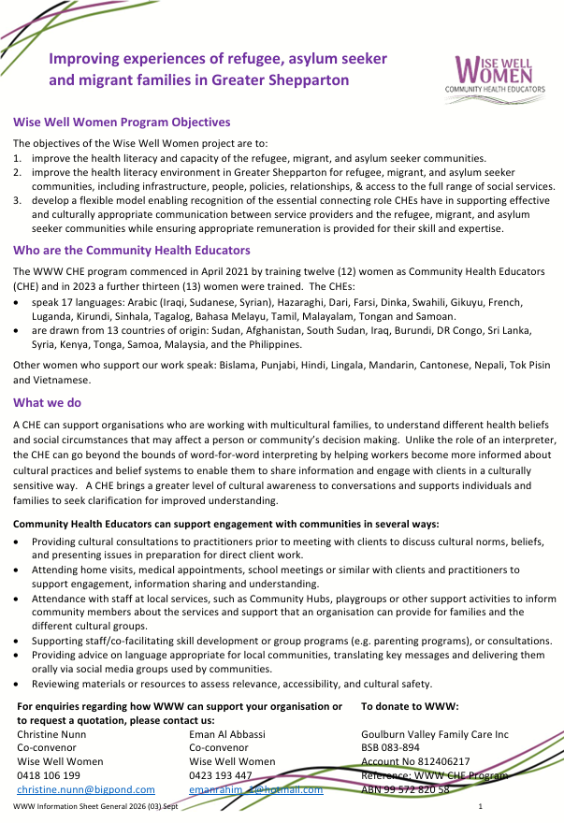

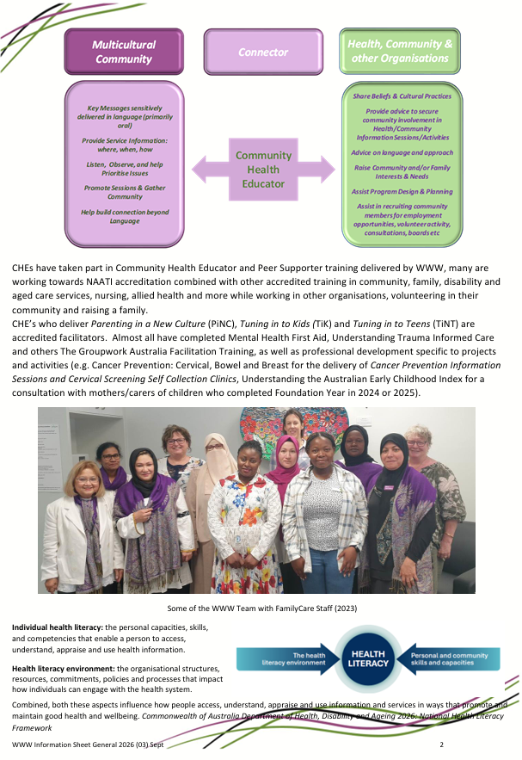


The University of Melbourne
Grattan Street, Parkville, Victoria 3010 Australia
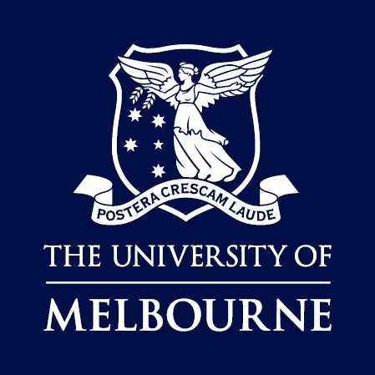
unimelb.edu.au

