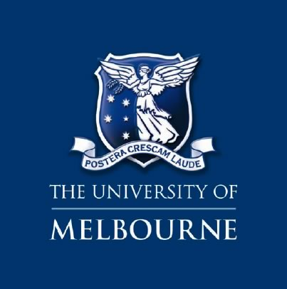
Created by: The Melbourne Social Equity Institute

This is an Accessibility Guide to the Sidney Myer Asia Centre and surrounds on the Swanston Street side of the University of Melbourne.

Access Guide – Sidney Myer Asia Centre, University of Melbourne (Parkville) - October 31 2014

Contents
Facilities for Visitors 5
Venue Access 5
Drop-off Zones 5
Parking 6
Public Transport 6
1. Buses 7
2. Trams 8
3. Trains 9
Outside Access 10
1. Swanston Street, Main Entrance 10
2. Monash Road Entrance 12
3. John Smyth side entrance 14
4. Rear Entrance (Carrillo Gantner Theatre) 15
Inside Access 17
Ground Floor 17
First Floor 20
Nearby Facilities 22

Facilities for Visitors
The Centre includes
- Two lifts available
- The Carrillo Gantner lecture theatre (with facilities for the hearing impaired)
- Teaching & learning rooms
- Outdoor dining and BBQ area
- The Yasuko Hiraoka Myer Room
- Male and Female Toilets
- Accessible toilets [Only available using the Basement Entrance, See Page 14]

Venue Access

Drop-off Zones
A drop-off zone is accessible via Gate 10, off Grattan Street, which will take you directly to the Centre. To get there, turn left off Grattan Street, right onto Kernot Road, left onto Wilson Avenue and finally right, onto Monash Road. The Centre will be at the end of Monash Road, on the right. [See Map below – blue arrows]
Monash Road can also be accessed directly by turning left off Swanston Street, after which the Centre will be on the left. However, using the Swanston Street entrance may require bollards to be lowered. To have the bollards lowered, please contact Campus Parking & Transport Services via the blue intercom on the left hand side of the road.
Gate 10

Parking
There is substantial parking available in the vicinity of the Centre: the following spaces are within five minutes’ walk:
- There are major parking lots located underneath South Lawn (accessible via Wilson Avenue), and underneath University Square (accessible via Bouverie Street). These spaces are open from 6am to 10pm Monday – Friday for a flat rate of $15.00 between 9am and 5pm and a flat rate of $8.00 after 5pm. On weekends between 7am and 7pm there is a flat rate of $8.00. The South Lawn car-park has 4 disabled parking spots, 3 located in the back left corner of the lot and 1 located in the back right corner of the lot. The University Square car-park has 12 disabled parking spots, all located at the rear of the first level, next to the lifts.

- Kernot Road on Campus, accessible via Grattan Street, has 12 spaces (including 3 accessible parks). From Monday – Friday during business hours a flat rate of $15.00 applies for all day parking or $8.00 for 3 hours. After 5pm on weekdays a flat rate of $8.00 applies. On weekends, daily parking is only $8.00.

- On Monash Road, directly to the right of Centre, there are 3 parking spaces and two accessible spots.
For further information regarding other parking options near the University of Melbourne, please see the link below:
http://au.parkopedia.com/parking/carpark/university_of_melbourne_university_square/3053/parkville/

Public Transport

For General travel information regarding getting to the University of Melbourne, please use the ‘Metlink Journey Planner’ on the Public Transport Victoria (PTV) website at:
http://ptv.vic.gov.au/journey#jpsearch%5Baction%5D=showPlanner

- Buses
The following bus routes provide direct access to the University of Melbourne:
- 200 – City to Bulleen (A)
- 207 – City to Donvale (A)
- 250 – Garden City / Port Melbourne to La Trobe University
- 251 – Garden City to Northland Shopping Centre
- 304 – City to Doncaster Shopping Town (A)
- 401 – North Melbourne to University of Melbourne (A)
- 402 – Footscray to East Melbourne (A)
- 505 – Moonee Ponds to University of Melbourne (A)
- 546 – Heidelberg to University of Melbourne (A)
Routes marked with this symbol ‘(A)’ are either partially or wholly serviced by wheelchair accessible buses and utilise accessible stops. For more information:
- Go to Metlink Journey Planner on the PTV website;
- Enter your journey details;
- Click ‘more search options’, in the bottom left hand corner of the search box;
- Select Special Requirements
- Choose ‘only uses services with wheelchair access’, ‘only use stops with wheelchair access’
Further details can also be found here:
http://pcs.unimelb.edu.au/traffic-and-parking/docs/UoM-Getting-here.pdf
OR by ringing your local bus service provider at the appropriate number, helpful contacts may include those found on the link below:
http://ptv.vic.gov.au/customer-service/operator-contacts/
OR by ringing Public Transport Victoria on 1800 800 007

- Trams
The following tram services arrive at the University of Melbourne regularly:
- 1 - East Coburg to South Melbourne Beach
- 3/3a -East Malvern to Melbourne University
- 5 - Malvern to Melbourne University (A)
- 6 – Glen Iris to Melbourne University (A)
- 8 – Toorak to Moreland (A)
- 16 – Kew to Melbourne University (A)
- 19 – North Coburg to City (Elizabeth Street) (A)
- 55 – West Coburg to Domain Interchange
- 59 – Airport West to City (Elizabeth Street)
- 64 – East Brighton to Melbourne University
- 67 - Carnegie to Melbourne University
- 72 – Camberwell to Melbourne University (A)
Routes: 1, 3/3a, 5, 6, 8, 16, 64 & 67 and 72 all stop on Swanston Street, immediately outside the Centre’s main entrance. This is a wheelchair accessible Super Stop.
For more details please see here:
http://pcs.unimelb.edu.au/traffic-and-parking/docs/UoM-Getting-here.pdf
To be certain that your route meets your specific requirements, or for more information, please consult the service provider directly at:
http://ptv.vic.gov.au/getting-around/accessible-transport/accessible-trams/
OR by ringing Public Transport Victoria on 1800 800 007

- Trains
The following train services provide access to the University of Melbourne

- City Loop trains which stop at Melbourne Central
Then take trams 1, 3/3a, 5, 6, 8, 16, 64, 67, 72 along Swanston Street to the Melbourne University stop)

- The Cragieburn, Sydenham, Upfield and Williamstown lines all run to North Melbourne Station
Then take the route 401 bus along Dryburgh Street to Melbourne University

For more details see here:
http://pcs.unimelb.edu.au/traffic-and-parking/docs/UoM-Getting-here.pdf
According to Public Transport Victoria, all of metropolitan train services are accessible. To be certain that your route meets your specific requirements, or for more information, please consult the service provider directly at
http://ptv.vic.gov.au/getting-around/accessible-transport/accessible-trains/
OR by ringing Public Transport Victoria on 1800 800 007

Outside Access
- Swanston Street, Main Entrance
The Centre stretches for 150 paces along Swanston Street, on a hard asphalt surface. The incline goes slightly downwards vertically towards Grattan Street and inwards horizontally towards the University.
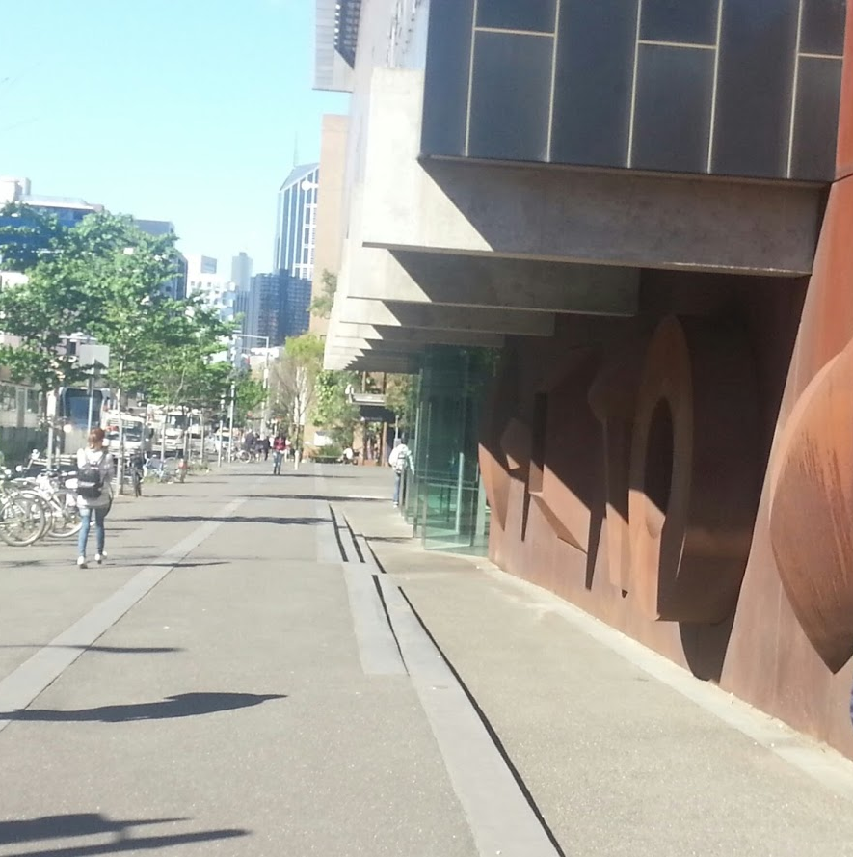
On the Swanston Street side of the Centre there are 3 small steps located 10 paces in from the road. After these steps, the Centre is a further 5 paces inwards.
The double doors of the main entrance are located 80 paces from the traffic lights near Monash Road and 70 paces from the John Smyth Building on the Grattan Street side. Another automated door is a farther 15 paces a towards Grattan Street. The last door on the Swanston Street side is a push/pull door, an extra 40 paces, again towards Grattan Street, or 15 paces to the left of the John Smyth building.
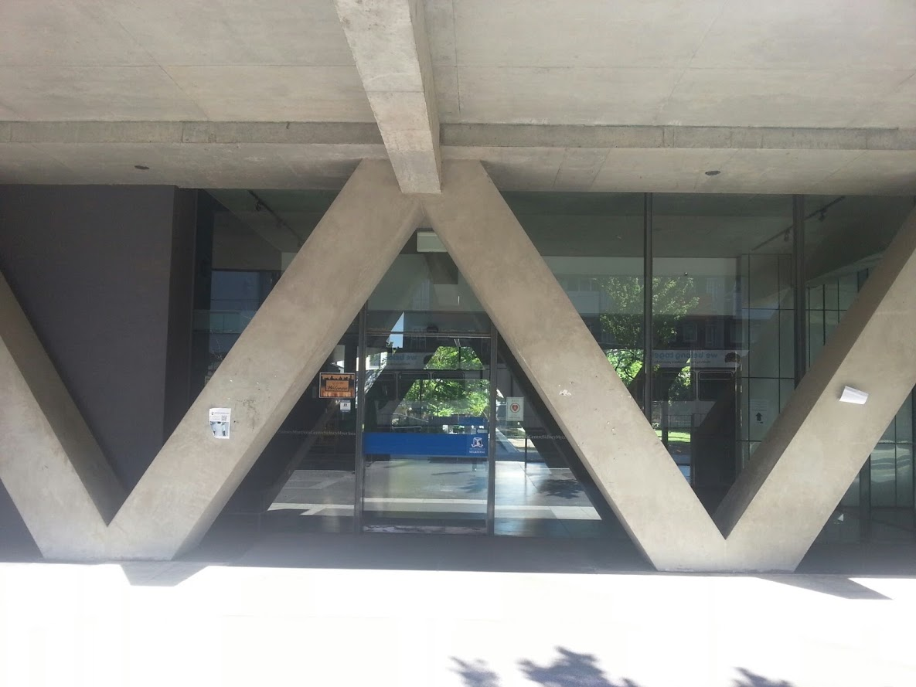
There is a bike rack located on the left hand side of the path, 60 paces down from Monash Road. Every 3 metres along Swanston Street there are also small tree saplings protected by metal coverings on the far left hand side of the path.

Monash Road Entrance
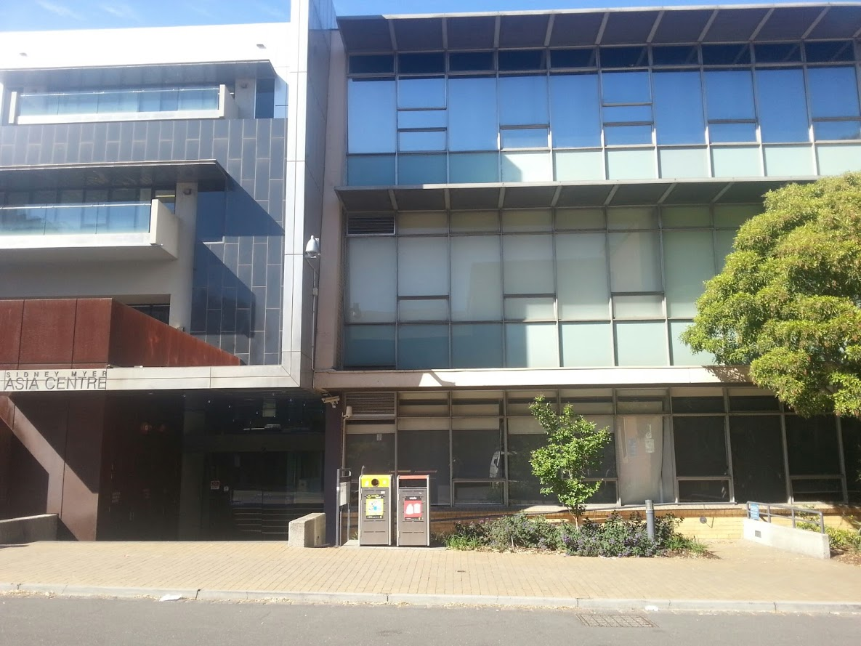
This entrance is to the right of the Centre from Swanston Street.
Brick pathways to the left and right of the Centre, each 3.5 paces in width, are marginally raised above the road surface, which is 10 paces in wide. The path has a slight downwards incline towards the University.
Steps leading to the Centre are located on the left hand side of Monash Road, 35 paces from Swanston Street. This staircase includes 5 steps, followed by a patch of slightly uneven surface. The staircase finishes 7 metres before the double automated doors, which are straight in front of the last step. Two bins sit to the right hand side of the steps.
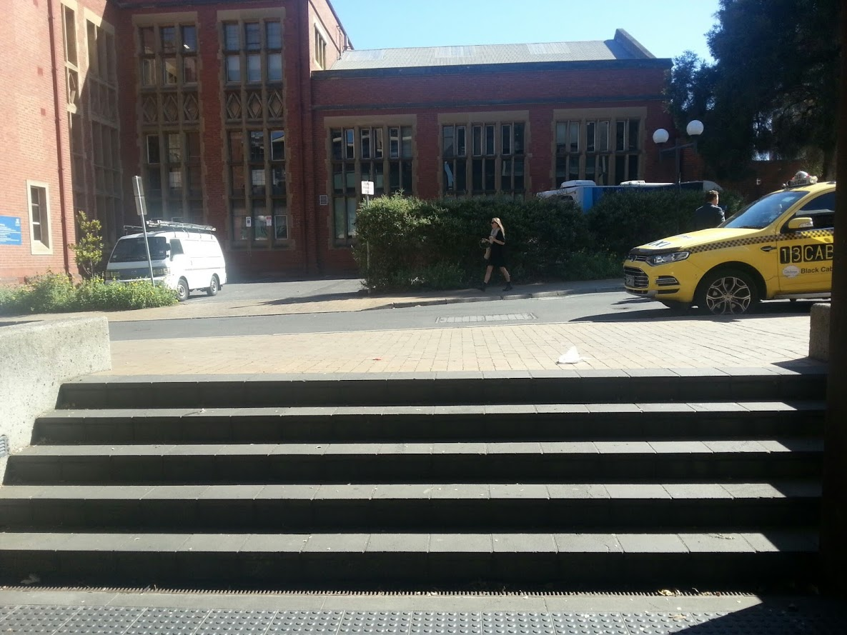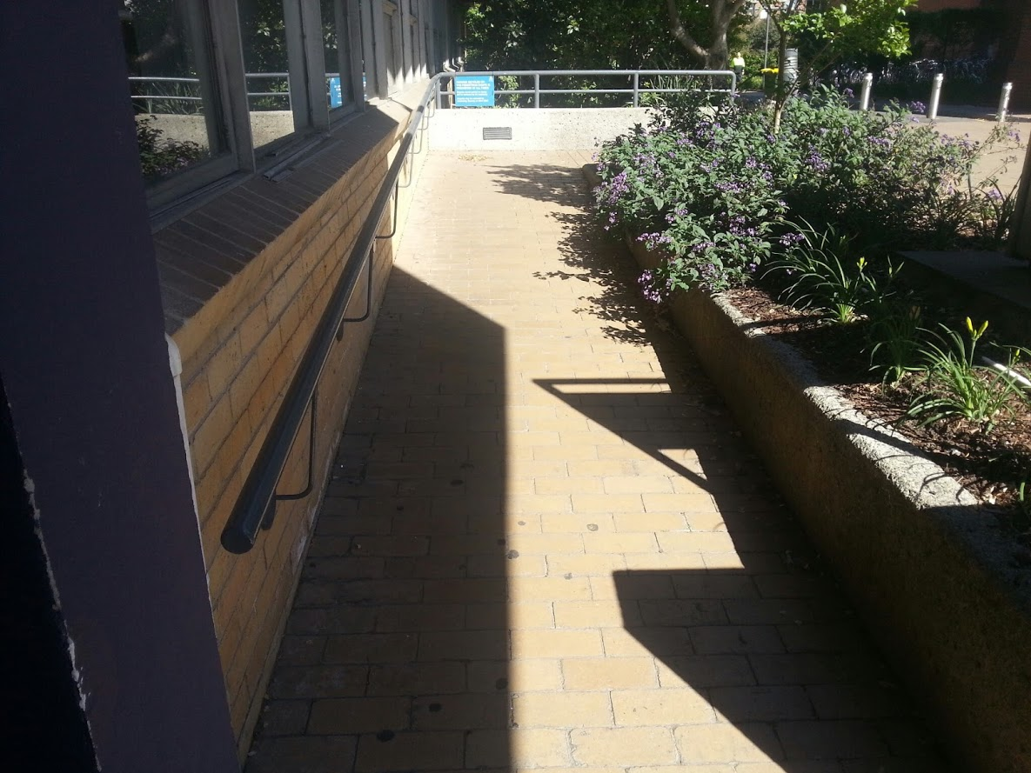
Ramp Access - A ramp is also available on this access route, located 57 paces from the Swanston Street, on the left hand side of Monash Road. This ramp extends for 5 paces straight ahead and then turns right for 15 paces at a slight downwards incline. The double automated does are located 7 paces to the right of the end of the ramp.
There is one post either side of Monash Road 25 paces in which are approximately a metre in height. Next to these, on the right hand side of Monash Road, is a full-sized map of the University. Further down, 55 paces from Swanston Street, there are 5 metal posts across the pathway.
85 paces in from Swanston Street there is a small blue drinking fountain located on the left hand side of Monash Road.

- John Smyth side entrance
On the John Smyth building side of the Centre (to the left of the Centre along Swanston Street), there is a pathway 10 paces wide by 35 paces long. There is one small metal post on either side of path, 3 metres in from Swanston Street.
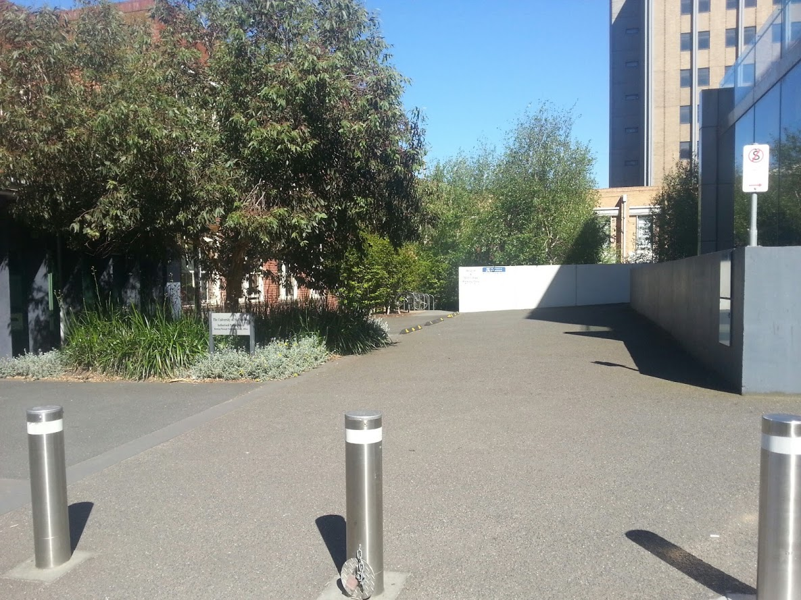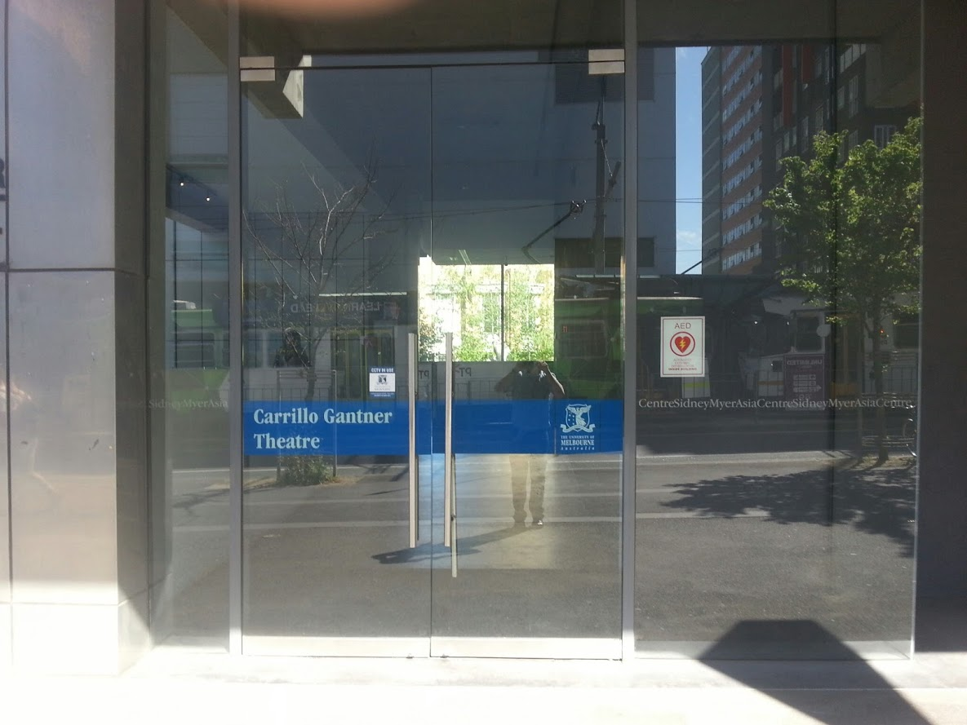
The entrance on this side is a pair of double doors, located 20 paces up from Swanston Street, at a slight upward incline towards the University.
20 paces after the double doors, there is a space 20 paces long by 3 paces wide, flanked by bike racks on either side and with a garden bed at the end.

At the end of this area there lies a steep, winding staircase, which lasts for 4 steps straight down, then 11 steps right, then another 4 steps down. There is only one hand rail, on the left hand side of the last two flights of these stairs.
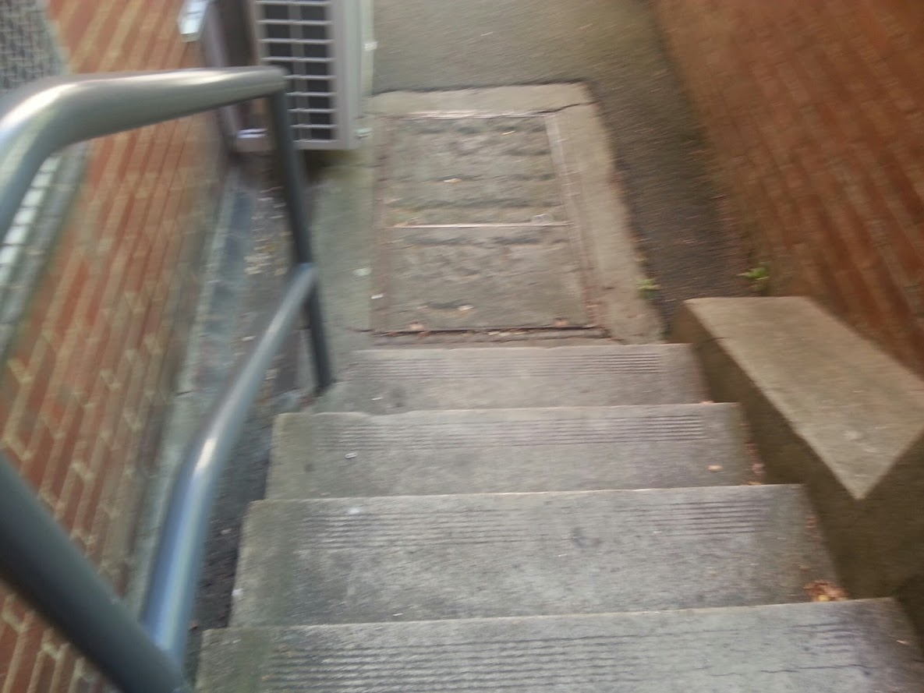

- Rear Entrance from the University Side (& Lower Entrance to Carrillo Gantner Theatre)

Along the rear side of the Centre there is a narrow pathway with a continuous, raised concrete flowerbed, 1 metre off the ground on the Swanston Street side, and a high concrete wall along the Campus side. This alley runs at a slight downwards incline towards the Centre. 15 paces from the John Smyth side of the alley there is a large metal grate and another 30 paces further on from that.
At the end of the alley there is an area, 12 paces long by 28 paces wide, which forms the lower entrance to the Carrillo Gantner Theatre, which is on the far right hand side. The building’s accessible toilet is only accessible from this entrance on the Basement level. Lifts from the other floors do not reach the Basement. *******
At the end of the area outside the Theatre, there is a large staircase that is 8 metres wide and contains 28 steps, in a pattern of 14 steps, followed by a platform, followed be another 14 steps. This staircase has long metal hand-railings on the far Campus side, in the middle of the staircase, and on the far Swanston Street side. An extension of this staircase to the right hand side is 4 steps by 5 paces wide, but runs into a dead end at a large concrete wall
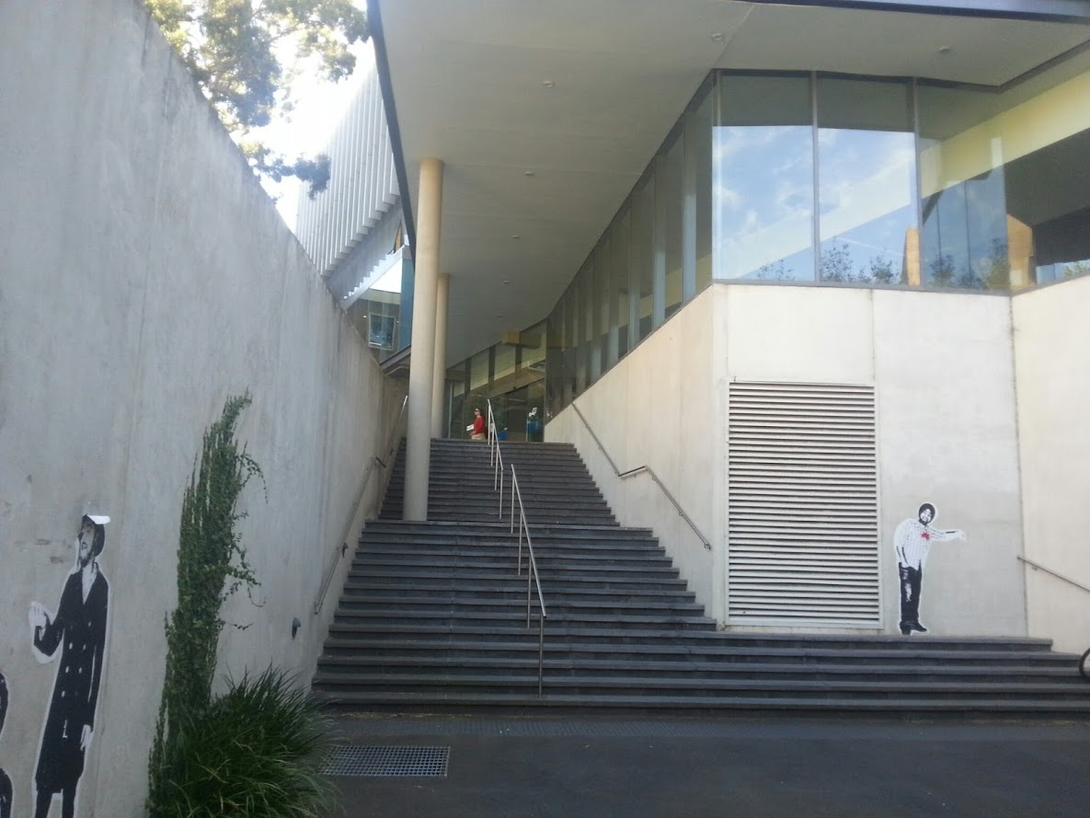
Ramp access – there is a long ramp beginning near the John Smyth Building at the rear of the Centre, running parallel to the alleyway. The ramp goes 35 paces straight ahead. Then there is a slight right hand turn, followed by another 100 paces straight ahead. A set of automated double doors lies 15 paces to the right of this ramp.
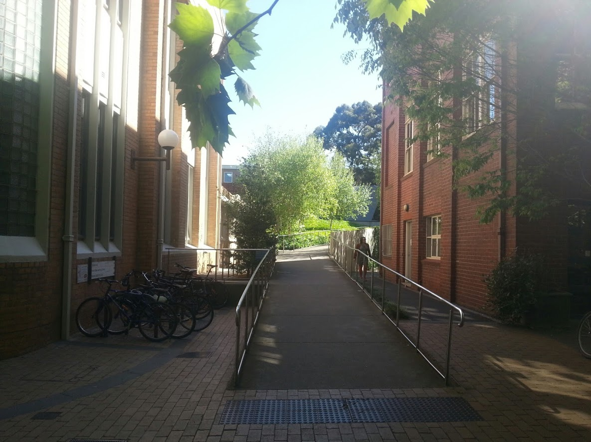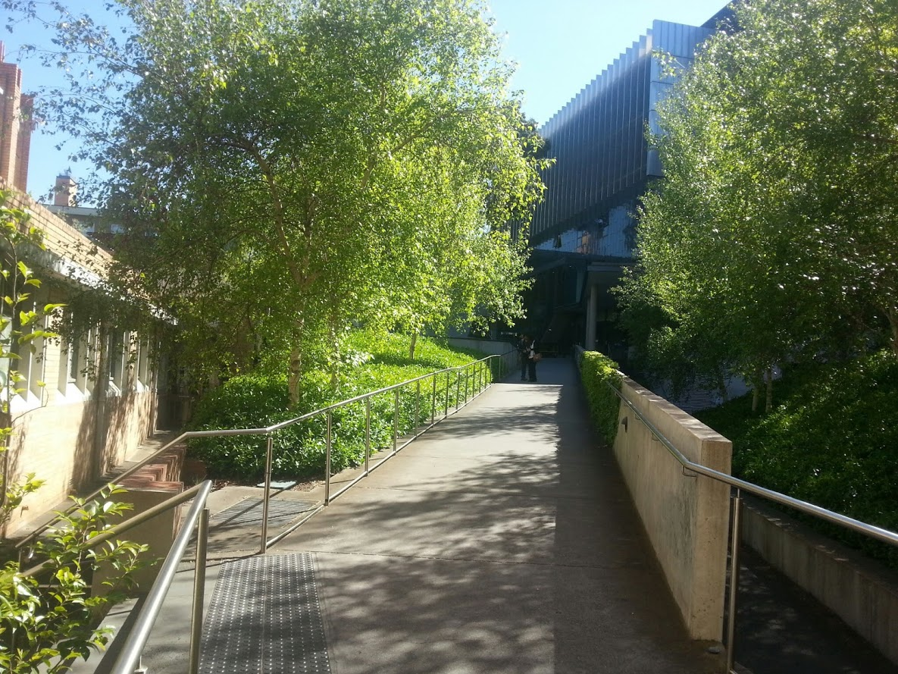

If you turn left instead at the end of the ramp, there is a long, narrow, pool-like water feature, stretching away from the Centre on you right hand-side as you walk towards Campus. There is a large metal grate 30 paces down the water feature, and another 55 paces further towards the Campus, where the pool ends.
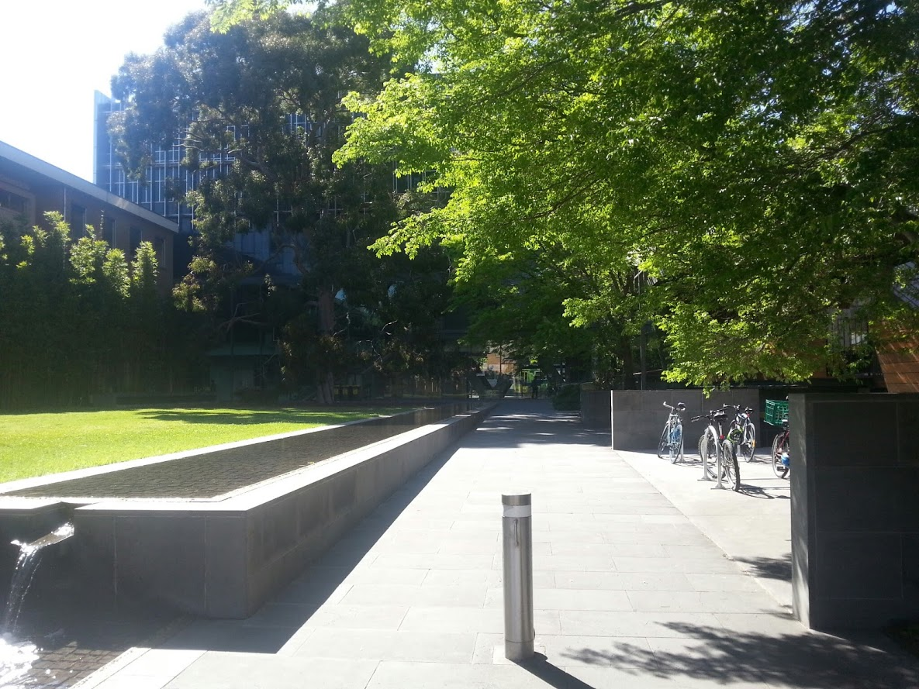

Inside Access

Ground Floor
The following description goes from the starts at the (Monash Road entrance), and ends on the far side of the Centre (closer to Grattan Street). Swanston Street is located on the left hand side, and the University Campus is located to the right hand side.
5 paces of matting come after the double automated doors, followed by hard, slippery, stone floor.
On the right hand side, 10 paces after the door, lies an entrance to the Alice Hoy building. The Department of Optometry and Vision Services is located down this corridor 30 paces, to the left, on Level 4 of the Building.
After the Monash Road entrance, there is an area 30 paces wide and 20 paces long, with a glass cabinet in the far left hand corner housing historical and cultural exhibits about the country of Oman. This area is very dimly lit.
25 paces from the Monash Road Entrance there is a stone pillar stretching from the floor to the ceiling in the middle of the walkway. After this point, natural lighting from the University side of the building brightens the room. Some low leather seats are located against the walls, on either side of the pillar.
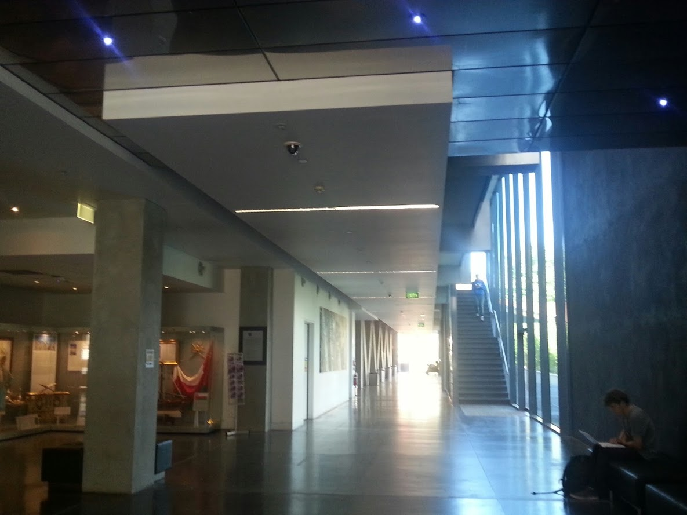
33 paces from the Monash Road entrance and 8 paces in from the brighter light, there are 2 lifts on the left hand side. These lifts are 15 paces wide and have a large stone bollard stretching from the floor to the ceiling on either side of them. There are two doors on the University side of the Centre, opposite the lifts, which lead out onto the main campus, one before the lifts and one after.
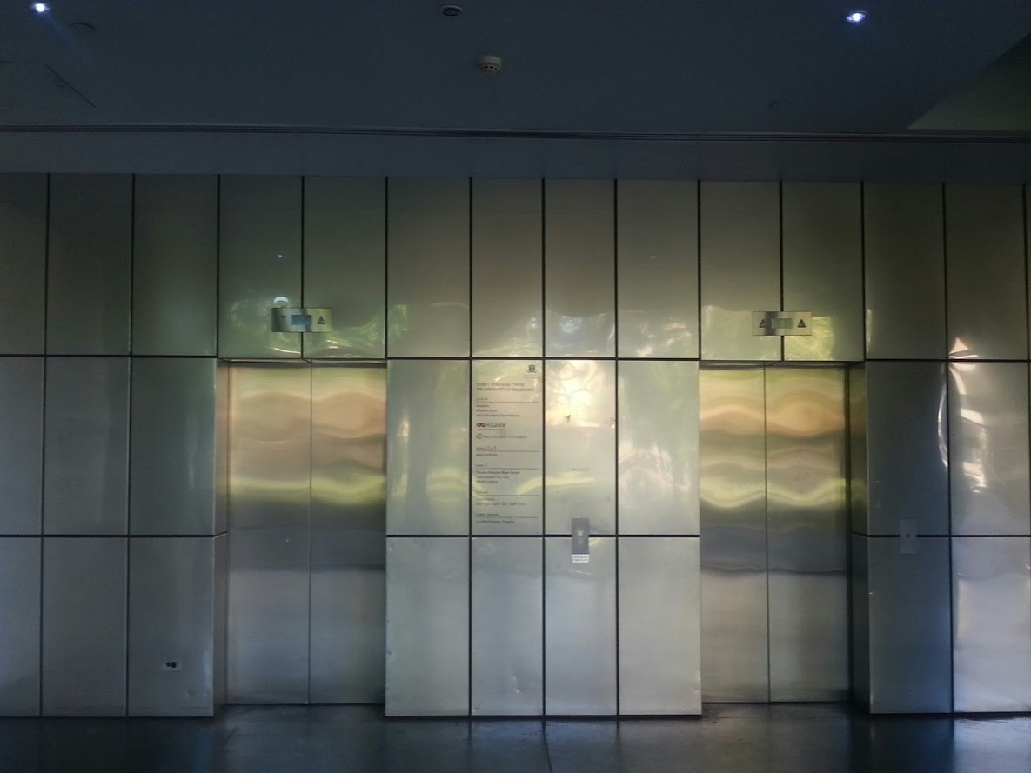
After the lifts there is a space 20 paces wide by 20 paces long, with four large, stone ‘V’s’, each a metre wide. To the left of this area, with two ‘V’s’ either side of it, lies the main Swanston Street entrance: two automated doors. There is seating along the walls of both sides of this area.
After the main entrance on the Swanston Street side, there is a passage of 40 paces in length by 10 paces in width. In this area, the large stone ‘V’ pattern is repeated on the Swanston Street side, whilst glass windows along the University side continue to provide natural light.
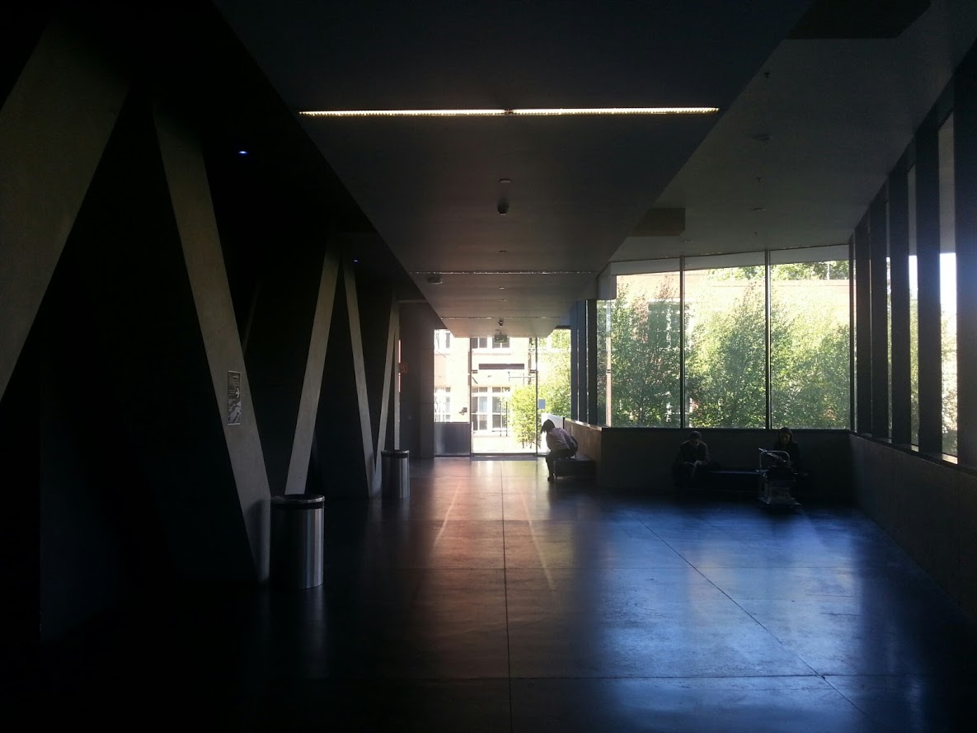
At the end of this area is a double automated door leading outside to the Grattan Street side of the Centre.

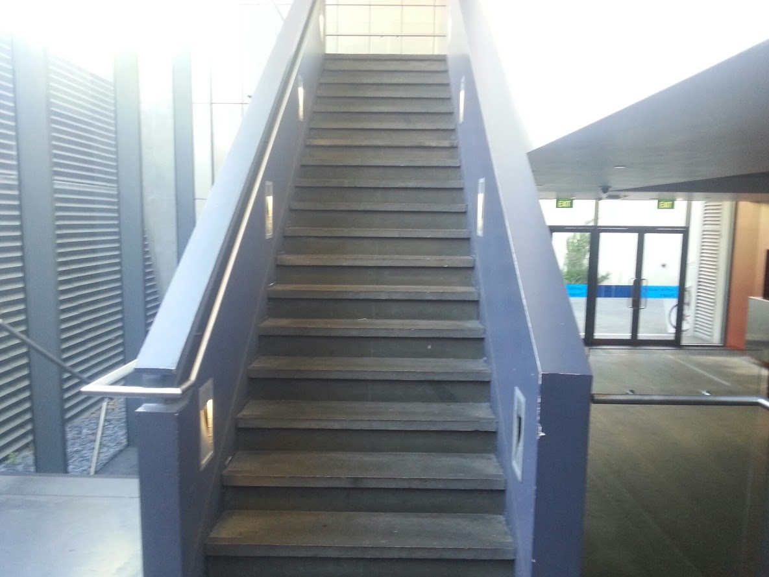
Standing near the far Grattan Street side of the Centre, 15 paces to the left (towards Swanston Street), is a winding flight of 18 steps with a rail on the right hand side, followed by a wrap-around (left-then-right) turn on a small platform, followed by a further 6 steps, that take you to the Basement level. 15 paces to the right of the stairs is the Carrillo Gantner Theatre, with two heavy double doors 8 paces apart.
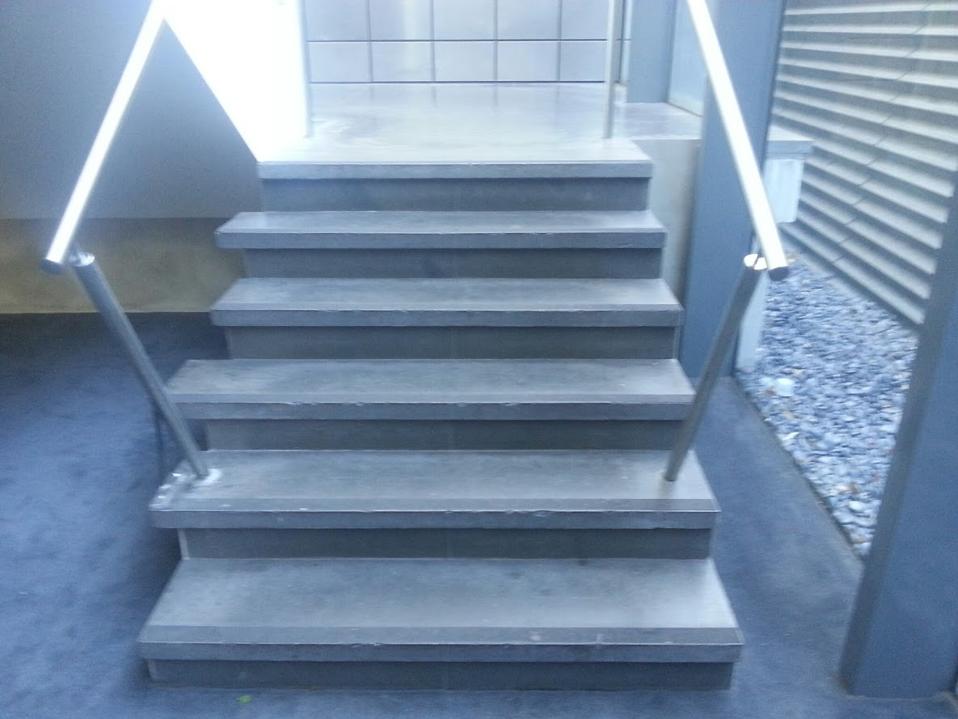

First Floor
The Yasuko Hiraoka Myer Room is located 20 paces directly to the right of the lifts on the First Floor of the Centre, through two sets of manual doors .
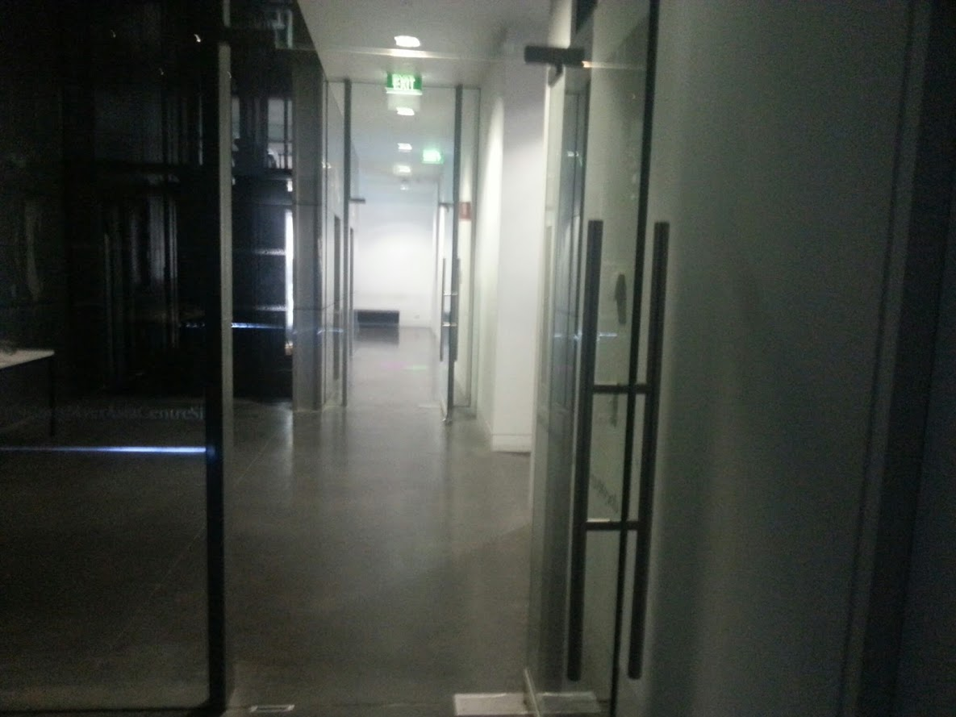

The space itself is approximately 25 paces by 25 paces. The inside of the space is a hard, stone like surface. There is also a wooden balcony with natural lighting on the far side of the room.
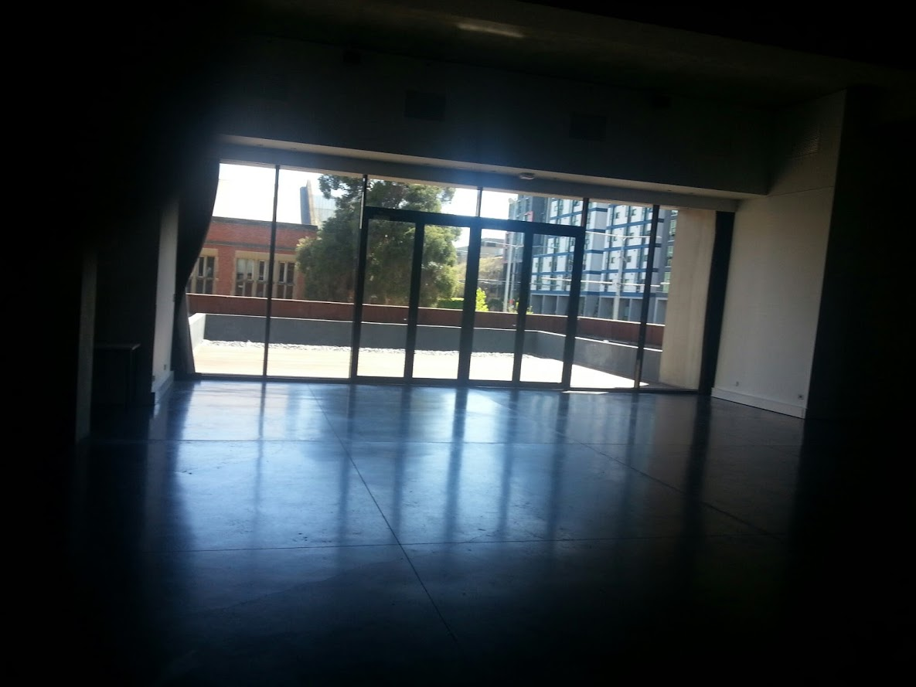
There are two large stone pillars, approximately 10 paces apart at either end of the room.
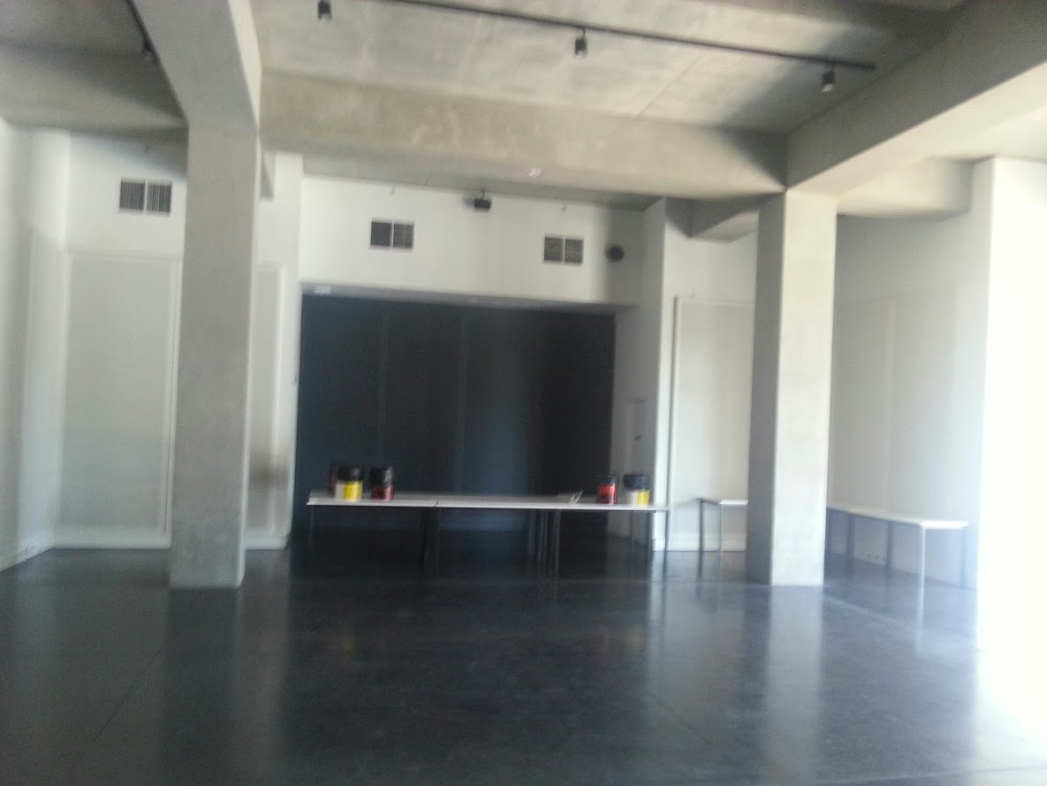

Lygon Street this way
Lot 6 Cafe
Romano’s
Tsubu Bar

Nearby Facilities

There are many quality dining options located close to the Sidney Myer Asia centre, including:
- Lygon Street food district;
- Romano’s Coffee;
- Lot 6 Café and;
- Tsubu Bar

The changes below are effective as of July 27 2014.
Please note, the route 253 bus has been consolidated into the route 251 service.
Please note this use to be the 201 service.
Please note, the 203 & 205 bus services have been consolidated into the route 200 service.
Trams marked with this symbol are partially serviced by accessible, low floor trams.
Use tramTRACKER® to find out if any of the next three trams at your stop will be a low-floor vehicle.
This entrance is the least navigable for people with mobility issues, best to avoid, if possible.
Walking the rear (University-side) of the Centre, from the John Smyth end towards the Monash road end.

